Connor Wood

candidate no: | 6611

Bach Chorale Evaluator

a2 non exam assessment

Contents

Analysis 2

Project Problem Definition 2

Background To The Problem 2

Example Question and Glossary of Terms 3

Meeting with Richard Butler 14

Existing Software 15

Existing Software & Language Research 15

Overview & Analysis of Current System 16

Prospective Users & Limitations 18

Data Flow Diagram of Current System 19

Entity Relationship Diagram 20

Tasks to be Computerised & the Benefits of Computerising 21

Proposed System Objectives 22

Potential Solutions & Justification of Chosen Solution 24

Design 26

Description of System 26

Interface Design/Planning 27

File Structure 44

Database Table Design 45

SQL Queries 46

Algorithm Design – Use of ‘Instance.’ 48

Regular Expressions & Exception Handling 48

Development of Algorithms & Data Structures 54

UML Class Diagram 78

Test Plan 80

Technical Solution 87

How To Run The Program 87

Annotation 89

Technical Solution – The Code 89

Testing 146

Screenshots of Tests 146

Changes Made & Re-testing 147

Unexpected Test Outcomes/Issues To Fix When Programming & Re-Testing 168

Evaluation 173

Table Of Objectives 173

# Analysis

### **Project Problem Definition**

Client: Mr Richard Butler, Head of Performing Arts, Ulverston Victoria High School

Contact: rbu@uvhs.uk

### **Background To The Problem**

Ulverston Victoria High School & Sixth Form is home to a very successful, nationally acclaimed performing arts department. It boasts one of the most highly rated state school Swing Bands in the country, as well as a critically acclaimed Wind Band. Each year, the department performs incredibly well, both locally and nationally, gaining top results at both GCSE and A-Level. Within the department are 2 music teachers, Mr Richard Butler, as well as Mrs Anne Heginbothom, both of whom teach Music at A-Level. As part of studying A-Level music, students must complete an exam paper, which contains a musical ‘Techniques’ question. Students are given an incomplete passage of music, written in four parts, which they must complete to a suitable standard, following very specific rules about composing music in the style of Bach, a famous Baroque composer. They are given a mark out of 12, depending on how well these rules are followed. Currently, in order to prepare for this exam question, students practice exercises, using photocopied, handwritten booklets prepared by both Richard Butler and Anne Heginbothom. The booklets are handed out, and students are free to complete questions at their own pace as part of their studies, and hand them in for marking at any time. Both completing questions by hand, and marking questions by hand can be time consuming, and booklets can easily be lost as they are handed in and handed back frequently. It can also be difficult to keep track of how students are performing and whether they are improving and how many questions they have completed. The music teaching staff would like a computerised system, where questions can be set, accessed and completed on the computer – they would also like the system to automatically score questions, and provide an easy way for staff to see how a student is performing.

Over the page is a questionnaire/interview style meeting I held with Richard Butler, to find out more about what he would like from a new system – including details of how students and staff can interact with the software and what key features he would benefit from being included.

I have provided a glossary of musical terms and information about the musical ‘Techniques’ exam questions to be answered, which any reader of this document may find useful in helping them understand more about this project.

### **Example Question and Glossary of Terms**

Figure 1, seen below, shows an example of a ‘Techniques’ questions that will be represented by my program – they will be created and customised by staff members, and then answered (therefore completed) by students.

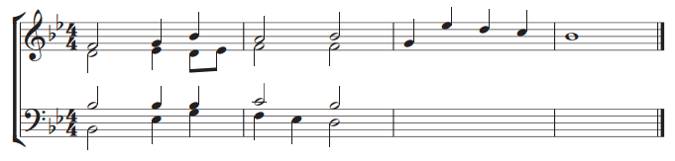**Question:** *‘Complete the music below for SATB voices in short score choosing suitable chords. Some credit will be given for the appropriate use on non-harmonic notes. Some space for rough work is given opposite, but you must write your answer on the score. (12 marks)(Past Paper Question 2013)*

**Figure 1 – an example question**

**Key Terms:**

**SATB** – abbreviation for Soprano, Alto, Tenor, Bass.

**Soprano** – high female voice – the top line of music in Figure 1.

**Alto** – low female voice – the second line of music in Figure 1.

**Tenor** – high male voice – the third line of music in Figure 1.

**Bass** – low male voice – the fourth line of music in Figure 1.

**Short Score –** Soprano & Alto lines are written on the same stave. Similarly, Tenor & Bass lines are written on the same stave.

**Stave –** The lines on which notes are written (see Figure 2).

**Treble Clef –** A sign which indicates that middle C is a line below the stave (see Figure 3).

**Bass Clef** – A sign which indicates that middle C is one line above the stave (see Figure 4).

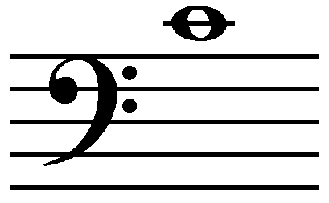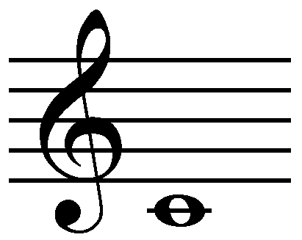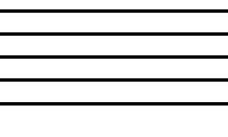

**Middle C**

**Figure 2 – Stave Figure 3 – Treble Clef Figure 4 – Bass Clef**

**Pitch:**

**Middle C –** The note C, roughly the centre note on a piano. The position of the note on the stave determines how high or low it is in pitch. A note in the space above middle C is a D, and the note on the line above D would be an E. The different lines must be written within the appropriate range for the type of singer (e.g. Soprano, alto, tenor or bass)

**Octave Numbers –** octave number 4 is the octave starting at middle C. Therefore, the note ‘C4’ is middle C. ‘F4’ is the note F above middle C. ‘C2’ would be the note C, two octaves below middle C.

**Singers Ranges –** for this ‘Techniques’ Question, vocal ranges are as follows:

Soprano: C4 – A5 Alto: F3 – D5

Tenor: B2 – G4 Bass: E2 – C4

**Length:** The shape/look of the note determines how long the note is to be sung for. For the purpose of this project I have provided a table below (Figure 5) which shows the length value associated with each type of note.

|  |  |  |
| --- | --- | --- |
| Note Graphic | Note Name | No. Quavers in Length |
| Image result for semibreve | **Semibreve** | **8** |
| Image result for minim | **Minim** | **4** |
| Image result for crochet note | **Crotchet** | **2** |
| Image result for quaver | **Quaver** | **1** |

**Figure 5 – Table of Note Values**

If a note is ‘dotted’ then half of its value is added on. Examples are shown below in Figure 6.

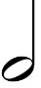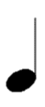

**= 2 quavers = 3 quavers**



**. = 3 quavers . = 6 quavers**

**Figure 6 – Dotted note values**

**Time Signatures:**

The Stave is divided up in to bars as shown below ( a double bar line at the end shows that the piece has finished).

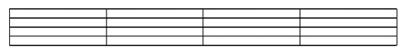

**Bar 1 Bar 2 Bar 3 Bar 4**

**Figure 7 - Bars**

A time signature tells you the maximum number of notes that can be placed in a bar. The top number tells you how many notes can be placed in the bar, and the bottom number tells you the type of note (all equivalent combinations of notes are allowed too, as shown below).

All the time signatures that could be used in techniques questions are shown below:



This means **4 crotchets** in a bar **or equivalent** – e.g. **8 quavers,** or 1 dotted crotchet 1 quaver & 2 crotchets, for example.

**Figure 8 – 4/4 Example**

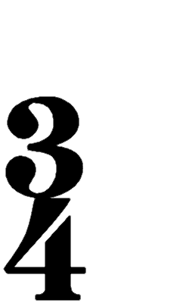

This means **3 crotchets** in a bar **or equivalent** – e.g. **6 quavers,** or 1 dotted crotchet 1 quaver & 1 crotchet, for example.

**Figure 9 – 3/4 Example**

**Notes on a Keyboard:** (using a keyboard will help to explain the next few ideas)

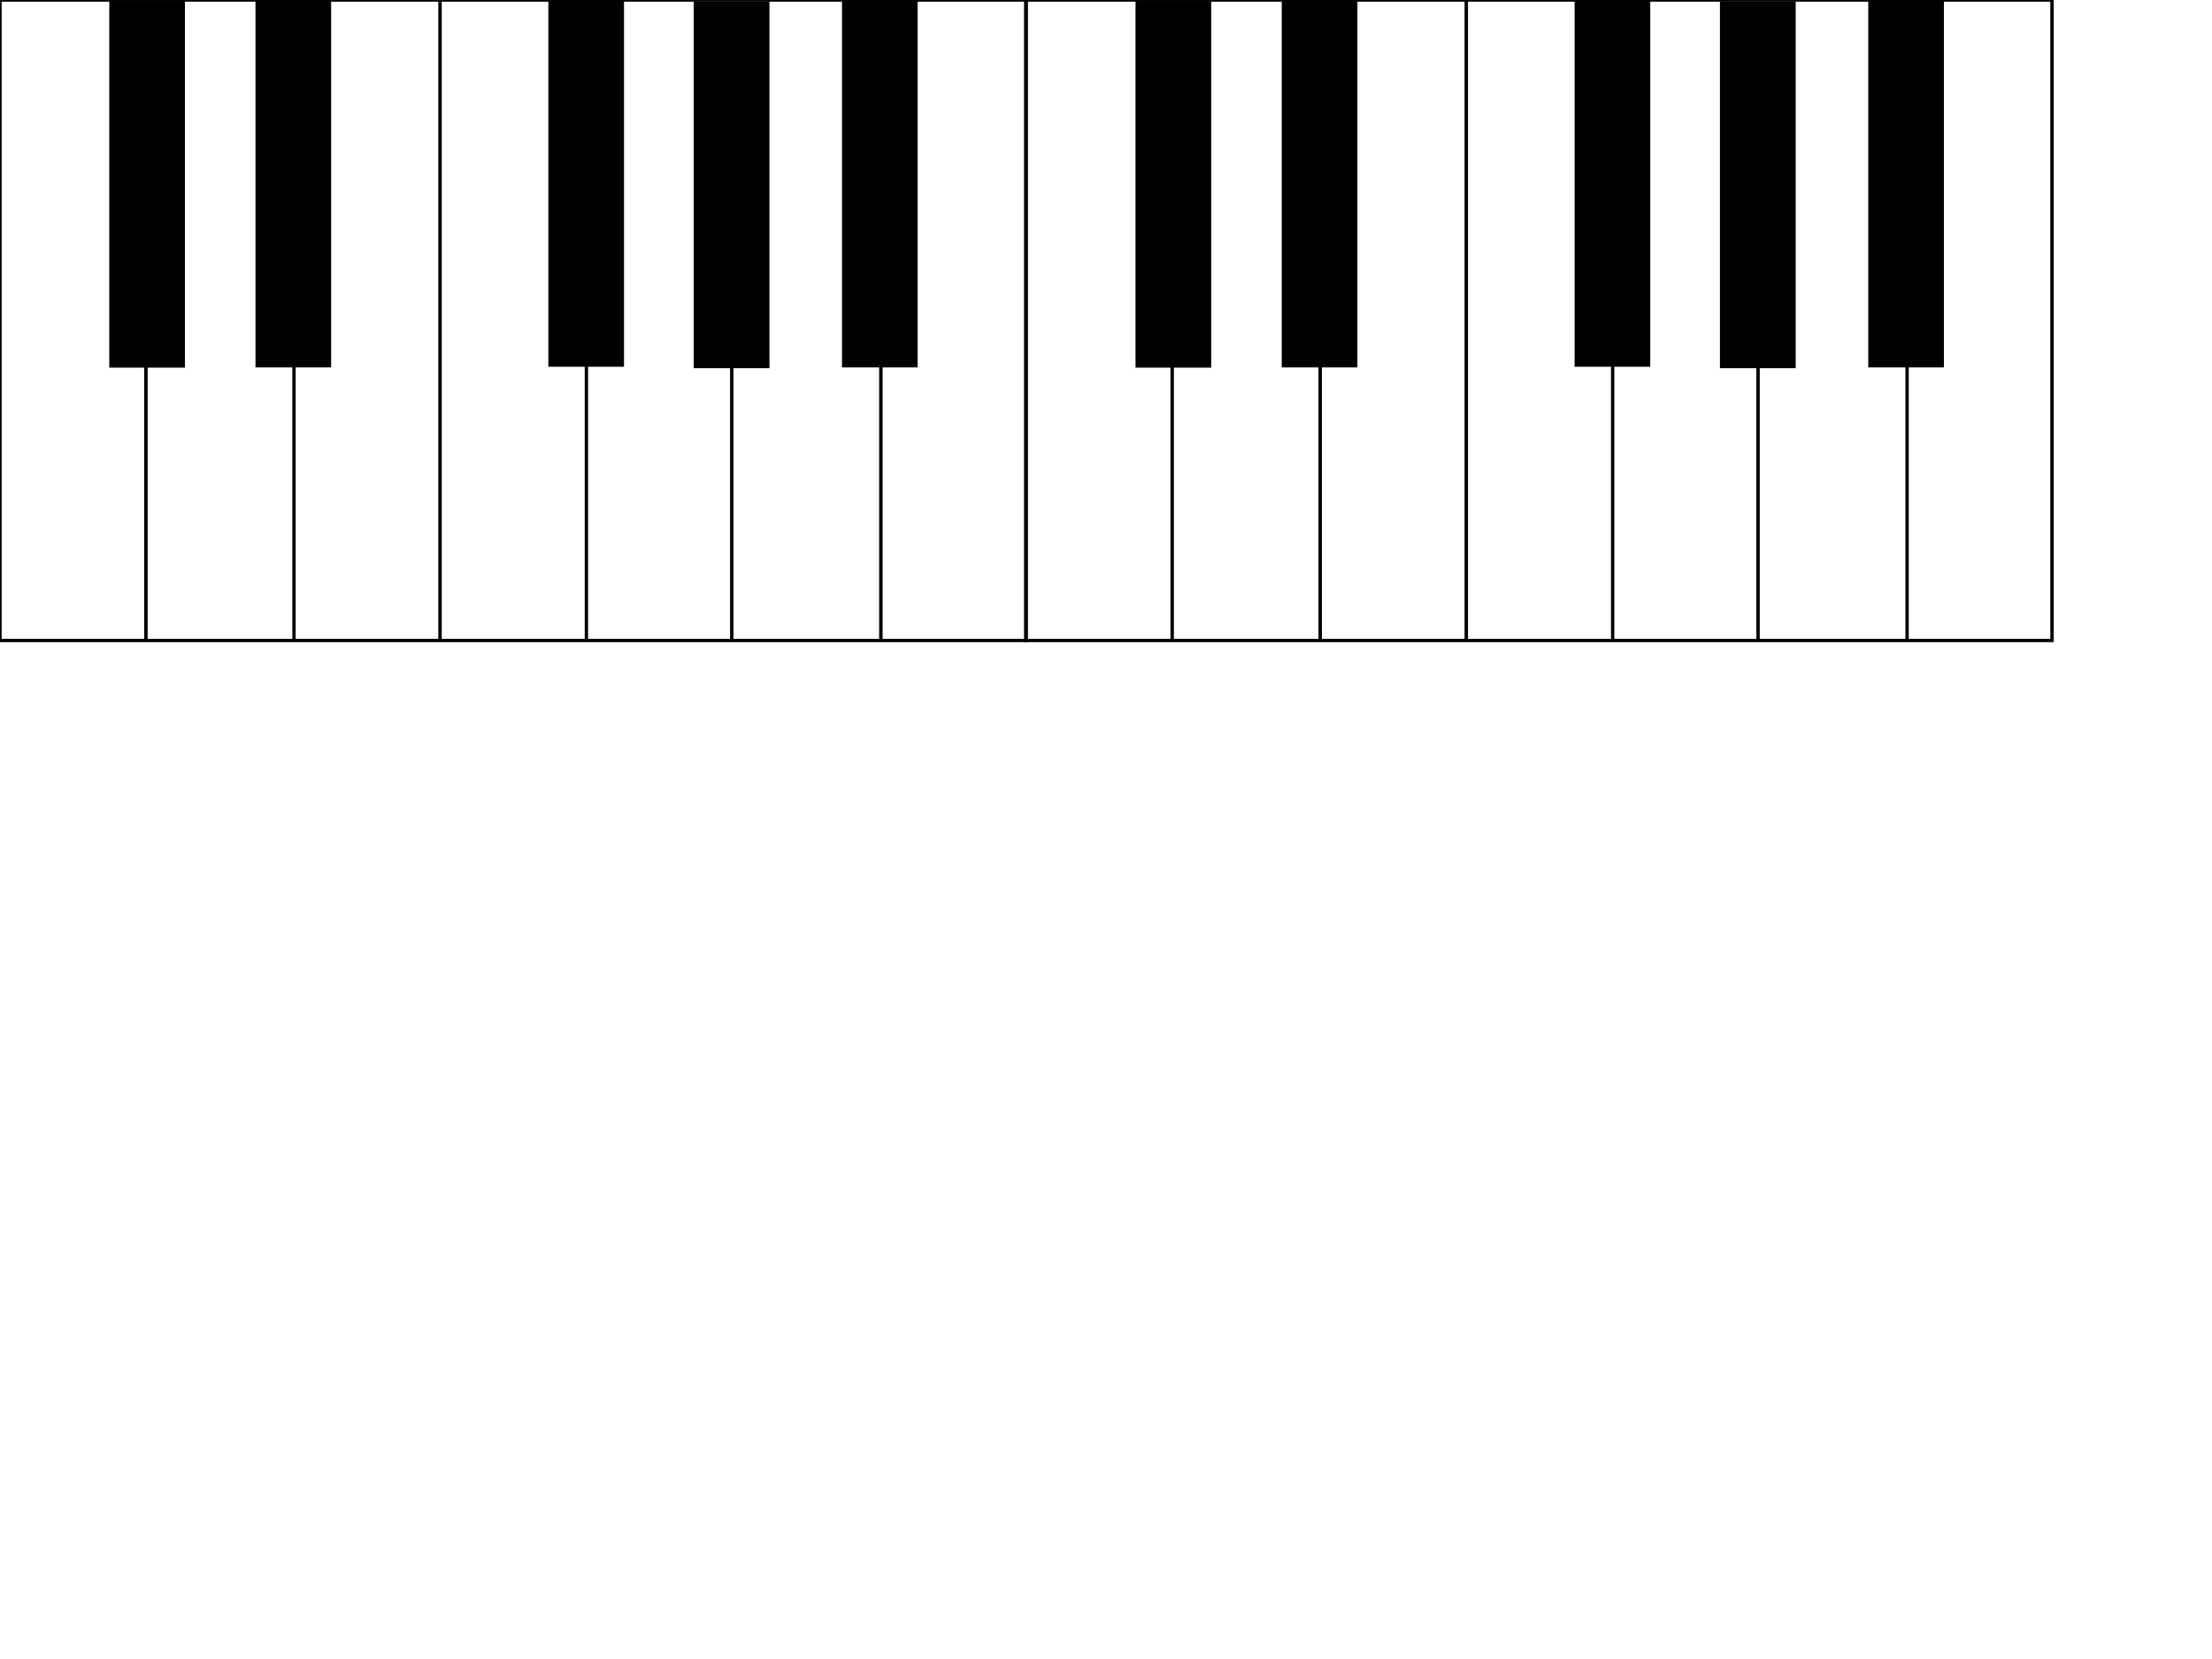

Notice that each of the black notes have two names for example G# (“G Sharp”) and Ab (“A Flat”) – they are still the same note. Different names are used depending on the key signature used.

**C# D# F# G# A#**

**Db Eb Gb Ab Bb**

**C D E F G A B C**

**Figure 10 – Keyboard Graphic**

**Semitone –** the smallest interval between notes, so the shortest step on a keyboard,

e.g. D – D#, E – F, A# - B

**Keys & Key Signatures:**

Key signatures are symbols shown at the start of the stave which describe a set of rules about the pitch of notes to be played throughout a piece of music.

**A stave with no key signature shows that the music is in the key of C Major. The notes can be numbered from I – VII, using roman numerals in ascending order.**

**Scale of C Major**

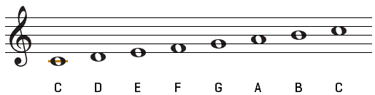

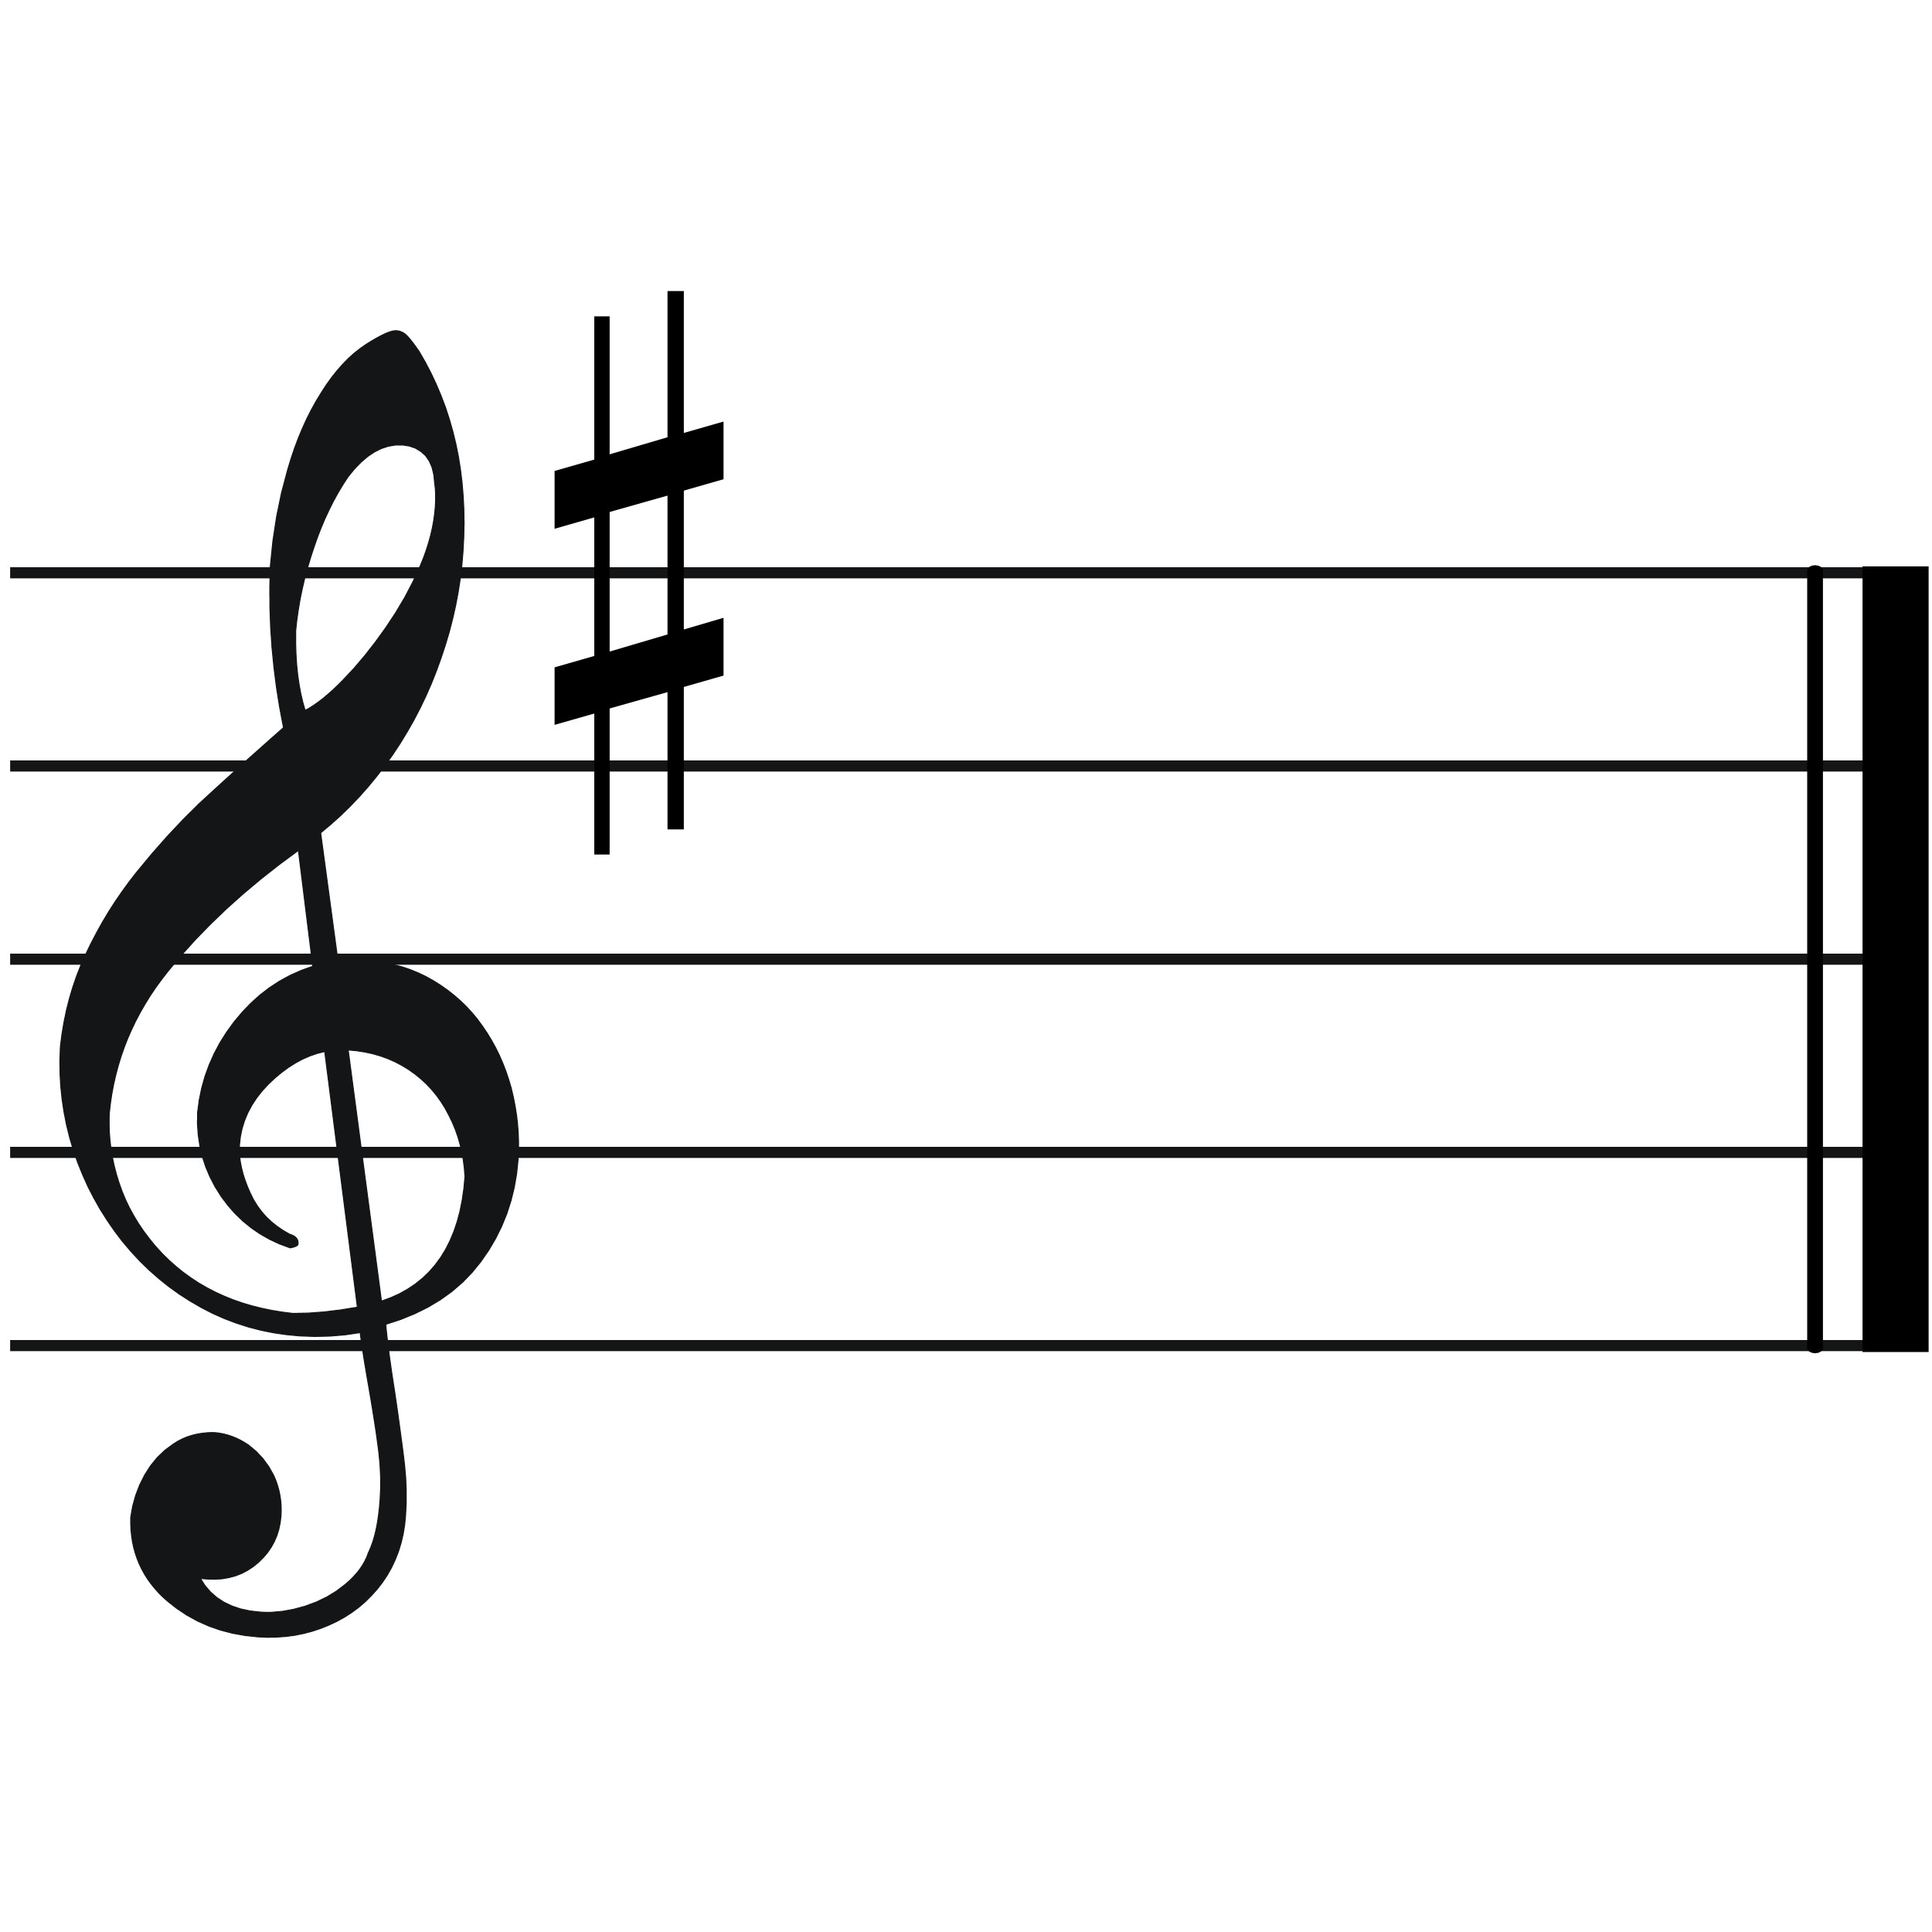

This Key Signature Represents **G Major**. Every time an F note is written,

**an F# is played instead.**

**Scale of G Major**

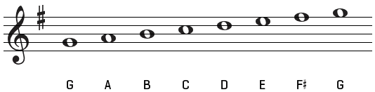

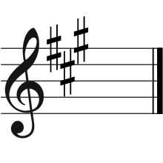

This Key Signature represents **F Major.** Every time a B is played, a Bb is played instead.

**Scale of A Major**

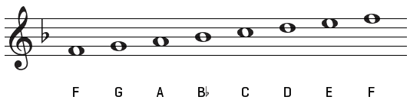

**For every major key, there is an equivalent minor key** – for example the Relative Minor (as they are known) of G Major is E minor.

The same key signature, means that the same rules are followed, however as these Techniques questions are based on the use of the harmonic minor scale, **7th note of the scale is also sharpened**, meaning that whenever a D is played, it also has to be D#, even though this isn’t shown in the key signature. The individual note will be marked with a sharp sign in front of it as shown below:

**Scale Of E Minor**

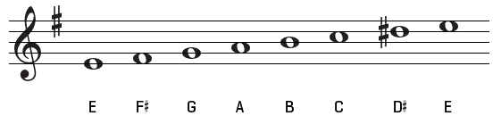

**Scale Of F# Minor (notice the bass clef)**

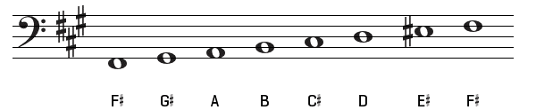

Over the page is a table containing every possible key signature and the keys that they represent – I’ve added some extra information that will be useful when storing information about key signatures in my program.

|  |  |  |  |  |
| --- | --- | --- | --- | --- |
| No. #s | Diagram | Sharps | Major Key | Minor Key |
| 0 | C-major a-minor.svg |  | C Major | A Minor |
| 1 | G-major e-minor.svg | F | G Major | E Minor |
| 2 | D-major h-minor.svg | F, C | D Major | B Minor |
| 3 | A-major f-sharp-minor.svg | F, C, G | A Major | F# Minor |
| 4 | E-major c-sharp-minor.svg | F, C, G, D | E Major | C# Minor |
| 5 | B-major g-sharp-minor.svg | F, C, G, D, A | B Major | G# Minor |
| 6 | F-sharp-major d-sharp-minor.svg | F, C, G, D, A, E | F# Major | D# Minor |
| 7 | C-sharp-major a-sharp-minor.svg | F, C G, D, A, E, B | C# Major | A# Minor |

|  |  |  |  |  |
| --- | --- | --- | --- | --- |
| No. bs | Diagram | Flats | Major Key | Minor Key |
| 0 | C-major a-minor.svg |  | C Major | A Minor |
| 1 | F-major d-minor.svg | B | F Major | D Minor |
| 2 | B-flat-major g-minor.svg | B, E | Bb Major | G Minor |
| 3 | E-flat-major c-minor.svg | B, E, A | Eb Major | C Minor |
| 4 | A-flat-major f-minor.svg | B, E, A, D | Ab Major | F Minor |
| 5 | D-flat-major b-flat-minor.svg | B, E, A, D, G | Db Major | Bb Minor |
| 6 | G-flat-major e-flat-minor.svg | B, E, A, D, G, C | Gb Major | Eb Minor |
| 7 | C-flat-major a-flat-minor.svg | B, E A, D, G, C, F | Cb Major | Ab Minor |

**A Few Extra Points:**

Cb Major is actually the same as B major, because if you refer to the keyboard, technically a Cb is just a B. The two key signatures are just different ways of representing the same key.

The same can be said for Gb Major and F# Major, as well as Db and C# Major as well as all of those key’s relative minor keys.

**Non - Harmonic/Chromatic Notes:**

Sometimes, a note that is usually ‘flattened’ or ‘sharpened’ due to a key signature, needs to just be the normal note again – if this is the case, then a natural sign is placed in front of the note on the stave as shown below. Notes which aren’t sharpened or flattened by the key signature can also be sharpened or flattened using the signs placed before a note if necessary.

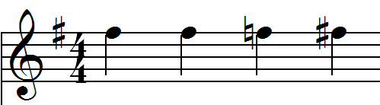

**F# F# F (natural) F#**

**Chords & Cadences:**

Answering a Techniques question is all about the use of appropriate chords & appropriate cadences.

**Chord** – A group of 2 or more notes played together.

**Triad** – A chord made up of 3 notes – these chords can be major or minor.) All the chords used in Techniques questions are Triads.

Triads are made up of a Root, a 3rd and a 5th

e.g. C Major (Notes: CEG) – Root: C, 3rd: E, 5th: G

Chords are numbered as follows **(example in Major Key – C Major):**

|  |  |  |  |
| --- | --- | --- | --- |
| **Roman Numeral** | **Chord Name** | **Notes in Chord** | **Note Numbers Used** |
| **I** | C Major | C E G | 1, 3, 5 (I, III, V) etc. |
| **II** | D Minor | D F A | 2, 4, 6 |
| **III** | E Minor | E G B | 3, 5, 7 |
| **IV** | F Major | F A C | 4, 6, 1 |
| **V** | G Major | G B D | 5, 7, 2 |
| **VI** | A Minor | A C E | 6, 1, 3 |
| **VII** | B diminished | B D F | 7, 2, 4 |

If something is Major, it sounds happy, whereas minor sounds sad.

Because the key signature is followed, in a major key, Chords I, IV and V are major.

Chords II, III and VI are minor.

Chord VII is diminished, and so it is against the rules in Techniques questions to use Chord VII in a major key.

Chords are numbered as follows **(example in Minor Key – E Minor):**

|  |  |  |  |
| --- | --- | --- | --- |
| **Roman Numeral** | **Chord Name** | **Notes in Chord** | **Note Numbers Used** |
| **I** | E Minor | E G B | 1, 3, 5 |
| **II** | F# Diminished | F# A C | 2, 4, 6 |
| **III** | G Major | G B D | 3, 5, 7 |
| **IV** | A Minor | A C E | 4, 6, 1 |
| **V** | B Minor | B D F# | 5, 7, 2 |
| **VI** | C Major | C E G | 6, 1, 3 |
| **VII** | D Major | D F# A | 7, 2, 4 |

Because the key signature is followed, in a minor key, Chords I, IV and V are minor.

Chords III, VI & VII are major.

Chord II is diminished, and so it is against the rules in Techniques questions to use Chord II in a minor key.

**Inversions:**

**If the root of the chord is in the bass part, the chord is not an inversion – it is in root position.**

**If the 3rd is in the bass part, the chord is in first inversion.** Notated using ‘(b)’ , so a chord II(b) in C Major would be the Chord D Minor, with the note F in the bass.

**If the 5th is in the bass part, the chord is in second inversion.** Notated using ‘(c’), so a chord IV(c) in E Minor would be the Chord A Minor, with the note E in the bass.

**Rules About Chords in Techniques Questions:**

Out of the four parts, 2 should play the root if possible. The 3rd should never be doubled. In a (c) inversion the 5th can be doubled if necessary and only one root played.

**Cadences**:

A combination of two chords in succession, to end a musical phrase is known as a cadence.

Perfect Cadence – A Chord V, followed by a Chord I, gives the greatest sense that the music is complete. At AS level, all of the cadences required to be completed by students are perfect.

My program will need to be able to identify chords from the stave and check that they are appropriate and that the final cadence is perfect.

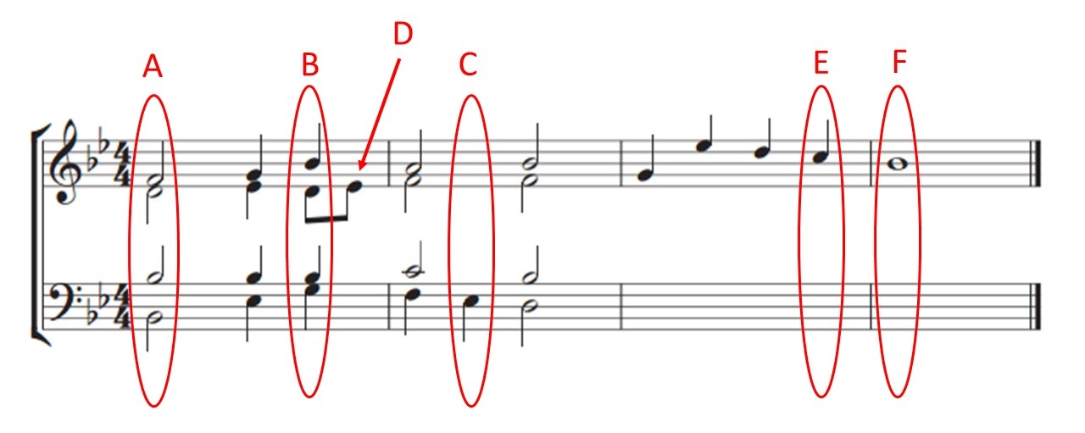**A few examples of Chord Identification are shown below (some of the examples are used to explain a few new ideas):**

**The Key of the piece is Bb major.**

It could have also been G Minor, but there are no F#s and the final note of the piece is Bb.

**Chord A:**

The notes written on the stave: Bb, Bb, D, F

These are noted 1, 1, 3, & 5 of the Bb major scale.

The chord is therefore a Chord I

The root is in the bass – the chord is in root position.

**Chord B:**

**Notice that the quaver in the alto line just after the chord does not affect the chord – chords are identified in techniques question on the beat. The quaver (labelled D) is just a passing note. Students who use passing notes in their answers gain extra marks.**

The notes written on the stave: G, Bb, D, Bb

These are noted 6, 1, 3, & 1 of the Bb major scale.

The chord is therefore a Chord VI

The root is in the bass – the chord is in root position.

**Chord C:**

**Notice that the minims in the previous chord are still being played at the next beat, therefore they make up the chord C along with the note in the Bass. The chord below is also a 7th Chord which is sometimes used in techniques questions.**

The notes written on the stave: Eb, C, F, A

These are noted 4, 2, 5, & 7 of the Bb major scale. 7,2,4 would be a chord VII which is banned.

The chord is therefore some sort of Chord V (5,7,2)

The remaining note is note 4. If we look at the scale which relates to note 5 (F major scale), note 4 (the Eb) is note 7 of the F Major Scale. We therefore have a chord 5, with an added 7th.

**The 7th note is in the bass, meaning this chord is a special sort of inversion, notated (d).**

**The chord is a V7 (d).**

**If my program has checked for triads in various inversion, it will then need to check that the chord isn’t actually a V7 before deeming the chord inappropriate.**

Chord E when filled in by the student should be a chord V, and chord E, should be a I to form a perfect cadence.

**Below is a completed version of the Techniques question shown at the start – completed by hand, as a student would complete currently:**

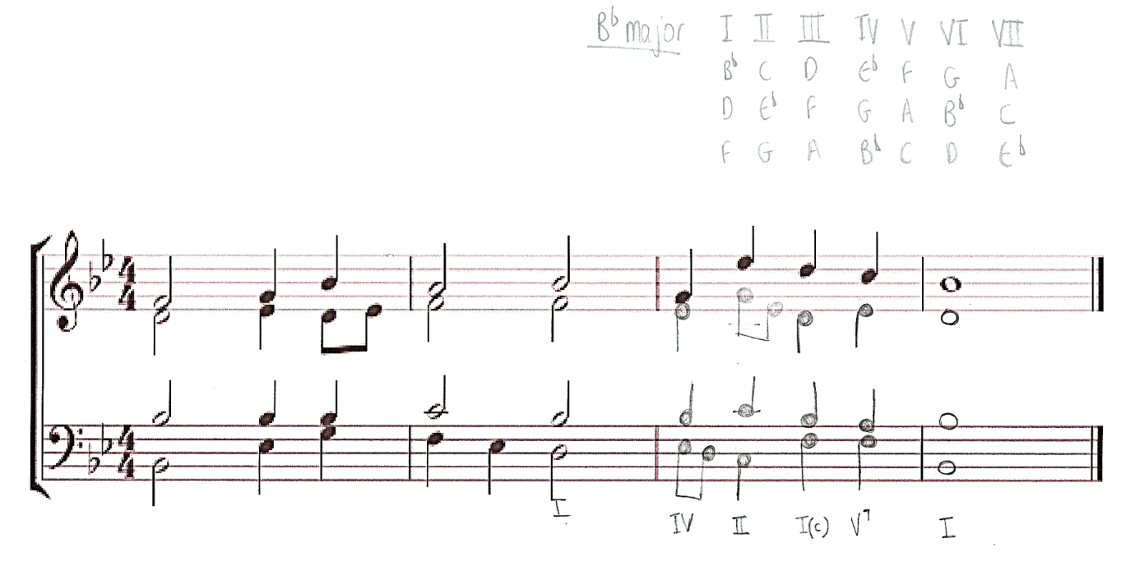

As you can see, I’ve actually used a chord V7 instead of a V, and I’ve specifically used a Chord I(c) before it. This is because there are two special types of perfect cadences which score the highest marks in Techniques questions. All of the different rules and specific marking criteria for Techniques questions will need to be formalised in the design stage, to ensure questions can be represented, answered and then marked properly by the program.

Below is the mark scheme that Mr Butler has edited and forwarded to me. It reflects how he teaches Bach Techniques. This is the type of mark scheme he would like the programs evaluation function to be based on. Using this, I have then devised a specific list of rules and guidelines that my program will need to consider when marking Techniques Questions.

**Mark Scheme**

**Each Chord worth roughly two marks. Questions given full marks to begin with and marks deducted.**

**Deduct no marks if** the chord choice is appropriate and there are no part-writing faults associated with it.

**Deduct one mark if** there is one problem with part writing, which might include:

* A single set of consecutives or exposed 5ths / 8ves terminates at the beat or falls within it
* A leading note is doubled
* Parts cross unnecessarily
* Final chord not being in root position
* A seventh is unprepared (apart from passing seventh)
* If one part is omitted

**Award 0 if** the chord is unsuitable, or two notes of the chord are incorrect or there are 2 or more problems with part-writing.

**Specific Bach Techniques Rules To Follow:**

* Never double the 3rd in a chord (?)
* No parallel 5ths or 8vs between parts
* The leading note (note 7 of the scale must rise)
* 7ths of chords must be prepared from the note above or the same note and then must fall (known as resolving)
* Following any bonus rules – three blind mice and PSR – award a ‘bonus point’ if so
* All other chords are appropriate for the key and soprano line

### **Meeting with Richard Butler**

I specifically sat down and met with Richard Butler, and we both agreed that the most important thing to work out initially was how he marks Bach Chorales and we therefore developed the specific glossary of terms, general information, and specific list of rules and guidelines you see above. After this, I asked him some more questions, the responses to which are below.

**Describe your current system of working.**

Myself and Anne currently hand write any Bach Chorale questions that we would like students to answer- we photocopy them and make them into booklets that they can work through at their own pace on paper. Students can hand their booklets in for marking at any time. We keep their marks in a handwritten mark book. They keep their booklets to revise from towards the end of the year.

**What is good about the current system?**

We see students booklets regularly, and so we easily keep track of how they are progressing. Also, because we write the questions, we can challenge students appropriately and understand the questions we have set really well, in order to help them best.

**Describe the problems with your current system?**

Handwriting questions is often time consuming, and photocopying booklets is becoming very expensive. Because booklets are being passed between teacher and student very frequently, they can sometimes be temporarily misplaced, or sometimes even lost by students. Marking Chorales can also sometimes be very time consuming – and often, they are either right or wrong – it would be great to find a way to automate the process.

**What specific features would you like to see in the program?**

I would like students to be able to input their answers and view them how they would appear if they were writing their answer on a musical stave. Similar to how software packages such as Sibelius display notation – unfortunately they are very costly to install on every computer in school, meaning they can only currently work on questions on the computer in lesson time. We want them to be able to use their free periods elsewhere in the school to study techniques. I understand that it may be difficult to replicate some of the subtleties involved with musical notation – for example having accidentals carry to the end of bar line, or tying notes together across bar lines. Things like this may have to be represented in a slightly different way, so as long as we are provided with instructions, that will be okay. And when they get their mark back, it would be good to get some feedback as to where marks were awarded/deducted or why they were specifically deducted. It would be good for them to be able to go back and view the answer and mark they got at a later date too.

**Would you like students to just be able to input their answers to chorales and receive a mark for them, or would you like to set questions and keep track of their progress?**

Ideally, I would like each student in my class to have their own student login – using their school email address and a password of their choice. Myself and Anne would then like our own accounts – we could then create student accounts and then assign them to our class. We could then set questions – inputting the given parts of a question (what we would have previously written down and photocopied as part of a booklet). Then a student could log on, access their teachers folder of questions, complete one when instructed to do so, and receive a mark. They could then save their answer to their personal folder, for us to access and review the mark should we wish. It would be great if we could see a summary page, from which we could see recently completed questions and marks, and track a specific student’s progress by tracking their scores.

**Who will actually use this software?**

Myself and Anne as teachers will use it to set questions, and then we have an average of about 12 students in each A Level class – so roughly 24 students. Obviously, new accounts would need to be created each year.

### **Existing Software**

As I discussed with Mr Butler, students are familiar with using Sibelius Software, which they use for composition, and sometimes techniques. But the software is expensive, and is therefore only installed on computers in the music room. Students therefore cannot work on Techniques questions on the computer in their own time. Sibelius also does not give extensive feedback. It only checks for parallel 5ths and octaves in a question.

I did however find it useful to use Sibelius with Richard Butler, in order to see what kind of information it required the user to input in order to successfully create a stave, as well as how the system behaved with regards to inputting notes, and dealing with key signatures and time signatures.

To find out more about Sibelius, you can visit: <http://www.avid.com/sibelius>

The newest version of Sibelius is now part of a subscription service, however the school use Sibelius 6.

### **Existing Software & Language Research**

I have also done some research into my preferred programming language. I am most familiar with Python, as it’s what we use to program in Computer Science lessons. I also have some familiarity with PyQt4, as we’ve used it in lessons sometimes too. I did some more research into the interface features that PyQt offers, as well as modules available to use in Python (for both general functionality as well as that specific to music). Here are some of the resources I used – research into some of these topics will help me when it comes to building the solution.

I discovered that one of the most useful things to me, in order for me to be able to display user’s work in the form of standard musical notation, would be ‘LilyPond’, a music engraver that works alongside python. It requires a standard text file (which I can produce using strings in python), to be saved as a ‘.ly’ file which can be opened using the Command Line, producing a PDF to be viewed by the user.

<http://lilypond.org/index.html>

Research into Regular Expressions for validation: <https://docs.python.org/2/howto/regex.html>

Finding out more about PyQt: <https://pythonprogramming.net/basic-gui-pyqt-tutorial/>

& <http://zetcode.com/gui/pyqt4/firstprograms/>

Using the command Window using python (useful for using LilyPond): <http://stackoverflow.com/questions/5702909/how-to-write-into-a-windows-command-window-from-python>

### **Overview & Analysis of Current System**

**Current System Description**

1. **– The booklets for students to work on are created.**
   1. The staff each teach their own classes about Bach Techniques and assess, from work completed in class, their students’ ability and strengths and weaknesses.
   2. They then look through the Bach Techniques folder, looking and picking out questions of appropriate difficulty level, ready to collate into a booklet.
   3. If there are not enough or no appropriate questions, the teacher hand writes some more to be added to the folder.
   4. The questions that have been selected are collated and sent for photocopying, where they are made into booklets for the teacher.
2. **– Students complete questions**
   1. Students complete questions in the booklet in any order that they like – they can get help if they need in lessons, before taking the work elsewhere to complete. The questions are currently handwritten, because students don’t have access to notation software on their computers in the rest of the school.
   2. The student can hand in their booklet for marking at any time they like.
3. **– Booklet handed in for marking**
   1. The teacher will mark any questions that the student has completed since they last marked the booklet.
   2. The teacher then updates their mark book with the students’ latest scores. They can use this book to monitor their progress and see if they are improving or if their marks are consistent or not.
   3. The booklet is handed back to the pupil, and any necessary verbal feedback or help is given, as well as the written feedback that has been provided in the booklet.
   4. If the booklet is still incomplete, the student continues answering more questions as part of their personal study.
4. **– Booklet Complete**
   1. This booklet can then be kept by the student for use as part of their revision.
   2. If there is still lots of time left in the year, or a student needs further practice or more difficult questions, a new booklet is produced by the teacher (the process starts again at 1.0)

**Current System Flowchart**

Analysing the current system in this way has allowed me to identify areas in which my program could easily save both time and money. The flowchart identifies a specific area at the start, where a lot of time is spent looking for questions suitable for a specific class, and actually making these into a booklet that can be photocopied. As well as time, lots of money is spent on the photocopying.

If harder questions then become more appropriate, or a student completes a booklet, more booklets have to be made.

A potential solution to this problem is that within my program, teachers can each have their own folders associated with their accounts, full of Techniques questions, which can be accessed time and time again, on screen, without the need for any photocopying. Rather than having to collate questions into a booklet, when students log in, they will be able to see a list of questions in their teacher’s folder, and they will be instructed by their teachers as to which questions they should complete.

Another thing that I’ve noticed from looking in more detail at the system, is that the mark book is shared between staff members, so that they can all track each other’s pupil’s progress. The mark book is difficult to keep up to date, as it’s passed between multiple staff and different questions are set for different pupils sometimes in the same class. It would be much better if the mark book could be computerised, perhaps using a database.

As part of my investigation and analysis into the existing system, I also spoke to some pupils, prospective users of the software, about what problems they currently face with the system. Students really like the idea of getting instant feedback from the program – it means they wouldn’t have to wait for the teacher to mark their work – they could ask questions and seek further help from a staff member only if it is necessary and they still have questions or are struggling.

### **Prospective Users & Limitations**

Both students and staff members will use this software for significant amounts of time – and both students and teachers need to find an interface which is easy to work with, and a program that generally saves them time compared to the current systems that they use.

The two main staff members using the software would be Richard Butler (the primary user who would have full administration rights), and Anne Heginbothom, who will have a staff account with certain permissions. Then around 12 students in each year group will each have an account to access the software.

Both staff and pupils are used to working with computers, so working with my program shouldn’t be a problem for them. They currently use Sibelius software to computerise musical notation – the issue is that they can only work on Sibelius in class – it’s too expensive to install on every computer in the school.

I would like the interface for inputting musical notation to mimic Sibelius slightly. There are some subtleties with regards to rules about musical notation that I won’t be able to implement given the timeframe and my current programming capabilities, however as long as I provide staff and students with a guide for the software, this shouldn’t be a problem. As long as the users are slightly familiar with the layout of the interface, and therefore using the software saves them time compared with hand writing questions, I see my program as beneficial.

**Specific Limitations:**

* **Available Hardware and Software**

I am only currently able to work with the limited software available to program with at my school. The software will need to run on the desktop computers and laptops available at the school – staff and students do not have access to tablets, and mobile phones are prohibited in school time.

* **My Programming Ability**

I am a computing student in my second year of study – I therefore only have limited programming capabilities, and this is my first large scale programming project. I will be programming using Python – I will need to look at the capability of this language to represent musical notation and playback MIDI files and work with databases.

* **Time**

The project has to be completed by the end of Easter, this will allow time for staff to implement and work with the software. They can then give feedback and we can make any changes ready for a full transition to the program for the next academic year.

### **Data Flow Diagram of Current System**

**The following data flow diagram/s will help me to understand what data my program will need to store and when it is used.**

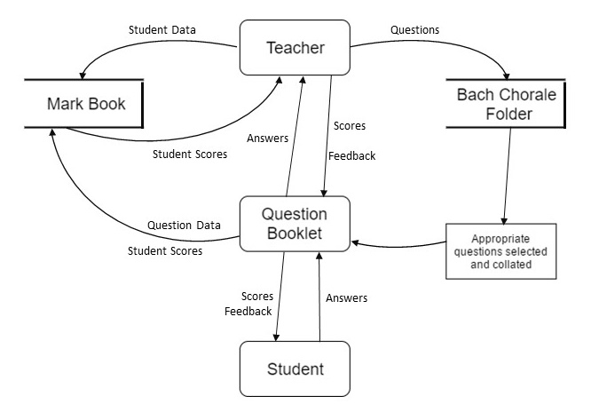

### **Entity Relationship Diagram**

The diagram below shows how data can potentially be stored to use in my program, in order to solve my client’s problem.

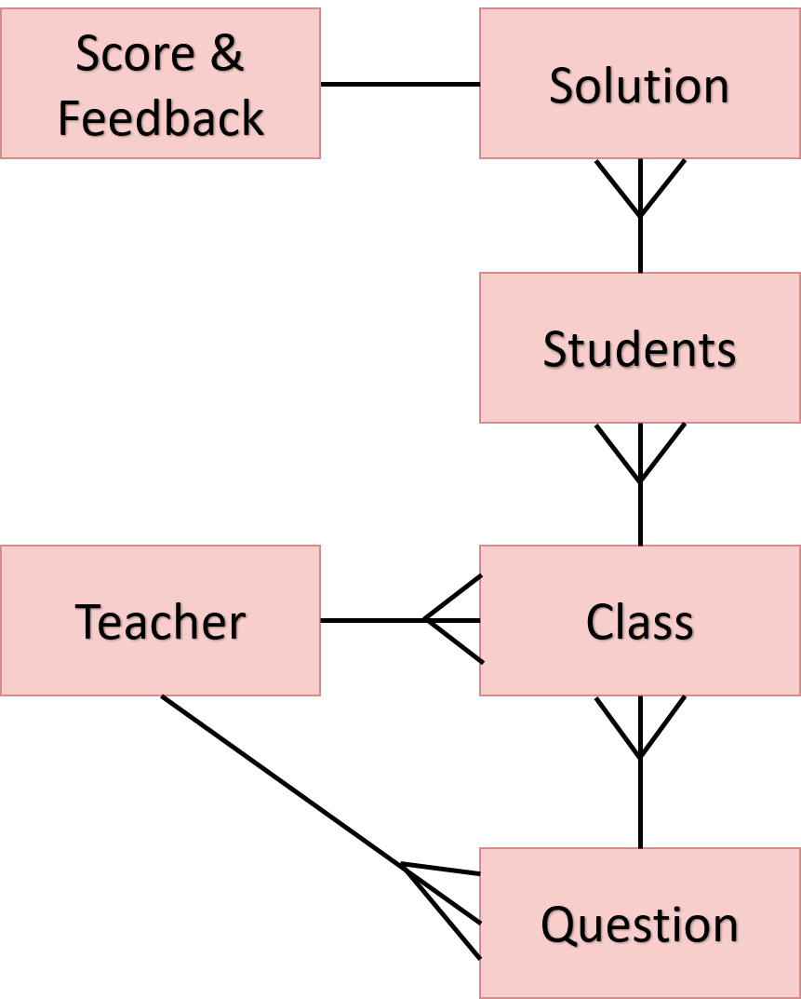

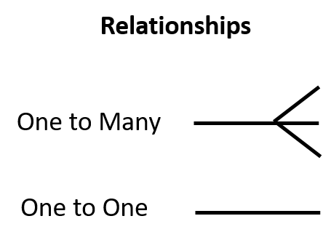

So as you can see, the way the system could potentially work is that staff could each be given their own logins, with the ability to be able to create classes, and student accounts. There will be many classes assigned to each teacher, and each class will have many students in it.

Then staff will be able to create Bach Questions, and when they wish to, they can assign it to a class to complete. The students can then login, and view the questions that they need to complete. Each student will produce many solutions, which can be marked with feedback given – which can be stored to be viewed by staff at a later date.

### **Tasks to be Computerised & the Benefits of Computerising**

* The creation of digital techniques questions by staff, to be digitally answered by students.
* The ranking of question difficulty, allowing for appropriate questions to be assigned to students.
* The ‘marking’ of student’s answers, providing them with a score and appropriate feedback.
* The collections and storing of student’s marks, in order to track their effort, work rate and progress.

**A Summary of the System:** **The Bach Chorale Evaluator is to allow staff and students to assign and answer Bach Techniques questions digitally as part of their A Level Studies. The system should follow standard musical rules, and allow users to view what they create how it would be written using standard musical notation. Students answers should be marked, in accordance with the mark scheme and rules of evaluation developed by myself and Richard Butler.**

**Qualitative Benefits:**

* Staff will find it easier to find questions of appropriate difficulty level and set them for students.
* Students will be able to answer questions using a computer anywhere in college in their free time, in a similar way to how they would in class using expensive software.
* Students will receive instant and direct feedback and will only have to seek one on one help if they or a member of staff feel they need it.
* All work is stored safely, digitally – a student’s work can no longer be lost because of them misplacing their booklet.

**Quantitative Benefits:**

* Staff save time, they no longer have to collate questions, or have them photocopied. They only need look at a students work if it requires attention or a student needs specific one on one help. Marks and feedback are also stored automatically, allowing teachers to easily view a student’s progress.
* The department saves money as booklets no longer need to be photocopied for students to use.
* Students save time, as they receive instant feedback and can quickly make changes in order to improve their subsequent answers.

### **Proposed System Objectives**

My overall analysis has shown me exactly how the current system works, and reasons why a computerised system would be of so much benefit to the clients. The objectives below will need to be met, to ensure that the program is useable, and successfully meets the client’s needs.

1. The program should be controlled by a login system – login should be required upon program launch.
2. If a user logs out, all windows open as part of their session should also close.
3. The following account types should exist:
4. **Administrator** – an admin account should be able to create other admin accounts, staff accounts and classes, with student accounts assigned to them.
5. **Teacher** – a teacher account should be able to create classes and add students to them.
6. **Student** – a student account should not be able to add any other accounts.
7. Usernames for accounts should be the same as the person’s school/college/staff email address

**Student -** 01ab2345@pupil.uvhs.org.uk

**Teacher & Admin** - abc@uvhs.uk

1. The system should be able to store up to 6 classes of students at any one time
2. Administrators & teachers should be able to create questions for students as follows:
3. They should be able to edit four musical lines (Soprano, Alto, Tenor & Bass)
4. Questions should be able to have the following set as their key signatures: C Major (0 sharps/flats), D Major (1 sharp), A Major (2 sharps), E Major (3 sharps), B Major (4 sharps), F# Major (5 sharps), F Major (1 flat), Bb Major (2 flats), Eb Major (3 flats), Ab Major (4 flats), Db Major (5 flats), Gb Major (6 flats).

Minor keys and key signatures beyond 5 sharps and 6 flats are not required for the system.

1. The system should be able to represent questions of ‘reasonable length’. Question are generally around 4 bars long, so a maximum of 20 bars would be reasonable.
2. The system should be able to manage time signatures 2/4, 3/4, and 4/4
3. If a note is added to the end of a bar, but is too long to fit within the bar, it should be carried over the bar line into the next bar (like a tie in music – this subtle behaviour is explained fully on page 58
4. )). If the note is being placed in the final bar and there is no available bar after that, then the note should not be place – it is too long.
5. When notes are inputted, they should be automatically sharpened or flattened as required by the key signature, as this is how standard musical notation works.
6. A user should be able to input notes of any length shown in Figure 5 ‘Table of Note Values’ (on page 6). Any of these values should also be able to be ‘dotted’ by the user. (although Semibreves are not required to be dotted for techniques questions, and dotting a quaver in my system will just place a quaver, as the smallest note values needed here are quavers)
7. Any pitches in the range C2 to B5 should be able to be represented in a question, using the system.

There is no need to represent any visual rests for the user, as if a question contains any blank space as it would on paper, it would be incomplete. Rests are only used by the system in the background, as an aid to determine if a question is complete, or where the next note a user inputs should be placed.

1. The system should be able to evaluate any question correctly ending in a perfect cadence, using either a “3 Blind Mice” bonus cadence, a “PSR” (prepare suspend resolve) cadence, or no bonus cadence. The system is not required to represent any other types of cadence. Users will not be using the system for any other types of cadence, and have been informed that if they did want to, the evaluation functionality would provide scores and feedback which would not reflect the answer.
2. Teachers should be able to save questions, to go back and edit at another time before assignment. They should be able to their own and edit other teacher’s questions at any time up until assignment. Then they should be unable to edit them.
3. All questions created by teachers should be stored in a specific directory for access at any time.
4. A teacher should be able to assign a difficulty rating to a question that they create and view this difficulty rating when they load a question, in order to make an informed decision about which questions to assign to their students.
5. Questions should be able to be assigned to multiple classes, by multiple teachers.
6. A teacher should be able to view all assignments set for students, as well as how many have completed them, and how many are still yet to complete them.
7. They should then be able to view a more detailed list of students who have completed the question, along with the score they received. The most recently completed, should be the first in the list. If a teacher then wishes, they should be able to view the student’s answer as a PDF, along with any feedback that was given to the student when their answer was evaluated.
8. If a teacher tries to assign a question to a class that it has already been assigned to a class, then they should be notified of this. If new students have been added to a class, then they should be able to continue and assign the question to those new students.
9. Students should be able to log in and view a list of questions that they need to complete. These questions should be saved in their own personal directory, ready to load.
10. They should be able to load any of those questions and input their answers, by editing the alto, tenor, and bass lines. There will be no need for the to edit the soprano line. They should use a question editor very similar to that of the teacher, but without functionality allowing them to assign a question.
11. A student should be able to save their answer, whilst in the middle of working on it – they do not have to ‘Evaluate’ it (and therefore submit it) straight away. They should be able to save it, close it and then load it again and continue working.
12. A student should not be able to edit the question set for them – if they try to delete any parts of a question that the teacher set, they should be prevented from doing so.
13. A Student should then be able to press ‘Evaluate’ which should submit their answer and immediately calculate a score out of 12, and output it for them along with any feedback if they went wrong. Full details of the feedback to be given can be found on page 36. This feedback is in accordance with the mark scheme and rules of evaluation on page 15.
14. A teacher should be able to view a list of students in a class along with their average score, as well as their 5 most recent scores – this is the system effectively replacing the paper mark book.
15. A Student should be able to view a full list of questions they have completed, along with the scores they received. The most recent should be at the top. They should also be able to view their average score, and view any of their past answers as a PDF, along with any feedback they received at the time of evaluation.
16. At any time when using the editor (as well as when mentioned in the objectives above) a user should be able to open a PDF showing what the state of their current question is in standard musical notation form.

### **Potential Solutions & Justification of Chosen Solution**

(this section still needs a little more organising and better reasoning given – I’ll do this once my program is completed and I know exactly what it does and doesn’t do).

1. **Part Manual/Part Computerised System**

This would involve questions being hand written by staff still, but then scanned into the system and given a difficulty rating. Information about the questions can be stored using data base, and a staff member can use this database to select questions of appropriate difficulty level for a specific class. The program will then automatically collate these questions into a template booklet which can be printed out. The program will also produce a customised mark book table specific to the teachers pupils and the questions that have been set. This can then be printed and completed by the teacher.

This solution would be good, given my current programming skillset and timeframe for the system to be completed. I have a good knowledge of constructing databases using SQLite.

However, unfortunately, this solution would not meet all of the client’s needs. This system would save staff time, because it would be easier for them to select questions of appropriate difficulty and store and re use questions thanks to the database. It also saves times for staff as they just need to fill in a marksheet that has been specially designed for them, rather than using a generic mark book which is time consuming to upkeep. However, the questions are still written and answered by hand, and work still needs handing in to mark and could still easily be lost. Money wouldn’t be saved, because booklets would be printed and photocopied on a regular basis.

1. **Fully Computerised System, Online Based**

This would involve using a database hosted online, which interacts with an interface built for staff, and an interface built for students. I would build a main interface which would allow staff to digitalise the Techniques questions, inputting them to view and work with on a graphical stave, similar to how software such as Sibelius works. Then the questions would be stored in the online database and teachers could assign them to student’s accounts. Then students could log in online and view the questions that they need to complete, using the student interface to input their answer, again in a similar way to how notation software such as Sibelius works. Then, the system will automatically score their answer and give them automated feedback, and teachers can then view student’s scores and feedback which will be saved in the database.

This solution would be ideal, because it means that no paper copies of anything are needed. Questions, answers and marks and progress data are all stored in a database, and students can work on questions both around college and at home, in the same way that they work on questions in the music classroom, using the expensive Sibelius software. This solution would actually fulfil more than just the client’s needs, because Students would be able to answer questions from home, as well as in college/school.

However, building such a system may be beyond my capability at the moment, as I haven’t much experience working with online applications – I haven’t ever built an online interface - and I’m not sure this could be completed given the current timeframe. It is also not required that students access this work from home, they need only be able to work on it on any computer in college or school, during their free periods. Hosting the program online and storing the data online could perhaps be implemented in the future though.

1. **Chosen Solution – Fully Computerised, Local System**

The program will consist of appropriate interfaces for staff and students, as described in solution 2. However, questions and answers can be stored in specific directories as binary files, on the school network, with references to them stored in a database built using SQLite, which will also store information about staff and students and information about which questions needs to be completed by which students. I can build the interface using python – a programming language I have most experience with, making this solution most appropriate for me.

This solution is my chosen solution, as all of the objectives and client’s needs can be fulfilled, in a way that utilises my skillset as a programmer most effectively within the given time frame to complete the project.

# Design

### **Description of System**

My system will be designed using the programming language Python 3.5.2, alongside PyQt 4, which I will use to develop the interface. The program will be built using an Object Orientated style of programming – the structure will follow suit, such that as a general rule, each Window (of the interface) will be represented using a Class, which will store any properties and methods required to be called upon by the user at the point in the programs execution. I have included a full Class diagram in this design section, along with a description of exactly how these classes, properties and methods are organised. When the program launches by displaying a login window, where the user is prompted for their username and password. Given that their credentials are correct, the user gains access, and depending on whether they are a Student or a Staff member, or an Administrator, they will see an appropriate window allowing them to perform certain actions.

An Administrator can add other staff members to the system (including those with administrator status), add Classes to the system in preparation for them to be populated with Students, Add Students to the system and assign them to their class, load any questions created by any staff member, edit them should they wish, and assign them to any class for students to complete, track all assignments of questions (by any teacher to any class) and view any students scores, and answers to any of those questions, track the progress of any particular student, and create questions that they may wish to assign to any students.

A Teacher (Staff member without administrator status) can Load any existing question created by any teacher and assign it to any class, and they can also create a new question and assign it to a class if they wish to. They can also track all assignments and track any pupil’s progress – viewing their answers to any question.

A Student can complete any question that has been assigned to them and receive a score and feedback. They can then view any of their past scores and answers to questions they have completed.

All users as part of editing a question (or completing one if they are a student), can see their question printed out in the python console, using a notation I’ve developed, specifically for this programme, which is described later on in the design. However, they also have the ability to view what the question looks like written using standard musical notation that they are familiar with. I am using a piece of software called ‘LilyPond’, which takes code that my python programme will output, and uses it as an input text file which it interprets, to display the appropriate standard musical notation. Again this is described in further detail in the design section.

The above, describes the basic functions available to each type of user, some of which I will break down and describe in more detail throughout the design section.

### **Interface Design/Planning**

After speaking to Richard Butler in more detail about how he wants the system to work, it was clear that they have no particular preference as to how the general interface design should look, as long as it’s self-explanatory and simple to use. The most important part of the interface which I have decided to ask him and his students for feedback on, are the windows that will be used to create questions and edit them (e.g. add and remove notes, view the musical notation and assign and submit questions).

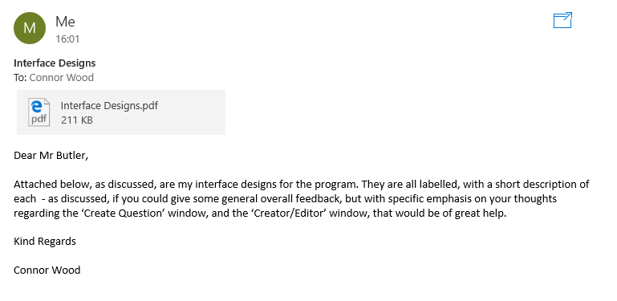I therefore sent them my general designs for each of the windows that make up the program, and specifically asked them for feedback on the ‘Create Question’ window and the ‘Creator/Editor’ window.

**Interface Designs**

**To: Rbu**

**R Butler**

**The Designs Are Shown Below:**

Annotations in black were sent to Richard Butler and his students.

Annotations in red are part of this document specifically for the design.

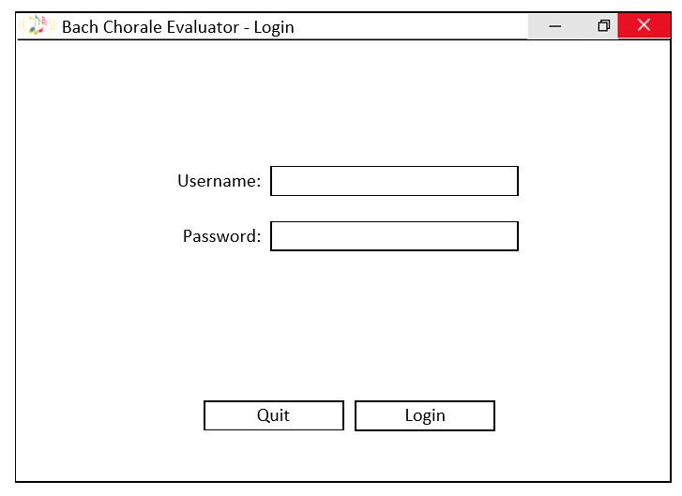

The interface is designed with PyQt4 in mind, throughout.

QLineEdit

QMainWindow

QLabel

QPushButton

**Login Window:**

The first window seen when the programme starts.

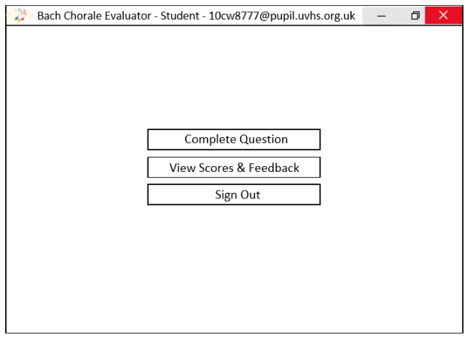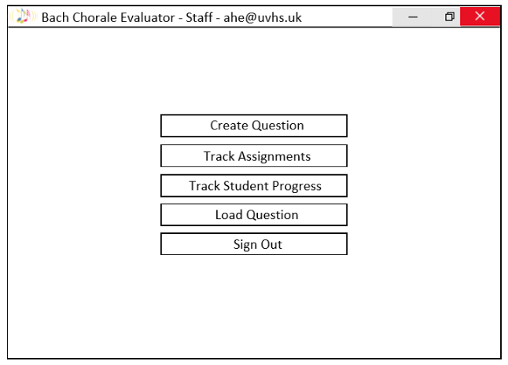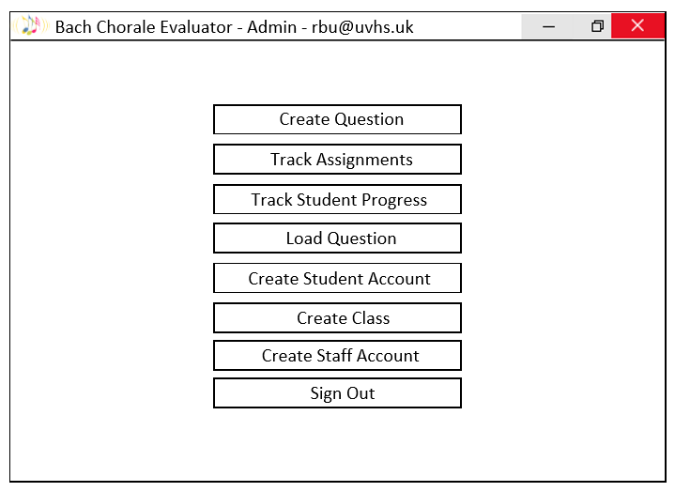

**Student Window:**

**Teacher Window:**

The Staff/Teacher and Student Windows both have the same layouts put just have slightly different variations of the features available to them as shown above. A staff member without Administrator Status can’t create staff accounts or classes or student accounts, as discussed. But they can Create and set questions, Load questions that they wish to use, and track all assignments and students. Instead of creating questions, students can complete questions assigned to them, and view their personal past scores and feedback for questions they have completed.

Easy to add buttons to a QVBoxLayout

QPushButton

QMainWindow

**Admin Window:**

This window loads if someone with Administrator Status logs in. They have access to all of the features shown here.

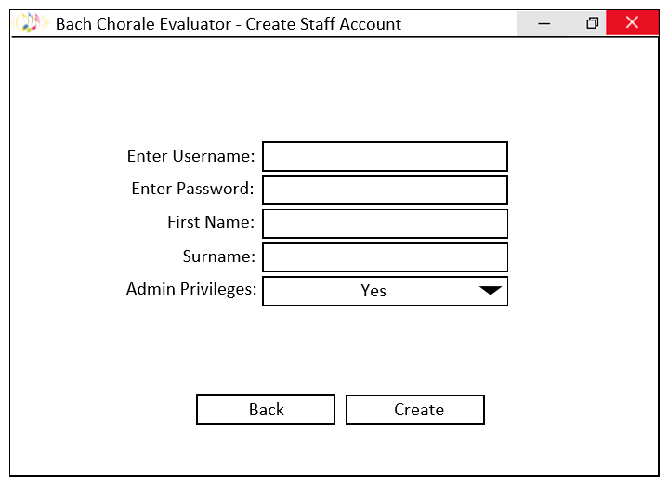

**Create Staff**

**Account Window:**

QMainWindow

QLabel

QComboBox

QPushButton

**General Layout for more complex windows:**

Describes layout of Create Staff Account Window.

QHBoxLayout

QVBoxLayout

QVBoxLayout

For line edits and Combo boxes.

QVBoxLayout

For labels.

QHBoxLayout – for bottom buttons

**The Create Student Account Window** is very similar to the previous one, but you select what Class you would like them to be in, rather than whether they have Administrator Privileges or not.

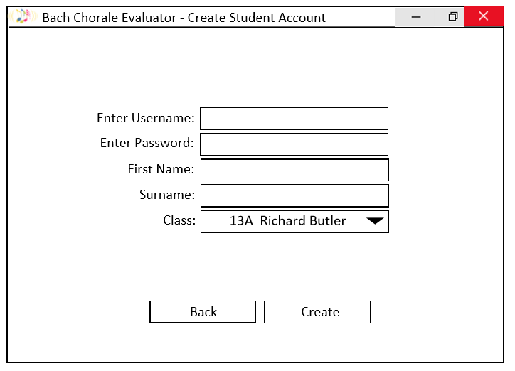

**Track Assignments Window:**

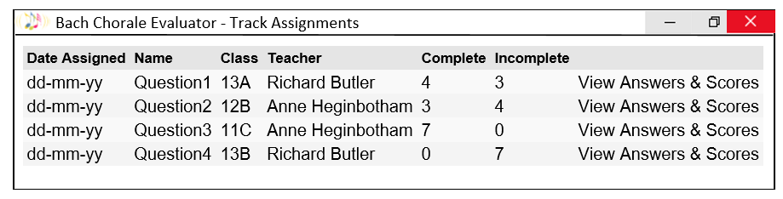

Can use a QTableWidget to create this and just add I to the Window’s main layout.

A teacher will be able to see all the questions that have been assigned to each class, along with how many people have completed and not completed the questions. If they then wish, they can press ‘View Answers & Scores’ (just a cell in the table with an action linked to it), and look at each individual student’s answer and the score they got.

**View Answers & Scores Window:**

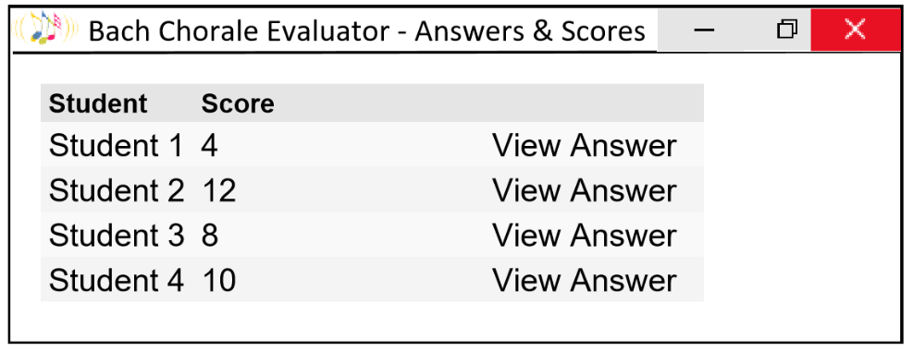

Again making use of the QTableWidget.

Pressing ‘View Answer’ will load the LilyPond PDF showing the Student’s answer using standard musical notation. (see LilyPond PDF section below) It will output their answer in the console (see console output section below), and also output all of the student’s feedback for the question. (see feedback output section below).

**Track Student Progress Window:**

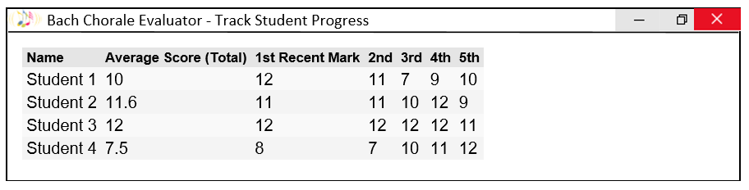

This allows a teacher to see all of the students on the system, and the 5 most recent scores they have received, along with their average score, taking all of their answers into consideration.

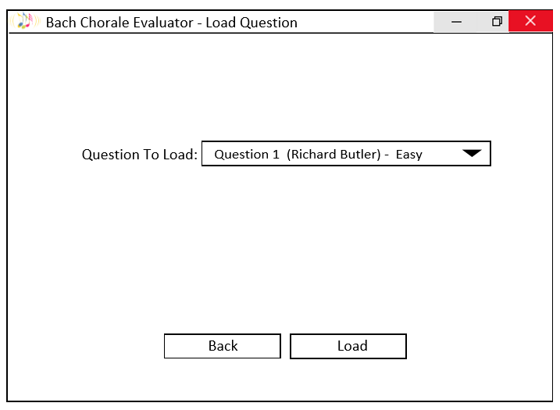

As discussed, when questions are created, they are assigned a difficulty level, which can be used here to select appropriate questions to assign for example.

**Load Question Window:**

This is how teachers can load questions already saved which they wish to edit or assign to classes. Once a question has been assigned it can no longer be edited, but can be assigned by other teachers, to other classes.

**View Scores & Feedback Window**

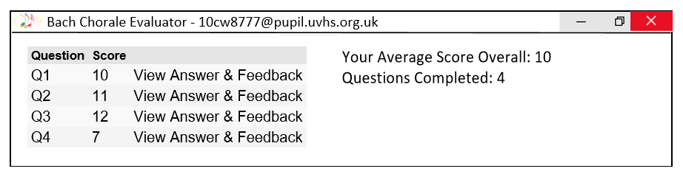

This is the window that students will use to see all of their previous answers and scores. If they wish to, they can then open the answer, which will load the LilyPond PDF showing the answer (see LilyPond PDF section below), and output their answer in the console (see console output section below), along with any feedback they received. (see feedback output section below).

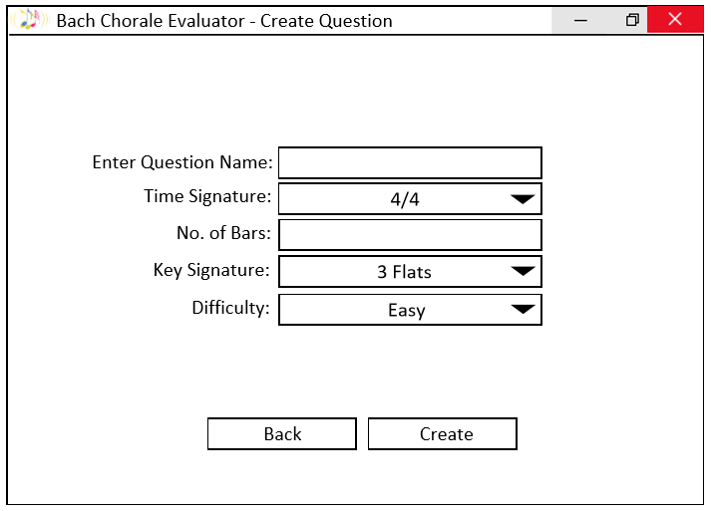

**Create Question Window:**

The window a teacher will use to create and automatically save a question.

Question names won’t have spaces in them, and the number of bars is typed in by the user, so that they can have as longer question or as shorter question as they like.

They select key signatures by determining how many sharps or flats the key signature has in – up to 5 sharps and 6 flats as discussed.

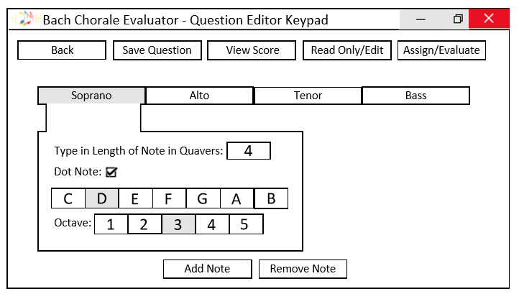

Would output a **LilyPond PDF**

This button depends whether you are a teacher or student.

4 quavers would place a minim

QCheckBox

Tabs to select which line to work on. QTabWidget

**Creator/Editor Window**

Staff and Students will all use some variation of this window, in order to create and assign questions, complete questions and submit and get feedback on them.

The Read Only/Edit feature toggles between allowing a teacher to edit the question, and then lock it down once they are happy with it – if they wish to edit it again, they press the button again. The Assign Button (not evaluate for a teacher) will bring up another window allowing the teacher to select what class they would like to assign a question to. Once a question has been assigned, even if you press the Read Only/Edit button, the question cannot be edited.

The Read Only/Edit button will not appear on the Student’s Creator/Editor Window. The Evaluate button (not Assign for a student), submits the student answer for the teacher to view when they wish, and it instantly provides the student with a score out of 12 and **feedback** as to where they have gone wrong (if they have).

The View Score button, allows the student or teacher to view the musical score (standard musical notation version) of what they have created or edited. This is the **LilyPond PDF version** of the musical score.

Whenever a note is added or removed (if it can be), the stave is **outputted into the python console** for the user to view – this doesn’t use standard musical notation, this uses a notation that I have developed for use in the programme, for users and for the programme to use to evaluate an answer, and produce the relevant text file that LilyPond needs in order to produce a proper musical score.

**Anything above in bold, is described further below.**

**Output for Python Console:**

A typical output which may be seen when using the program is shown overleaf, along with appropriate annotation to show how it should be read and what each symbol means.

Such notation will be output every time a note is added or removed, as well as when a question is loaded or a request to view the equivalent LilyPond PDF is made.

Annotations in red over the page, show how the programme will interact with this notation in order for other functions to work.

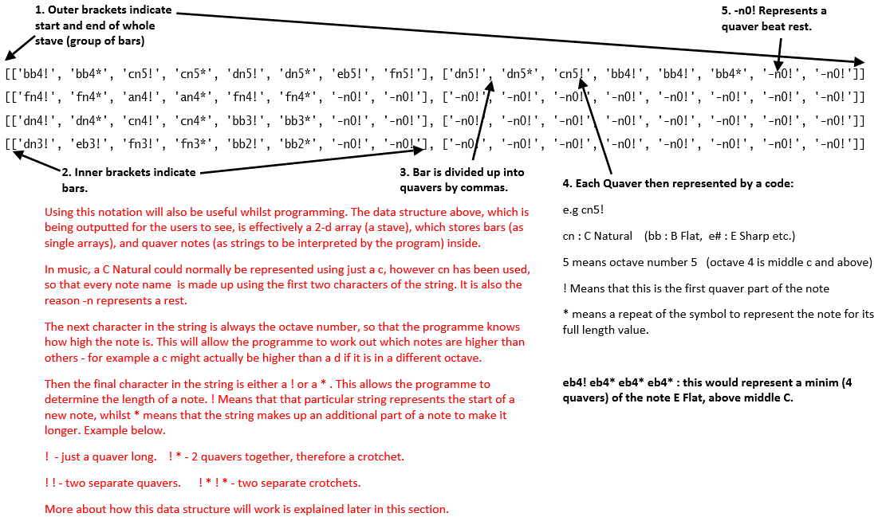

**LilyPond PDF Output:**

The image below shows the equivalent output by LilyPond, using the text file that my programme will create.

The stave extends as notes are added, hence the top stave is longer than the bottom at the moment.

As you can also see, rests are not displayed as there is no need for them to be – a completed question has no rests within it – there may however be redundant space at the end of a bar (e.g. Where all the parts are just rests (represented by the ‘-n0!’ string), which the programme will deal with when it comes to evaluating and scoring an answer.

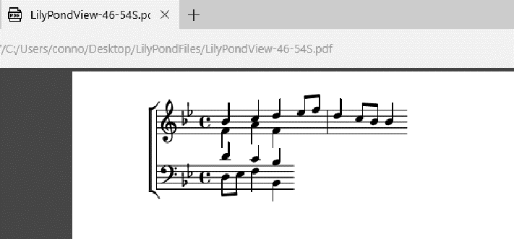The PDF shows the correct clefs (bass and treble), as well as the key signature and time signature used in the question. Note that ‘C’ is another way of represented 4/4 time.

**Feedback/Evaluation Output:**

When a student submits their answer, it is immediately evaluated and given a score out of 12. Any feedback is also outputted in the console for them to view, and below I’ve described how this works. Whenever a student wants to view a past question or a teacher wants to view a student’s answer to a question, when the LilyPond PDF loads and the Stave is also outputted to the console, any feedback they received is also outputted.

The program evaluates each chord that has been inputted and names it appropriately,

e.g. ‘Chord V7(a)’ or ‘Chord I(c)’

These are outputted in order to allow students and teachers to check that the chords they intended are actually the chords that they wrote.

The program then also outputs any appropriate feedback regarding that chord. It checks that:

* 7ths in any chord evaluated are prepared and resolve correctly. If they do not the following messages could be outputted underneath the chord.

“Seventh not prepared correctly.”

“Seventh does not resolve correctly.”

* The chord exists - if it cannot identify the chord, then instead of a chord name, this is outputted:

“Unidentified/incorrect chord – check for missing third or incorrect notes. (-2marks)”

* That the leading note hasn’t been double when forming the chord, otherwise this message is outputted:

“Doubled Leading Note (-1mark)”

* That the chord is appropriate to use, otherwise, any of these messages could be printed out, depending on the problem:

“Chord VII in any form is banned. Inappropriate (-2marks)”

“Try not to use Chord III – if you have to, make it a III(b)” – (this is something that Richard requested was added in when marking Chorales.)

“Not very appropriate to use a 7th Chord here” – doesn’t lose marks but they should only really be used at cadences.

After this, any feedback on the Cadence (the final 2 or 3 chords, depending on the question) is outputted.

The program will check that the final chord was a Chord I in root position, otherwise any of the following may be outputted:

“Final Chord should be in root position. (-1mark)”

“Chord is inappropriate. Should be a Chord I (-2 marks)”

It then checks that the penultimate chord was any form of Chord V or Chord V7. If not, the following is outputted:

“Chord is inappropriate. Should be a Chord V or V7 (-2 marks)”

The program then evaluates every note on the stave, quaver by quaver, checking for errors in part writing etc. It checks for:

* Bass and Tenor parts crossing over
* Tenor and Alto parts crossing over
* Soprano and Alto parts crossing over
* That the Tenor and Alto parts more than an octave apart
* Parallel Fifths in answer
* Parallel Octaves in answer
* The Leading Note falling

If any errors are found, the appropriate feedback message from the following (see below) is then outputted, along with a message indicating how many quavers into the answer the problem can be found.

**Potential Feedback Messages**

“Leading note falls. (-1mark)”

“Bass and Tenor have crossed. (-1 mark)”

“Tenor and Alto have crossed. (-1 mark)”

“Soprano and Alto have crossed. (-1 mark)”

“Tenor and Alto more than an octave apart. (-1 mark)”

“Parallel 5ths between ________ and __________ . (-1 mark)”

“Parallel octaves between ________ and __________ . (-1 mark)”

Finally, the program will check if there was an opportunity to use a bonus cadence (either a 3 Blind Mice Cadence, or a PSR [prepare, suspend, resolve] cadence). (see analysis for information on bonus cadences)

If there was opportunity for one and it had been executed correctly, then the following may be outputted:

“Bonus Cadence used. (+1 mark)”

However, if there was an opportunity for one that was missed, although it won’t deduct any marks. One of the following may be outputted:

“PSR Cadence opportunity missed.”

“3 Blind Mice Cadence opportunity missed.”

After sending all of this to Richard Butler, he and his students made the following recommendations in an email reply to me:

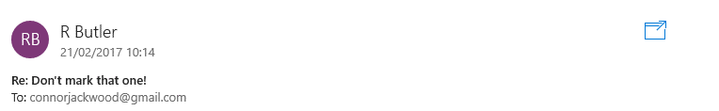

**Re: Interface Designs**

**To: connorjackwood@gmail.com**

Dear Connor,

Thank you very much for sending me these designs. I have had a look through them with a few students who will potentially be using the system, and we really like the layout – we have just made a few recommendations that you could perhaps implement:

1. The Creator/Editor Window looks very busy with lots of buttons everywhere – could we perhaps use dropdown boxes as you have used in other windows, so it’s clear what selections we are making?
2. For simplicity, would it be possible to just make a question ‘read only’ when a teacher assigns it to pupils – I feel I may get confused by that feature if I try to use it myself, and surely it’s only actually needed when a question is assigned by me for my pupils?
3. Could we possibly have an undo button in case we make a mistake when editing?
4. And rather than having another window to assign a question (just so there aren’t too many), could we just implement a dropdown box and an assign button to just be added to the Creator/Editor Window?
5. We’ve also previously used a scale between 1 and 5 to rank the difficulty of questions. Can we carry on this way rather than using “Easy” and “Hard”?

If you require any more information from me, then please get in touch. We’re very happy though and look forward to seeing how the system comes along!

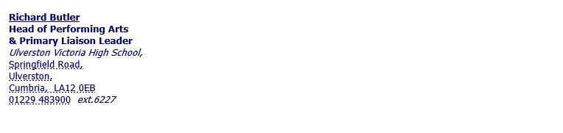

I implemented necessary changes, and below are screenshots of some of the main windows that make up the interface.

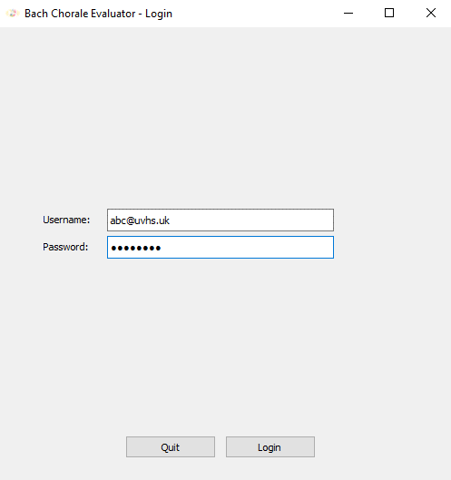

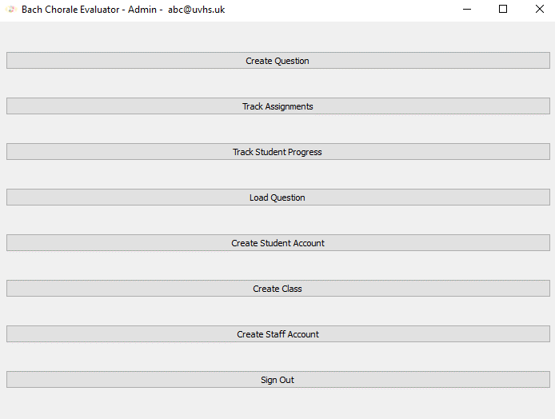

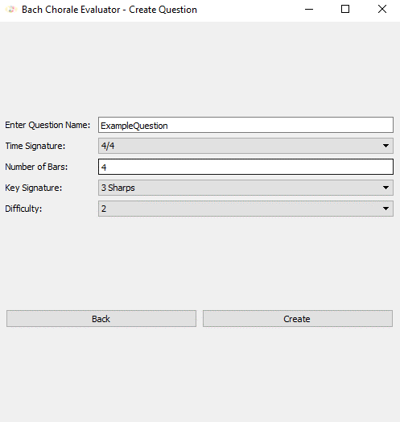

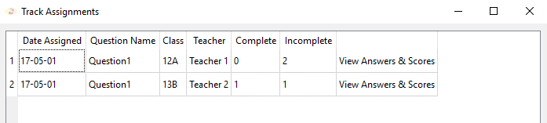

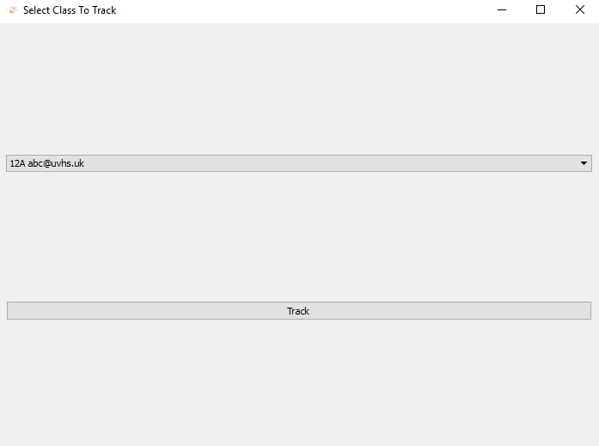

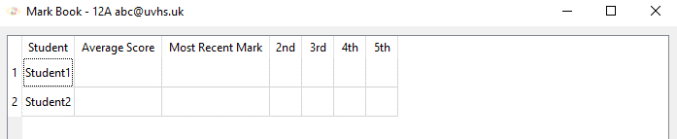

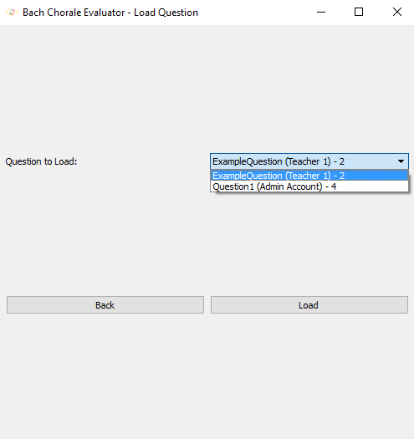

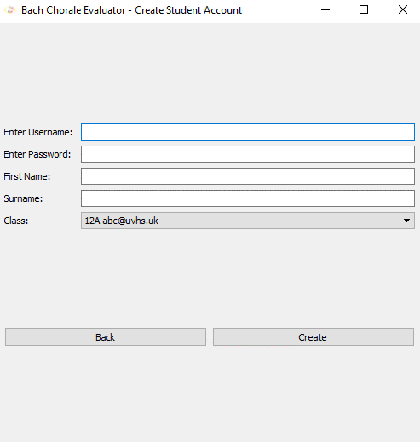

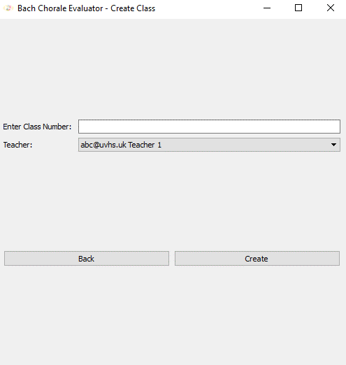

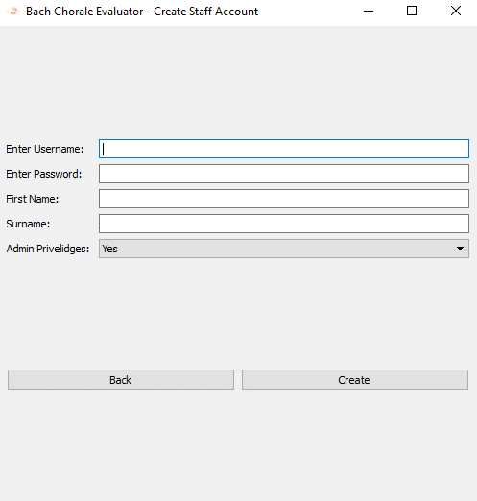

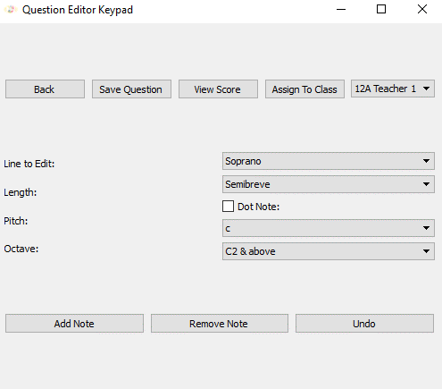

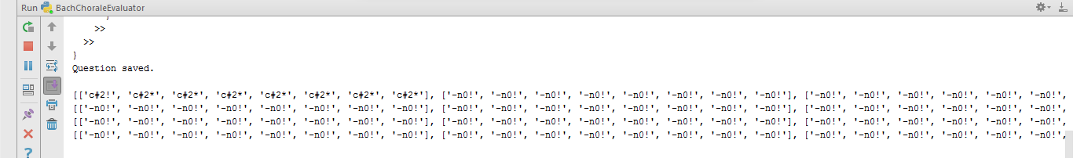

### **File Structure**

Using my data flow diagram of the current system, along with my entity relationship diagram, I have developed the following file structure for the program, along with DDL statements to produce my database.

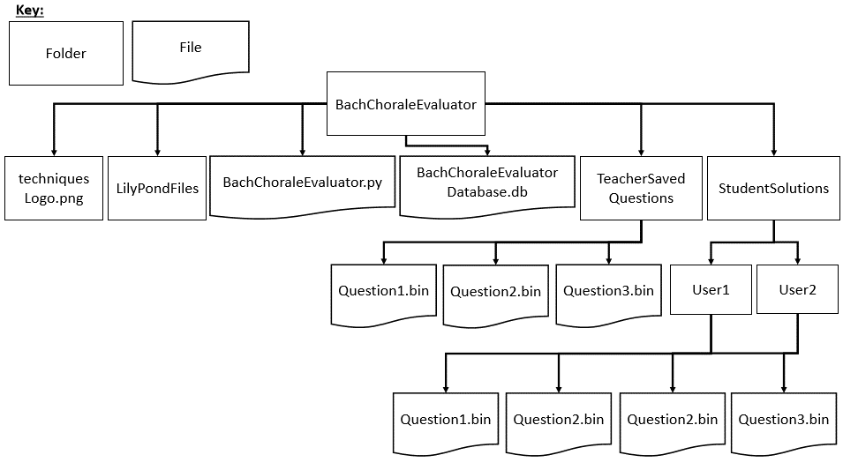The program exists inside its own folder – ‘Bach Chorale Evaluator’. Inside this folder is the main python file to be executed, as well as the database, and any other files required for the program to run, such as the logo to display at the top left of each window. 2 other folders exist inside this program folder – one for storing Teacher’s questions as binary files, and the other for storing student’s solutions as binary files. The binary files will store information about specific Stave objects (Questions or Solutions described and formed using part of my OOP model) instantiated and saved by the program. All Teacher’s questions can be saved together, and be accessed by any staff member, whilst student solutions are saved in their own individual sub-directories – each Student’s solution to an individual question will have the same name, but be stored in the appropriate folder. A diagram shows this full structure below. Question and Solution IDs stored in my database will be the names of the files stored in the directories shown below.

This diagram represents what the file structure might look like, given that two questions have been created and saved by teachers. Questions 1 & 2 have been assigned to User1 (a student), whilst questions 2 & 3 have been assigned to User2 (another student).

References to all of those questions and solutions will be stored in the database (BachChoraleEvaluatorDatabase.db), and all of these questions and solutions can be accessed using the program.

### **Database Table Design**

Using my entity relationship diagram, objectives, previous discussions with users and dataflow diagram of the current system, I have developed the following table designs.

**Table Designs:**

TEACHER(teacherID, firstName, surname, password, admin)

CLASS(classID, teacher)

STUDENT(studentID, class, firstName, surname, password)

QUESTION(questionID, class, creator, dateAssigned, assignedBy, difficulty)

SOLUTION(question, student, score, date)

Anything in red needs to be overlined.

**DDL Statements to Generate Database:**

CHECK THE INTEGER(1) THING AND CHECK ALL THIS IS CORRECT AND WHETHER IT NEEDS CHANGING IN PYTHON. COMMAS AFTER PRIMARY AND FOREIGN KEY STATEMENTS?

CREATE TABLE Teacher (

teacherID VARCHAR(11) PRIMARY KEY,

firstName VARCHAR(20),  
surname VARCHAR(20),  
password VARCHAR(20),  
admin INTEGER(1));

CREATE TABLE Class (

classID VARCHAR(3) PRIMARY KEY,  
teacher VARCHAR(11),  
FOREIGN KEY(teacher) REFERENCES Teacher(teacherID));

CREATE TABLE Student (

studentID VARCHAR(26) PRIMARY KEY,  
class VARCHAR(3),  
firstName VARCHAR(20),  
surname VARCHAR(20),  
password VARCHAR(20),

FOREIGN KEY(class) REFERENCES Class(classID));

CREATE TABLE Question (

questionID VARCHAR(20),  
creator VARCHAR(11),  
class VARCHAR(3),  
dateAssigned DATETIME,  
assignedBy VARCHAR(11),

difficulty INTERGER(1),  
PRIMARY KEY (questionID, class)  
FOREIGN KEY(creator) REFERENCES Teacher(teacherID)  
FOREIGN KEY(class) REFERENCES Class(classID));

CREATE TABLE Solution (

question VARCHAR(20),  
student VARCHAR(26),  
score INTEGER(2),  
date DATETIME,  
PRIMARY KEY (question, student)  
FOREIGN KEY(student) REFERENCES Student(studentID)

FOREIGN KEY(question) REFERENCES Question(questionID));

The following SQL statement will also initialize the database, so that there is one default administrative account that can be used to login and set up the program for a specific set of users.

INSERT INTO Teacher(teacherID, firstName, surname, password, admin)  
VALUES("admin", "Admin", "Account", "default", 1);

### **SQL Queries**

Below are some of the SQL queries that I will use in my system, in order to maintain my database effectively, and to provide users with information they need to track their own (if students), or their students (if teachers) progress. Anything in red, will need to be passed in as a property of one of my objects in the program, and may be named slightly differently when the program is built.

1. **Statements allowing Teachers to Track Assignments**

SELECT Question.dateAssigned, Question.questionID, Question.class, Teacher.firstName, Teacher.surname  
FROM Question, Teacher  
WHERE class != 0  
AND Question.assignedBy = Teacher.teacherID

ORDER BY Question.dateAssigned DESC;

When a teacher first creates a question, a record is created with class set to 0, dateAssigned set to None and assigned by set to 0. (this explains line 4 of this statement). Then when a question is assigned to a class, a new record is added to the Question table, with details of the Class is was assigned to, and which teacher assigned it, along with the date is was assigned.

SELECT Solution.score  
FROM Solution, Student  
WHERE question = question_name  
AND Student.class = class  
AND Student.studentID = Solution.student;

This statement fetches the score for each student. If a student has not submitted the question yet then score will be set to ‘#’. The property keeping count of incomplete questions will go up by one for every ‘#’ fetched. The property keeping count of complete questions goes up by one every time an integer is fetched.

These two statements are used as part of the code which produces this table, allowing teachers to view all assignments:

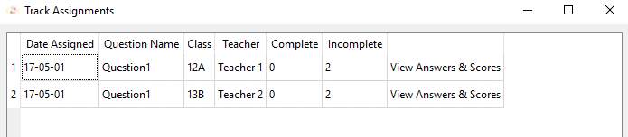

1. **Selecting all solutions for a particular assignment (specific question and class)**

If the user then presses the View Answers & Scores button for an assignment in the table above, the following statement will fetch information to produce a table showing information about students who have answered the question.

SELECT Student.firstName, Student.surname, Solution.score, Student.studentID, Solution.date  
FROM Solution, Student  
WHERE Solution.question = selected_assignment

AND score != ‘#’  
AND Student.class = selected_class  
AND Student.studentID = Solution.student  
ORDER BY Student.date DESC;

This statement will be used to produce the following table:

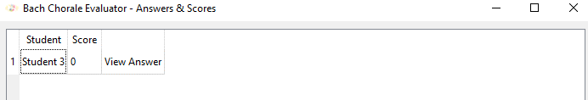

1. **Listing all questions in alphabetical order, allowing staff to choose a question to load.**

SELECT Question.questionID, Teacher.firstName, Teacher.surname, Question.difficulty  
FROM Question, Teacher  
WHERE Question.class = 0  
AND Question.creator = Teacher.teacherID  
ORDER BY Question.questionID ASC;

1. **Listing all questions that a specific student hasn’t yet completed.**

SELECT Solution.question, Question.dateAssigned, Teacher.surname  
FROM Solution, Question, Teacher  
WHERE Solution.student = current_username  
AND Solution.score = ‘#’  
AND Question.class = user_class  
AND Solution.question = Question.questionID  
AND Question.assignedBy = Teacher.teacherID  
ORDER BY Question.dateAssigned ASC; - this line ensures the question they were assigned first, is at the top encouraging students to complete them first.

When a question is assigned to a class, a solution will be added to the solution table, for every student in that class. The score will be initialised to ‘#’ meaning that it hasn’t yet been submitted.

1. **Listing the scores of the students who have completed a particular assignment.**

SELECT Student.firstName, Student.Surname, Solution.score,Student.studentID  
FROM Solution, Student  
WHERE Solution.question = **assignmentName**AND score != ‘#’  
AND Student.class = **assignmentClass**AND Student.studentID = Solution.student

### **Algorithm Design – Use of ‘Instance.’**

The design of some of my algorithms shown in the rest of this section are reflective of my use of Python as my programming language, and also reflective of the Object Orientated style of programming I have a adopted. Therefore the python specific ‘self.’ feature which demonstrates use of an instance property has been replaced with ‘Instance.’. This means that ‘Instance.length’ would be an instance property for use in any method is a particular class, whereas ‘Length’ would be a local scope variable only for use inside the method in which it appears.

### **Regular Expressions & Exception Handling**

**Regular Expressions**

I’ve developed the following Regular expressions for use in the program, they are used to ensure that usernames for user accounts are valid, passwords are strong enough, and that question names do not contain spaces (THAT ONE STILL NEEDS IMPLEMENTING), as they can’t contain spaces due to the way I’m manipulating them and using them in the program. A space indicates the end of the question name which allows the program to successfully fetch a full question name from the interface using a for loop. (EXPLAIN THIS FURTHER)

1. **Teacher/Admin Account Usernames**

The staff will be required to use their staff email addresses as their usernames – these are something that are definitely unique to them, and means that they can be used as a username and primary key in the database.

Staff email addresses are always made up of 3 letters (generally their first initial, followed by the first two letters of their surname), followed by ‘@uvhs.uk’.

**Regular Expression: [a-z][a-z][a-z]@uvhs.uk**

1. **Student Account Usernames**

**Students will use their student email addresses as their usernames, as again, they are definitely unique to each student and can therefore be used as a unique username and primary key for the database.**

Student email addresses are made up of two integers (representing the year that the student would have joined year 7 in the school. So currently, in the year 2017, year 11 usernames begin with ‘12’, year 12 usernames begin with ‘11’, and year 13 usernames begin with ‘10’), followed by their first and last initials e.g. ‘ab’, followed by 4 integers (0-9), and then ‘@pupil.uvhs.org.uk’.

The regular expression is made up of two parts. Part one is worked out by the program depending on what year it is (using the python ‘datetime’ module). This forms the regular expression which validates the first two characters of the student username.

**Pseudocode for Part One**

FUNCTION valid_years

current_year 🡨 datetime.now(Year) how do I show this??

current_year 🡨 current_year[2] + current_year[3]

regex_for_year 🡨 ‘(‘ + str(int(current_year – 5) + ‘|’ + str(int(current_year – 6) + ‘|’ + str(int(current_year – 7)+ ‘)’

RETURN regex_for_year

END FUNCTION

**Regular Expression – Parts One and Two:**

valid_years + **'[a-z][a-z][0-9][0-9][0-9][0-9]@pupil\.uvhs\.org\.uk**

1. **Class Names**

The program will be used by years 11, 12 and 13, and class names are of the format described below by the regular expression.

**Regular Expression: 1(1|2|3)[A-Z]**

1. **Passwords**

Certain constraints are placed on passwords for all accounts used in order to make the accounts secure enough. Passwords must be at least 8 characters in length and contain 1 digit (0-9), one uppercase letter and one lowercase letter. Special characters cannot be used.

**Regular Expression: (?=.*?\d)(?=.*?[A-Z])(?=.*?[a-z])[A-Za-z\d]{8,}**

**Contain at least 1 digit** At least one upper case **At least one lowercase** At least 8 characters

The red part means as many uppercase, lowercase and digits.

**Exception Handling & Validation**

Exception handling ensures that in the case of incorrect input by a user, the program will respond appropriately and not crash due to an error.

Here are some suggestions and descriptions of situations where I feel exception handling will be necessary, along with any sections of code that I can use to either combat these exceptions, or prevent them using validation.

1. **Validating Username & Password input**

As well as validation using regex when accounts are created, it’s also important to validate passwords entered, making sure that they correspond to the appropriate username when logging in.

**Example Pseudo Code (including appropriate SQL Statement)**

username 🡨 username_line.inputted_text()  
password 🡨 password_line.inputted_text()

connection.execute(''' SELECT password  
 FROM Teacher  
 WHERE teacherID = ?''', (username,))  
valid_password 🡨 connection.fetchone()  
valid_password 🡨 valid_password[0]

if password = valid_password THEN  
Close Current Window

Open Teacher Window

1. **Method to Implement All Checks Using Regular Expressions**

Valid years is the method which uses the current year to work out which usernames are valid for year 11, 12 and 13 students, as shown in the Regular Expressions section.

‘Re’ is the module used for checking strings with regular expressions.

METHOD regex_validation(user_input, check)  
 IF check = "Teacher" THEN  
 regex 🡨 '[a-z][a-z][a-z]@uvhs.uk'  
 ELIF check = "Student" THENregex 🡨 valid_years() + '[a-z][a-z][0-9][0-9][0-9][0- 9]@pupil\.uvhs\.org\.uk'  
 ELIF check = "ClassID" THEN  
 regex 🡨 '1(1|2|3)[A-Z]'  
 ELIF check = "File" THEN  
 regex 🡨 '[A-Za-z1-9\d]{1,20}'  
 ELSE  
 regex 🡨 '(?=.*?\d)(?=.*?[A-Z])(?=.*?[a-z])[A-Za-z\d]{8,}'

ENDIF  
 match 🡨 re.match(regex, user_input)  
 IF match is not None then  
 return True  
 ELSE  
 return False

ENDIF

ENDMETHOD

So for example, checking a valid username could be done like this:

username 🡨 username_line.inputted_text

IF regex_validation(username, “Student”) THEN

Continue with code, as username was of a valid format.

1. **Exception Handling – Creating Accounts/Questions That Already Exist**

A potential problem which may need dealing with would be if a teacher was to name a question using the same name as an existing one, or if a user tried to create an account with a username that already exists. Both of these actions would cause an IntegrityError to be returned by sqlite3. I have therefore used try except blocks to combat such errors.

**Example Pseudo Code**

TRY

connection.execute(‘’’INSERT INTO Question(questionID, creator, class, assignedBy, difficulty)

VALUES(?,?,?,?,?)’’’, (question_id, creator, 0, 0, difficulty))

connection.commit()

EXCEPT sqlite3.IntegrityError THEN

OUTPUT “Question with this name already exists.”

ELSE

Continue executing code.

ENDIF

1. **Dealing with Erroneous/Extreme User Input**

A potential way in which a user could cause the program would be with extreme input values. For example, when a teacher has to type in the number of bars in length they would like the question to be, entering 1,000,000 would make it very hard for the program to process. I must ensure such values can’t be input by a user.

I have limited the length of a question to being 20 bars – if a teacher types in a number larger than 20, they are asked for another input.

Question names can only consist of letters and numbers (with no spaces) so that the question name can be used as the file name without causing any error.

1. **No Questions to Load/No Classes To Assign/No Teachers To Assign**

If there are no questions to load, when a teacher presses the load question button, they must be notified that there are no questions to load, and the loading window does not need to open.

If there are no classes to assign question to, then if a teacher creates a question, the assign button and the QComboBox used to select a class should not load as part of the window used to edit the question. The teacher should also be notified that there are no classes available to assign questions to.

If there are no teachers (apart from the default admin account) to assign classes of students to, then the user should be notified of this, and they should not be able to create a class.

1. **Validating Note Input**

I must ensure that students cannot add notes to a stave which is already full, otherwise the program will error. More on this particular behaviour of the program is explained in more detail further on in this section.

1. **Ensuring Assigned Questions & Submitted Answers Cannot Be Changed**

I must make sure that Students cannot continue to edit a question that they have submitted. I must also make sure that teachers cannot change questions after they have been assigned, and that students cannot edit the notes added by a teacher to form the question. More on this particular behaviour of the program is explained in more detail further on in this section.

1. **Validating Note Removal**

If students or teachers were to try to remove notes from an empty line, then unless exception handling is implemented, the program would crash. I will deal with this using the following code:

If the line is empty, then the first position of the line (which will be stored in this property at this point) will be ‘-n0!’

IF Instance.to_remove = ‘-n0!’ THEN

OUTPUT “Nothing to remove.”

If Instance.error is set to 1, later on the program will ensure (using further validation) that the removal doesn’t actually take place.

Instance.error 🡨 1

ENDIF

1. **Validating Use of Undo**

If the user tries to undo something, when they haven’t actually performed any action, I need to make sure that the user is notified of this, and that the program doesn’t try to fetch data about an operation from an empty stack. I will prevent the program from crashing using the following code:

IF Instance.operation_stack_pointer = -1 THEN

Instance.operation_stack_pointer indicates the position of the item at the top of the stack. -1 indicates therefore that the stack is empty.

OUTPUT “Nothing to undo.”

ELSE

Continue to execute code in the method which will undo an operation.

ENDIF

I will also reset the stack every time the editor is loaded, so that a student cannot undo actions of the staff member who last edited the question. This will also make sure that they can’t undo actions they carried out last time they accessed and saved a question if they have done so.

1. **Ensuring Teacher Sets A Question That Can Be Evaluated**

As you will see from the explanation of the evaluate_answer method further on in this section, questions must be of a certain format to be eligible to be evaluated by the system. Questions must finish on beats 1 or 3, so that the system can correctly identify and evaluate chords after locating the position of the final chord. A question must also allow for at least three chords to be inputted by a student (and therefore be at least 3 crotchets long), so that the system can identify cadences. As discussed with Mr Butler, a question set by a teacher would never need to be less than 3 crotchets long, otherwise there would be no cadence to evaluate. I will implement the following code for this:

Teachers should also set questions requiring a perfect cadence as an answer – the system does not check that Teachers have done this, but if any other cadences are required (eg. Imperfect), a student submitting an answer would end up losing marks even if it was completely correct. This is because as agreed with Mr Butler, the system only needs to work for perfect cadences, as for the exam, they are the type of question to be answered.

The following code will implement this validation/exception handling successfully:

**METHOD assign_question()**  
 Instance.question.find_final_position()  
 IF Instance.question.final_position MOD 2 <> 0 OR

Instance.question.final_position < 4 THEN  
 OUTPUT "Question cannot be assigned. Must finish on the beat and allow for at least 3 chords."  
 ELSE

Continue executing method. This will save and assign the question successfully.

ENDIF

ENDMETHOD

1. **Validating Question Assignment**

Another potential issue could arise in the following scenario. A teacher carries out the following sequence of steps:

1. Creates a class
2. Add 4 students to the class
3. Creates a question and assigns the question to the class
4. Adds 2 more students to the class

If they then want to assign the question to those two students, then the program would re assign the original question the students who may have already completed it, erasing their work.

One solution to this would be to not allow a question to be assigned to a class it has already been assigned to, however this would mean that those two students would not be able to complete the question.

Instead, the program will behave as follows when assigning a question:

1. The assignment of the question will be entered as a record (?) into the Question table of the database.
2. The primary key of this table is both the QuestionID and Class (which the question is being assigned to) combined. If we get an integrity error, then notify the user and ask them to confirm that they wish to continue with the assignment. A second record is therefore not added to the table.
3. If they wish to continue, then notify them of each pupil for which the question has already been assigned (the blank question file will not be saved and overwrite their work – they are not assigned the question again.)
4. The program then assigns the question to any new students added to the class, saving the blank question in their directory storing their questions to complete and updating the Solution table in the database, to keep track of which questions have been assigned to whom.

### **Development of Algorithms & Data Structures**

Below are some of the key algorithms and data structures along with what they do. The UML Diagram seen on page 81, shows where these algorithms and data structures fit into the overall design and structure.

1. **The CreatorWindow Class – Adding notes, Removing notes & Undoing actions**

**Creating A Note**

As I mentioned earlier, as the explanations of various of my algorithms use multiple methods in different Classes at times, whereas convention in Python to differentiate between local scope variables and instance properties of a class is to use **‘self.’**, I’ll be using **‘Instance.’**, as a convention to indicate those instance properties.

**Methods Used from CreatorWindowClass**

**create_note_btn_clicked()**

‘Instance.question’ is an instantiation of the stave class, storing properties about the question, including whether or not the question has been assigned by a teacher (‘Instance.question.assigned’) or submitted by a student as a solution (‘Instance.question.submitted’).

**EXCEPTION HANDLING EXAMPLE:** When a teacher creates a question, Instance.question.assigned = 0 and Instance.question.submitted = 0. When the teacher assigns the question to a class, Instance.question.assigned = 1. When a student edits their version of the question in order to input their answer, Instance.question.assigned = 0 again, and then when they submit the answer Instance.question.submitted = 1. The code highlighted in yellow below ensures that the user can’t edit part of a question that they shouldn’t be able to.

This method is called when the user presses the Add Note button on the interface available to them. The procedure then fetches the users choices from the various dropdown boxes (asking them about note length, the line they wish to edit (soprano, alto, tenor or bass), the pitch of the note and the octave number of the note).

**create_note(p_length, p_pitch, p_line, p_octave, p_dotted)**

This procedure sets the appropriate properties for the note ready for it to be placed. Indexing is used to store numbers representing each of these properties. For example, Instance.length is worked out as the number of quavers needed to represent the note (the number of spaces that will be used in the Abstract Data Type used to represent the notes). Some of the text that will be needed to be output for LilyPond to interpret is also set here – it often needs to be different to the properties used to represent the note in my ADT.

**prepare_note()**

This procedure creates the symbol to represent the note in LilyPond, known as ‘Instance.lily_note’, as well as the symbols used to represent the note in my ADT, known as ‘Instance.note_id’ and ‘Instance.repeat_id’. ‘Instance.question.key_settings.to_sharpen’ and ‘Instance.question.key_settings.to_flatten’ are arrays containing the integers representing the notes of the scale that need to be sharpened or flattened for that question’s particular key signature. (See analysis for information on key signatures) If the integer representing the note to be placed is in one of these arrays, then the pitch needs adjusting accordingly. ‘is’ and ‘es’ are interpreted by LilyPond as instructions to sharpen or flatten a note.

**EXAMPLE OF ‘note_id’:** ‘bb4!’ **EXAMPLE OF ‘repeat_id’:** ‘bb4*’

**place_note()**

The abstract data type that I have created to store the data about notes is basically combines the behaviours of 2-d arrays and stacks. This procedure basically maintains each of the four ADTs (one for each line, soprano, alto, tenor and bass). A diagram of the outputted ADTs can be seen on page 31(?). The four ADTs are stored as properties (‘line_values’) of the Line class. There is an instantiation of the Line class for each line – known as ‘s_line’, ‘a_line’, ‘t_line’ and ‘b_line’.– for each question. Therefore manipulating one of the ADTs would require referring to is as ‘Instance.question.s_line.line_values’ for example. ‘Instance.creator_position’ represents the position in the selected ADT at which the next note is to be placed. If the creator position was [3, 4] then it would be index [3][4], which is bar 4, quaver 5 as shown below:

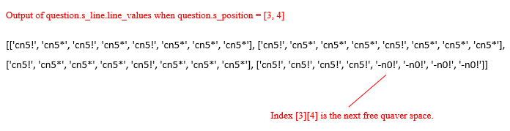 ‘Instance.creator_line’ and ‘Instance.creator_position’ are just copies made of the selected Line’s properties – it means the code doesn’t need to be repeated for each line selection. The same code can execute, regardless of whether it’s the Soprano, Alto, Tenor or Bass line being edited. The copying is done at the start of the procedure, and the appropriate properties are then updated at the end.

**The ADT behaves as follows:**

Notes can be added to the ADT as long as it is not full (technically, the ADT is always full, as a free space is represented by ‘n-0!’). Notes are added sequentially and removed backwards (adding and removing is like pushing and popping from a stack). If a note is too big to be added, then exception handling will be used. An example of this occurring is shown below:

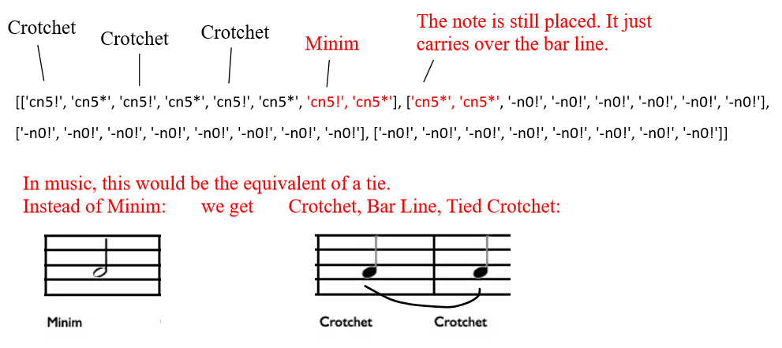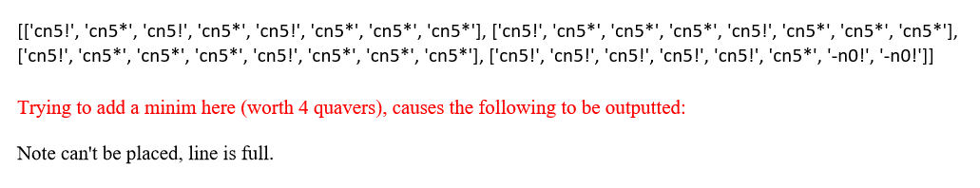Notes can be spread across two of the arrays that exist within the ADT – in actual music, notes are tied across bars – here the note is essentially placed across two arrays – it is ‘carried over’. An example of when this would occur is shown below:

**place_lily_note()**

Finally, if placing the note in the ADT was successful, then the text output to be interpreted by LilyPond needs to be updated, so that the user can view and accurate version of their question as standard musical notation.

**Method used from Stave Class**

**update_display()**

This method simply outputs each of the four Line object’s ‘line_values’ attributes, for the user to view the ADT.

**Anything highlighted in green has been added in for the purpose of an ‘undo’ feature, which is explained further as its own section below.**

**Pseudo Code for Methods used in CreatorWindow Class**

**METHOD create_note_btn_clicked()**

IF question.assigned = 1 THEN

OUTPUT “Question has been assigned so cannot be changed.”

ELIF question.submitted = 1 THEN

OUTPUT “Question has been submitted so cannot be changed.”

ELSE

length 🡨 Instance.length_list.selectedText

pitch 🡨 Instance.pitch_list.selectedText

line 🡨 Instance.line_list.selectedText

octave 🡨 Instance.octave_list.selectedText

IF Instance.dot_note_edit.isChecked THEN

dotted 🡨 1

ELSE

dotted 🡨 0

END IF

Instance.undo 🡨 0

Instance.create_note(length, pitch, line, octave, dotted)

ENDIF

ENDMETHOD

**METHOD create_note(p_length, p_pitch, p_line, p_octave, p_dotted)**

lengths 🡨[None, “Quaver”, “Crotchet”, None, “Minim”, None, None, None, “Semibreve”]

lily_lengths 🡨 [None, “Semibreve”, “Minim”, None, “Crotchet”, None, None, None, “Quaver”]

pitches 🡨 [“c”, None, “d”, None, “e”, “f”, None, “g”, None, “a”, None, “b”]

lines 🡨 [“Soprano”, “Alto”, “Tenor”, “Bass”]

octaves 🡨 [“C2 & above”, “C3 & above”, “Middle C & above”, “C5 & above”]

lily_octaves 🡨 [“,”, “”, “’”, “’’”]

length 🡨 p_length

Instance.length 🡨 lengths.index(length)

Instance.lily_length 🡨 string(lily_lengths.index(length))

Instance.dotted 🡨 p_dotted

IF Instance.dotted = 1 THEN

Instance.length 🡨 length * 1.5

Instance.length 🡨 integer(length)

Instance.lily_length 🡨 lily_length + ‘.’

ENDIF

pitch 🡨 p_pitch

Instance.pitch 🡨 pitches.index(pitch)

line 🡨 p_line

Instance.line 🡨 lines.index(line)

octave 🡨 p_octave

Instance.octave 🡨 octaves.index(octave) + 2

Instance.lily_pitch 🡨 pitch

Instance.lily_octave 🡨 lily_octaves[octaves.index(octave)]

Instance.prepare_note()

ENDMETHOD

**METHOD prepare_note()**

IF Instance.pitch in Instance.question.key_settings.to_sharpen THEN

Instance.pitch 🡨 Instance.pitch + 1

Instance.lily_pitch 🡨 Instance.lily_pitch + ‘is’

IF Instance.pitch in Instance.question.key_settings.to_flatten THEN

Instance.pitch 🡨 Instance.pitch - 1

Instance.lily_pitch 🡨 Instance.lily_pitch + ‘es’

Instance.lily_note 🡨 string(Instance.lily_pitch) + string(Instance.lily_octave) + string(Instance.lily_length)

Instance.note_id 🡨 string(Instance.question.key_settings.notes_sharps_flats[Instance.question.key_signature[0]][ Instance.pitch]) + string(Instance.octave)

Instance.repeat_id 🡨 Instance.note_id + “*”

Instance.note_id 🡨 Instance.note_id + “!”

place_note()

ENDMETHOD

**METHOD place_note()**

Instance.error 🡨 0

IF Instance.line = 0 THEN

Instance.creator_position 🡨 Instance.question.s_position

Instance.question.creator_line 🡨 Instance.question.s_line.line_values

Instance.question.lc_line 🡨 Instance.question.ls_line

ELIF line = 1 THEN

Instance.creator_position 🡨 Instance.question.a_position

Instance.question.creator_line 🡨 Instance.question.a_line.line_values

Instance.question.lc_line 🡨 Instance.question.la_line

ELIF line = 2 THEN

Instance.creator_position 🡨 Instance.question.t_position

Instance.question.creator_line 🡨 Instance.question.t_line.line_values

Instance.question.lc_line 🡨 Instance.question.lt_line

ELSE

Instance.creator_position 🡨 Instance.question.b_position

Instance.question.creator_line 🡨 Instance.question.b_line.line_values

Instance.question.lc_line 🡨 Instance.question.lb_line

ENDIF

original_position 🡨 creator_position

IF Instance.creator_position[0] >= Instance.question.number_of_bars THEN

OUTPUT “Note can’t be placed, line is full”

Instance.error 🡨 1

ELSE

FOR x in range(Instance.length - 1) DO

Instance.creator_position[1] 🡨 Instance.creator_position[1] + 1

IF Instance.creator_position[1] = question.bar_quaver_limit THEN

Instance.creator_position[0] 🡨 creator_position[0] + 1

Instance.creator_position[1] 🡨 0

ENDIF

IF Instance.creator_position[0] >= Instance.question.number_of_bars THEN

OUTPUT “Note too long to be placed here.”

Instance.error 🡨 1

ENDIF

ENDFORLOOP

Instance.creator_position 🡨 original_position

IF Instance.error = 1 THEN

OUTPUT “Error: note not placed.”

ELSE

Instance.question.creator_line[creator_position[0]][creator_position[1]] 🡨 Instance.note_id

Instance.creator_position[1] 🡨 creator_position[1] + 1

IF Instance.creator_position[1] = Instance.question.bar_quaver_limit THEN

Instance.creator_position[0] 🡨 Instance.creator_position[0] + 1

Instance.creator_position[1] 🡨 0

ENDIF

FOR x in range(Instance.length – 1) DO

Instance.question.creator_line[Instance.creator_position[0]][ Instance.creator_position[1]] 🡨 Instance.repeat_id

Instance.creator_position[1] 🡨 Instance.creator_position[1] + 1

IF Instance.creator_position[1] = Instance.question.bar_quaver_limit THEN

Instance.creator_position[0] 🡨 Instance.creator_position[0] + 1

Instance.creator_position[1] 🡨 0

ENDIF

ENDFORLOOP

IF Instance.error = 0 THEN

Instance.place_lily_note()

IF Instance.line = 0 THEN

Instance.question.s_line.line_values 🡨 Instance.question.creator_line

Instance.question.s_position 🡨 creator_position

Instance.question.ls_line 🡨 Instance.question.lc_line

ELIF line = 1 THEN

Instance.question.a_line.line_values 🡨 Instance.question.creator_line

Instance.question.a_position 🡨 creator_position

Instance.question.la_line 🡨 Instance.question.lc_line

ELIF line = 2 THEN

Instance.question.t_line.line_values 🡨 Instance.question.creator_line

Instance.question.t_position 🡨 creator_position

Instance.question.lt_line 🡨 Instance.question.lc_line

ELSE

Instance.question.b_line.line_values 🡨 Instance.question.creator_line

Instance.question.b_position 🡨 creator_position

Instance.question.lb_line 🡨 Instance.question.lc_line

ENDIF

ENDIF

Instance.question.update_display()

IF Instance.undo = 0 THEN

Instance.operation = [0, Instance.line]

Instance.question.operation_stack.append (Instance.operation)

Instance.question.operation_stack_pointer 🡨 Instance.question.operation_stack_pointer + 1

ENDIF

ENDIF

ENDIF

ENDMETHOD

**METHOD place_lily_note():**

#”s1”, “s2” and “s2.” are rest symbols in LilyPond notation – if there were rests there then no notes have been placed yet, and the line needs setting to blank ready to place the first note.

if “s1” in Instance.question.lc_line or “s2” in Instance.question.lc_line or “s2.” in Instance.question.lc_line THEN

Instance.question.lc_line = “”

Instance.question.lc_line = Instance.question.lc_line

+ Instance.lily_note

ENDIF

ENDMETHOD

**Removing A Note**

**This algorithm will also form part of the CreatorWindow class.**

**Methods from CreatorWindow Class**

**remove_note_btn_clicked()**

Similarly to CreatorWindow.create_btn_clicked(), this method validates the button press, ensuring that the question hasn’t been assigned to a class, or submitted to students, and can still actually be edited. It then fetches the necessary information (the user’s selection of line – Soprano, Alto, Tenor or Bass), and then calls the CreatorWindow.remove_note(line) method.

**remove_note(line)**

This method actually removes the note, updating the ADT I’ve developed, as well as editing the output used to display musical notation using LilyPond. As in the ‘CreatorWindow.create_note’ method, this method copies the information from the line the user wishes to edit, so that the same code can be executed, regardless of which line is being edited. This explains the use of ‘Instance.remove_position’ (which is the array describing the indexing of the next available space to place a note on the line), as well as ‘Instance.remove_line’ and ‘Instance.r_lily_line’ (r standing for remove).

**EXCEPTION HANDLING EXAMPLE:** Each instantiation of the Stave Class (referred to here as ‘Instance.question’) has four further Line objects stored as attributes. They are ‘ros_line’ (ros: read only soprano), ‘roa_line’, ‘rot_line’ and ‘rob_line’. When a teacher has assigned a question and a student is editing their own version (where Instance.question_assigned will be 0, and until they submit a question Instance.question.submitted will be 0), the Read Only line objects will store the ADTs as they were when the teacher assigned the question. When removing notes, the appropriate Read Only line is checked, and if a note exists at the given position, then the note cannot be removed. This prevents the student from accidently or intentionally changing the question set. Any code that demonstrates this is highlighted below in yellow.

**Anything highlighted in green has been added in for the purpose of an ‘undo’ feature, which is explained further as its own section below.**

**METHOD remove_note_btn_clicked()**

IF Instance.question_assigned = 1 THEN

OUTPUT “Question assigned and so cannot be edited.”

ELIF Instance.question_submitted THEN

OUTPUT “Question has been submitted and so cannot be changed.”

ELSE

lines 🡨 [“Soprano”, “Alto”, “Tenor”, “Bass”]

line 🡨 lines.index(Instance.line_list.selectedText)

Instance.undo 🡨 0

Instance.remove_note(line)

Instance.update_display()

ENDIF

ENDMETHOD

**METHOD remove_note(line)**

Instance.error 🡨 0

Instance.line 🡨 line

IF Instance.line = 0 THEN

Instance.remove_position 🡨 Instance.question.s_position

Instance.remove_line 🡨 Instance.question.s_line

Instance.r_lily_line 🡨 Instance.question.ls_line

Instance.question.read_only_line 🡨 Instance.question.ros_line.line_values

ELIF Instance.line = 1 THEN

Instance.remove_position 🡨 Instance.question.a_position

Instance.remove_line 🡨 Instance.question.a_line

Instance.r_lily_line 🡨 Instance.question.la_line

Instance.question.read_only_line 🡨 Instance.question.roa_line.line_values

ELIF Instance.line = 2 THEN

Instance.remove_position 🡨 Instance.question.t_position

Instance.remove_line 🡨 Instance.question.t_line

Instance.r_lily_line 🡨 Instance.question.lt_line

Instance.question.read_only_line 🡨 Instance.question.rot_line.line_values

ELSE

Instance.remove_position 🡨 Instance.question.b_position

Instance.remove_line 🡨 Instance.question.b_line

Instance.r_lily_line 🡨 Instance.question.lb_line

Instance.question.read_only_line 🡨 Instance.question.rob_line.line_values

ENDIF

Instance.remove_position[1] 🡨 Instance.remove_position[1]- 1

IF Instance.remove_position[1] = -1 THEN

Instance.remove_position[1]🡨 Instance.question.bar_quaver_limit – 1

Instance.remove_position[0] 🡨 Instance.remove_position[0] – 1

ENDIF

Instance.to_remove 🡨 Instance.remove_line.line_values[Instance.remove_position[0]] [Instance.remove_position[1]]

IF Instance.to_remove = ‘-n0!’ THEN

OUTPUT “Nothing to remove”

Instance.error 🡨 1

ENDIF

operation_pitch 🡨 Instance.to_remove[0] + Instance.to_remove[1]

operation_octave 🡨 Instance.to_remove[2]

operation_dotted 🡨 0

operation_length 🡨 0

WHILE Last Character of Instance.remove_line.line_values [Instance.remove_position[0]] [Instance.remove_position[1]] <> “*” DO

IF Instance.error = 1 THEN

Instance.remove_position[1]- 1

IF Instance.remove_position[1] = -1 THEN

Instance.remove_position[1]🡨 Instance.question.bar_quaver_limit – 1

Instance.remove_position[0] 🡨 Instance.remove_position[0] – 1

ENDIF

ELIF Instance.question.read_only_line[Instance.remove_position[0]] [Instance.remove_position[1]] <> “-n0!” THEN

OUTPUT “Note here is part of the question. Cannot edit.”

Instance.error 🡨 1

OUTPUT “Error: Note not removed”

ELSE

Instance.remove_line.line_values [Instance.remove_position[0]] [Instance.remove_position[1]] 🡨 “-n0!”

operation_length = operation_length + 1

Instance.remove_position[1] 🡨 Instance.remove_position[1]- 1

IF Instance.remove_position[1] = -1 THEN

Instance.remove_position[1]🡨 Instance.question.bar_quaver_limit – 1

Instance.remove_position[0] 🡨 Instance.remove_position[0] – 1

ENDIF

ENDIF

ENDWHILE

IF Instance.error <> 1 THEN

Instance.remove_line.line_values [Instance.remove_position[0]] [Instance.remove_position[1]] 🡨 “-n0!”

operation_length 🡨 operation_length + 1

Instance.lily_index 🡨 length(Instance.r_lily_line) – 1

IF Instance.r_lily_line[Instance.lily_index] = “.” THEN

operation_dotted 🡨 1

Instance.r_lily_line 🡨 Instance.r_lily_line – last character

Instance.lily_index 🡨 Instance.lily_index – 1

ENDIF

Instance.r_lily_line 🡨 Instance.r_lily_line – last character

Instance.lily_index 🡨 Instance.lily_index – 1

WHILE Instance.r_lily_line[Instance.lily_index] NOT IN [“1”, “2”, “4”, “8”, “.”] AND Instance.lily_index > 0 DO

Instance.r_lily_line 🡨 Instance.r_lily_line – last character

Instance.lily_index 🡨 Instance.lily_index – 1

ENDWHILE

IF Instance.r_lily_line[Instance.lily_index] NOT IN [“1”, “2”, “4”, “8”, “.”] THEN

Instance.r_lily_line 🡨 Instance.r_lily_line – last character

ENDIF

IF operation_dotted = 1 THEN

operation_length 🡨 operation_length/1.5

ENDIF

operation 🡨 [1, Instance.line, operation_pitch, operation_octave, operation_length, operation_dotted]

IF Instance.undo = 0 THEN

Instance.question.operation_stack.append(operation)

Instance.question.operation_stack_pointer 🡨 Instance.question.operation_stack_pointer + 1

ENDIF

IF Instance.line = 0 THEN

Instance.question.s_position 🡨 Instance.remove_position

Instance.question.s_line 🡨 Instance.remove_line

Instance.question.ls_line 🡨 Instance.r_lily_line

ELIF Instance.line = 1 THEN

Instance.question.a_position 🡨 Instance.remove_position

Instance.question.a_line 🡨 Instance.remove_line

Instance.question.la_line 🡨 Instance.r_lily_line

ELIF Instance.line = 2 THEN

Instance.question.t_position 🡨 Instance.remove_position

Instance.question.t_line 🡨 Instance.remove_line

Instance.question.lt_line 🡨 Instance.r_lily_line

ELSE

Instance.question.b_position 🡨 Instance.remove_position

Instance.question.b_line 🡨 Instance.remove_line

Instance.question.lb_line 🡨 Instance.r_lily_line

ENDIF

ENDIF

ENDMETHOD

**Undo Button Design**

The purpose of the undo button will be to allow the user to reverse any of the decisions they made about adding and removing notes. so if they add a note, then add a note and then remove a note using the usual buttons, pressing the undo button three times should add the note they removed and then remove the two notes they added. I had to design the undo button algorithms along with the adding a removal of notes, so there were already some references to the attributes used in the algorithms above. They have been highlighted in green.

The undo function can be implemented using a stack stored in the Stave class, named ‘operation_stack’. This property is initialised as an empty array.

As well as this, a pointer to keep track of the height of the stack is also defined as ‘operation_stack_pointer’ initialised to -1, indicating an empty stack.

There are two types of operations that need to be kept track of, so that they can be undone if required. These are adding a note and removing a note. I will represent these operations using arrays of length 6. The best way to show you what they will represent will be using two examples.

**Example 1 describes an operation which was adding a note to the alto line. We don’t need to store the length and pitch, because the algorithms to remove the note don’t need that information – they determine it.**

Example 1: [0, 1]

1 = dotted

0 = not dotted

Length in quavers

2 = C2 & above

3 = C3 & above

4 = Middle C and above

5 = C5 and above

1 = c,

2 = d,

3 = e etc.

0 = Soprano

1 = Alto

2 = Tenor

3 = Bass

0 = added (so needs removing)

1 = removed (so will need adding)

**Example 2 describes a note that was removed from the tenor line. It was the note e (we don’t need to know whether it was E sharp or E flat – if it is added again the adding a note algorithm will automatically handle that), with octave number 4, lasting 2 quavers (therefore a crotchet) undotted. All of this information is stored in case the note needs to be added again.**

Example 2: [1, 2, 3, 4, 2, 0]

**The code highlighted in green (in the ‘Adding a Note’ and ‘Removing a Note’ sections) shows how each operation that the user performs is stored in the stack I have created.**

The pseudo code below shows what will happen when the undo button is pressed, and how the appropriate, effectively opposite operation is performed.

**METHOD undo_button_pressed()**

IF Instance.question.assigned = 1 THEN

OUTPUT “Question assigned and so cannot be edited.”

ELIF Instance.question.submitted = 1 THEN

OUTPUT “Question has been submitted and so cannot be changed.”

ELSE

lengths 🡨 [None, “Quaver”, “Crotchet”, None, “Minim”, None, None, None, “Semibreve”]

lines 🡨 [“Soprano”, “Alto”, “Tenor”, “Bass”]

octaves 🡨 [“C2 & above”, “C3 & above”, “Middle C & above”, “C5 & above”]

Instance.undo 🡨 1

IF Instance.question.operation_stack_pointer = -1 THEN

OUTPUT “Nothing to undo.”

ELSE

Instance.operation 🡨 Instance.question.operation_stack[Instance.question. operation_stack_pointer]

Instance.question.operation_stack.remove(Instance.operation)

Instance.question.operation_stack_pointer 🡨 Instance.question.operation_stack_pointer – 1

IF Instance.operation[0] = 0 THEN

Instance.remove_note(Instance.operation[1])

ELSE

length 🡨 lengths[Instance.operation[4]]

pitch 🡨 Instance.operation[2]

line 🡨 lines[Instance.operation[1]]

octave 🡨 octaves[integer(Instance.operation[3]) – 2]

dotted 🡨 Instance.operation[5]

Instance.create_note(length, pitch, line, octave, dotted)

ENDIF

Instance.question.update_display()

ENDIF

ENDIF

ENDMETHOD

**EXCEPTION HANDLING EXAMPLE:** As you can see the algorithm above sets Instance.undo to 1 (highlighted in yellow). This ensures that when Instance.create_note() and Instance.remove_note(line) are called, they don’t add the operation to the stack again – otherwise pressing the undo button multiple times wouldn’t undo multiple operations. It would undo one operation, and then undo the undoing, creating an unwanted cycle.

1. **The Stave Class – Initialising a Stave, LilyPond Display and Evaluating an Answer**

Stave objects are created using the CreatorWindow Class, and are stored as Instance.question properties in the CreatorWindow objects.

CreatorWindow objects are created in a number of ways, but the scenario which we will be particularly concerned with here is when a Teacher/Staff member creates a new question using an instantiation of AdminQuestionForm. A line in one of the methods in that Class will instantiate a CreatorWindow object as follows:

Instance.window 🡨 CreatorWindow(time_signature, number_of_bars, key_signature, question_id, username, loading)

‘time_signature’, ‘number_of_bars’, ‘key_signature’ and ‘question_id’ will all have been input by the user. ‘username’ is stored from when the user first logged in. ‘loading’ is set to 0, because the user isn’t loading a question, they are creating a new one.

Then the following lines of code will be executed in the CreatorWindow constructor:

IF loading = 0 THEN

Instance.question 🡨 Stave(time_signature, number_of_bars, key_signature, question_id)

Instance.question.create_stave()

Then the interface for the CreatorWindow can be built and shown for the user to edit the stave that has been created for them.

Below is an explanation of the Stave constructor and the create_stave method – both of which initialise a stave ready to be edited and viewed in LilyPond as a PDF when requested by the user.

**Initialising a Stave Object**

**Methods used from Stave Class**

**constructor(time_signature, number_of_bars, key_signature, question_id)**

The purpose of the constructor is to define all of the properties of the Stave Class that will need to be used. As described previously in this section, Instance.s_position, Instance.a_position, Instance.t_position and Instance.b_position are used to keep track of the next available position in each of the four lines available to edit. Instance.operation_stack and Instance.operation_stack_pointer are used for ‘undo’ button functionality. Instance.bar_quaver_limit will be calculated using the create_stave method. This will store the number of quaver spaces available in each bar on the stave. Instance.number_of_bars stores the number of bars that makes up the question (as set earlier by the teacher). The properties that will become Line objects are initialised to None, ready to be used later. Instance.blank_line will store a Line object which can be copied and set for each of the other lines, in order to save having to execute lots of the code in the Line Class four times. Instance.ros_line, Instance.roa_line, Instance.rot_line and Instance.rob_line are used to keep track of what a user is and isn’t able to edit. For example, any notes contained in Instance.ros_line, will not be able to be deleted from Instance.s_line should the user try to – a good example of validation/exception handling. Instance.creator_line and Instance.read_only line will be used as temporary properties to store whichever Line is being edited by the user. This means that one set of code can be executed on these properties, rather than needing four versions (one for each line). Instance.l_blank_line, Instance.l_global, Instance.ls_line, Instance.la_line, Instance.lt_line and Instance.lb_line are all properties used to edit the code used to create a LilyPond PDF. This ‘code’ will be stored as a string, as the property ‘Instance.lily_code’. Instance.key_settings is used to store a Key object, containing information for the question about sharpening and flattening notes according to the question’s Key signature. Instance.feedback_text will store any feedback that needs to be given to a student when their answer is evaluated. It will be stored as a string to be printed out. Instance.es_line, Instance.ea_line, Instance.et_line and Instance.eb_line will be used to store data in the appropriate form to evaluate the Student’s answer. (An explanation of the evaluation can be found further down in this section).

**create_stave()**

This method runs the Key object’s ‘create_key_settings’ (change name!!) method which given the teacher’s input of key signature, alters the Key object’s properties so that the rules of the chosen Key signature are followed when students and teachers edit the question. The ‘set_bar_quaver_limit’ method is also called which calculates the number of quavers that will be in each bar given the Time signature selected by the teacher.

After this, Instance.blank_line then stores a Line object that is created, to act as a blank line. The line object basically represents a line with the correct number of bars, with every quaver space set to a rest. An example of this is shown below:

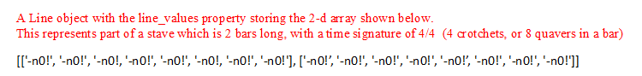

Then all of the properties which will need to store Line objects are updated to store a copy of this blank line. This means that the Line objects constructor only needs to be executed once for each question.

Then the blank line used as part of the LilyPond code is created using the ‘create_lily_line’ method, and is stored as the Instance.l_blank_line property. Then a copy of this property is assigned to every property that will be used to represent a line as part of the LilyPond code. Finally, this method defines the Instance.lily_code property. An example of the string that it could represent, which is output and interpreted by LilyPond is shown below:

global = { \key d \major \time 4/4}

SopranoMusic = {s1 s1 s1 s1}

AltoMusic = {s1 s1 s1 s1}

TenorMusic = {s1 s1 s1 s1}

BassMusic = {s1 s1 s1 s1}

\score {

\new ChoirStaff <<

\new Staff <<

\clef "treble"

\new Voice = "Soprano" { \voiceOne

\global

\SopranoMusic

}

\new Voice = "Alto" { \voiceTwo

\global

\AltoMusic

}

>>

\new Staff <<

\clef "bass"

\new Voice = "Tenor" { \voiceThree

\global

\TenorMusic

}

\new Voice = "Bass" { \voiceFour

\global

\BassMusic

}

>>

>>

}

**This output would produce the following as a PDF:**

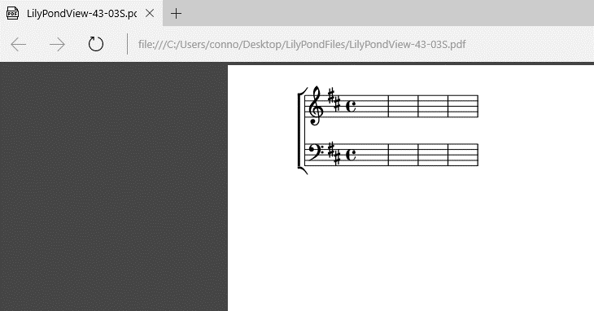

I developed the Instance.lily_code string by reading the LilyPond documentation, which is available online accessed via the following link:

<http://lilypond.org/doc/v2.18/Documentation/learning.pdf>

The Instance.lily_code property shown in the pseudo code will produce a string of the correct format, similar to the boxed text above using the appropriate Stave, Line and Key properties.

**set_bar_quaver_limit()**

This method uses the user’s inputted time signature, to calculate the number of quavers per bar. Understanding the explanation of Time Signatures in my analysis section will help understand why this method works. However, an example is shown below:

**create_lily_line(time_signature, bars)**

The purpose of this method is to return a string which represents a blank line of appropriate length, to be output as part of the LilyPond code, in order to correctly represent the stave to be output on a PDF. Rests are indicated in LilyPond using ‘s’, and the rests need to be set to an appropriate length given the time signature. An example is shown below and the pseudo code is annotated:

**Methods used from Line Class**

**constructor(bars, quavers_remaining)**

When a line object is created, the number of bars and the number of quaver spaces per bar are passed in as parameters. Then Instance.line_values is the array that will become a 2-d array representing the full line. Then the build_line method is called.

**build_line()**

This method is primarily a for loop, which loops around a different number of times, depending on how many bars long the question is going to be. The loop adds the necessary number of quaver spaces (represented byt the string “-n0!”) to the array representing a bar, which is then appended to Instance.line_values. An example of the creation of a line object was shown above, in the create_stave method explanation.

**Methods used from Key Class**

**constructor() and create_key_settings(key_sig)**

The purpose of a Key object is to fully represent the rules of a specific key signature, so that when a user is editing a question, notes that they add are sharpened and flattened appropriately. An example is shown below:

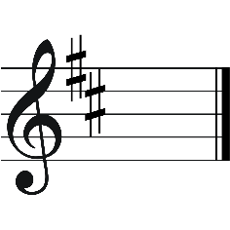The key of D Major has 2 sharps (F# and C#). This means that whenever the notes C or F are placed, they need to be sharpened automatically.

The image on the left shows the key signature of D Major (see analysis section for further explanation.)

The constructor and create_key_settings will both execute as the Stave object is created.

Properties used are initialised by the constructor and then updated using the create_key_settings method.

key_sig is a parameter passed into this method, and to show best how it works, we’ll use what would be passed in for D Major as an example.

‘key_sig’ would be an array: [0, 2, 2]

0 = working in terms of sharps

1 = working in terms of flats

Forms indexing for Instance.notes_sharps_flats which stores every possible note that can be used in a question. The first array is used if working in terms of sharps, and the second if working with flats. Remember bb is the same as c# etc.

Combined with the first integer, gives us the position of the name of the key.

Instance.notes_sharps_flats[0][2]

stores the string ‘dn’, (d natural) for the key of D Major.

Tells us that there are two sharps (in this case not flats) used in this key signature.

The rules of music means that when there are two sharps, they must be F and C.

Instance.sharps stores all of the index positions of notes that could be sharpened in the program:

F (5), C(0), G(7), D(2), A(9)

5 and 0 are therefore appended to the property Instance.to_sharpen for this key signature. If a note in this array is placed by a user, the pitch will be sharpened.

The Pseudo Code for these methods is shown further on in this section.

**Pseudo Code for Methods from the Stave Class**

**METHOD constructor(time_signature, number_of_bars, key_signature, question_id)**

Instance.incomplete_when_evaluated 🡨 0  
Instance.question_id 🡨 question_id  
Instance.student 🡨 ''  
Instance.file_name 🡨 program_file_path + “TeacherSavedQuestions/” + question_id  
Instance.s_position 🡨 [0, 0]  
Instance.a_position 🡨 [0, 0]  
Instance.t_position 🡨 [0, 0]  
Instance.b_position 🡨 [0, 0]  
Instance.operation_stack 🡨 []  
Instance.operation_stack_pointer 🡨 -1  
Instance.time_signature 🡨 time_signature  
Instance.bar_quaver_limit 🡨 0Instance.number_of_bars 🡨 number_of_bars  
Instance.key_signature 🡨 key_signatureprint('Key signature being used: ', Instance.key_signature)  
Instance.blank_line 🡨 NoneInstance.s_line 🡨 None Instance.a_line 🡨 None  
Instance.t_line 🡨 None  
Instance.b_line 🡨 None  
Instance.ros_line 🡨 NoneInstance.roa_line 🡨 None  
Instance.rot_line 🡨 None  
Instance.rob_line 🡨 None  
Instance.creator_line 🡨 None  
Instance.read_only_line 🡨 None  
Instance.l_blank_line 🡨 ""Instance.ls_line 🡨 ""  
Instance.la_line 🡨 ""  
Instance.lt_line 🡨 ""  
Instance.lb_line 🡨 ""  
Instance.lc_line 🡨 ""  
Instance.key_settings 🡨 Key()Instance.feedback_text 🡨 ""  
Instance.lily_code 🡨 ""  
Instance.es_line 🡨 []  
Instance.ea_line 🡨 []  
Instance.et_line 🡨 []  
Instance.eb_line 🡨 []  
Instance.assigned 🡨 0  
Instance.submitted 🡨 0

ENDMETHOD

**METHOD create_stave()**

Instance.key_settings._create_key_settings(Instance.key_signature)  
Instance._set_bar_quaver_limit()  
Instance.blank_line 🡨 Line(Instance.number_of_bars, Instance.bar_quaver_limit)  
Instance.s_line 🡨 Instance.blank_line  
Instance.a_line 🡨 Instance.blank_line  
Instance.t_line 🡨 Instance.blank_line  
Instance.b_line 🡨 Instance.blank_line  
Instance.ros_line 🡨 Instance.blank_line  
Instance.roa_line 🡨 Instance.blank_line  
Instance.rot_line 🡨 Instance.blank_line  
Instance.rob_line 🡨 Instance.blank_line  
Instance.l_blank_line 🡨 Instance.create_lily_line(Instance.time_signature, Instance.number_of_bars)  
Instance.ls_line 🡨 Instance.l_blank_line  
Instance.la_line 🡨 Instance.l_blank_line  
Instance.lt_line 🡨 Instance.l_blank_line  
Instance.lb_line 🡨 Instance.l_blank_line  
Instance.lily_code 🡨 "global = { \key" + " " + Instance.key_settings.lily_key_name + " \\" + Instance.key_settings.tonality + " \\" + "time " + str(Instance.time_signature[0])+ "/" + str(Instance.time_signature[1]) + "}" + "\n \n" + "SopranoMusic = " + "{" + Instance.ls_line + "}" + " \n" + "AltoMusic = " + "{" + Instance.la_line + "}" + " \n" + "TenorMusic = " + "{" + Instance.lt_line + "}" + " \n" + "BassMusic = " + "{" + Instance.lb_line + "}" + " \n \n" + \\score {\n \\new ChoirStaff << \n \\new Staff << \n + " \\clef \"treble\" \n \\new Voice = \"Soprano\" { \\voiceOne \n \\global \n \\SopranoMusic \n }"  
+ " \n \\new Voice = \"Alto\" { \\voiceTwo \n \\global \n \\AltoMusic \n } \n >> \n \\new Staff << \n" + " \\clef \"bass\" \n \\new Voice = \"Tenor\" { \\voiceThree \n \\global \n \\TenorMusic \n }" + " \n \\new Voice = \"Bass\" { \\voiceFour \n \\global \n \\BassMusic \n } \n >> \n >> \n}"

ENDMETHOD

**METHOD set_bar_quaver_limit()**

time_sig_values 🡨 [**None**, 8, 4, **None**, 2, **None**, **None**, **None**, 1]  
Instance.bar_quaver_limit 🡨 time_sig_values.index(Instance.time_signature[1]) * Instance.time_signature[0]

END METHOD

**METHOD create_lily_line(time_signature, bars)**

lily_line 🡨 “”

IF time_signature = [4, 4] THEN

symbol 🡨 “s1”

ELIF time_signature = [3, 4] THEN

symbol 🡨 “s2.”

ELSE

symbol 🡨 “s2”

ENDIF

FOR x in range(bars – 1) DO

lily_line 🡨 lily_line + symbol + “ “

END FOR

lily_line 🡨 lily_line + symbol

RETURN lily_line

ENDMETHOD

**Pseudo Code for Methods from the Line Class**

**METHOD Constructor(bars, quavers_remaining)**

Instance.bars 🡨 bars

Instance.quavers_remaining 🡨 quavers_remaining

Instance.line_values 🡨 []

Instance.build_line()

ENDMETHOD

**METHOD build_line()**

FOR x in range(Instance.bars) DO

bar 🡨 []

FOR y in range(Instance.quavers_remaining) DO

bar.append(“-n0!”)

ENDFOR

Instance.line_values.append(bar)

ENDFOR

ENDMETHOD

**Pseudo Code for Methods from the Key Class**

**METHOD Constructor()**

Instance.key_name 🡨 ""  
Instance.tonality 🡨 ""

Instance.notes_sharps_flats 🡨 [["cn", "c#", "dn", "d#", "en", "fn", "f#", "gn", "g#", "an", "a#", "bn"], ["cn", "db", "dn", "eb", "en", "fn", "gb", "gn", "ab", "an", "bb", "bn"]]  
Instance.raw_scale 🡨 []  
Instance.scale 🡨 []  
Instance.sharps 🡨 [5, 0, 7, 2, 9, 4, 11]  
Instance.flats 🡨 [11, 4, 9, 2, 7, 0, 5]  
Instance.number_of_sharps_flats 🡨 0  
Instance.to_sharpen 🡨 []  
Instance.to_flatten 🡨 []

ENDMETHOD

**METHOD create_key_settings(key_sig)**

Instance.key_name 🡨 Instance.notes_sharps_flats[key_sig[0]][key_sig[1]]  
Instance.lily_key_name 🡨 Instance.notes_sharps_flats[key_sig[0]][key_sig[1]]  
Instance.lily_key_name 🡨 string(Instance.lily_key_name)  
IF Instance.lily_key_name[1] = "b" THEN  
 print('correct path.')  
 Instance.lily_key_name 🡨 Instance.lily_key_name[0] + "es"  
 print(Instance.lily_key_name)  
ELIF Instance.lily_key_name[1] = "#" THEN  
 Instance.lily_key_name 🡨 Instance.lily_key_name[0] + "is"  
 print(Instance.lily_key_name)  
ELSE  
 Instance.lily_key_name 🡨 Instance.lily_key_name[0]  
ENDIF

Instance.tonality 🡨 "major"  
Instance.pointer 🡨 key_sig[1]  
FOR x in range(12) DO  
 Instance.raw_scale.append(Instance.notes_sharps_flats[key_sig[0]][x])  
 Instance.scale.append(Instance.notes_sharps_flats[key_sig[0]][(key_sig[1] + x) % 12])

ENDFOR  
Instance.scale.append("-n")  
Instance.number_of_sharps_flats 🡨 key_sig[2]  
IF key_sig[0] = 0 THEN  
 FOR x in range(Instance.number_of_sharps_flats) DO  
 Instance.to_sharpen.append(Instance.sharps[x])

ENDFOR  
ELSE  
 FOR x in range(Instance.number_of_sharps_flats) DO  
 Instance.to_flatten.append(Instance.flats[x])

ENDFOR

ENDIF

ENDMETHOD

Another method worth mentioning is a method in the Stave class, named lily_pond_display() which is responsible for actually producing and opening the LilyPond PDF for the user to view. This method ensures that:

1. The PDF is only stored whilst it is being viewed – as soon as the PDF is closed it is deleted – storing it would unnecessarily waste space.
2. Multiple PDFs for the same question can be opened at the same time so a user can view the question at different stages of editing. This is done by using the question name, along with a unique time stamp as the PDF’s name.
3. If the question has been submitted and Feedback given by the system, this feedback is outputted for the user to read.

**Annotated Pseudo Code for this method**

Updates string to be interpreted by LilyPond, incase user has updated question since last viewing.

**METHOD lily_pond_display()**

Instance.lily_code 🡨 "global = { \key" + " " + Instance.key_settings.lily_key_name + " \\" + Instance.key_settings.tonality + " \\" + "time " + str(Instance.time_signature[0])+ "/" + str(Instance.time_signature[1]) + "}" + "\n \n" + "SopranoMusic = " + "{" + Instance.ls_line + "}" + " \n" + "AltoMusic = " + "{" + Instance.la_line + "}" + " \n" + "TenorMusic = " + "{" + Instance.lt_line + "}" + " \n" + "BassMusic = " + "{" + Instance.lb_line + "}" + " \n \n" + \\score {\n \\new ChoirStaff << \n \\new Staff << \n + " \\clef \"treble\" \n \\new Voice = \"Soprano\" { \\voiceOne \n \\global \n \\SopranoMusic \n }"  
+ " \n \\new Voice = \"Alto\" { \\voiceTwo \n \\global \n \\AltoMusic \n } \n >> \n \\new Staff << \n" + " \\clef \"bass\" \n \\new Voice = \"Tenor\" { \\voiceThree \n \\global \n \\TenorMusic \n }" + " \n \\new Voice = \"Bass\" { \\voiceFour \n \\global \n \\BassMusic \n } \n >> \n >> \n}"

file_front 🡨 'C:/Users/conno/Desktop/LilyPondFiles/LilyPondView-%s'%datetime.datetime.now().strftime('%S-%MS') **THIS PATH NEEDS CHANGING AND DESIGN FILE STRUCTURE THEN UPDATED – ESPECIALLY FOR TECHNICAL SOLUTION EXPLAINING HOW TO RUN THE CODE**  
file_name 🡨 file_front + '.ly'  
pdf_name 🡨 file_front + '.pdf'  
log_name 🡨 file_front + '.log'  
file 🡨 open(file_name, 'w')  
file.write(Instance.lily_code)  
file.close()  
os.system(file_name)  
os.system(pdf_name)  
time.sleep(5)  
os.remove(file_name)  
os.remove(pdf_name)  
os.remove(log_name)  
IF Instance.submitted = 1 THEN

LilyPond creates a log when it interprets a string. This will show if there were any errors when interpreting the string - useful for reporting any errors if a user has a problem using the program. Especially if new features are added in the future which may cause errors.

Pauses program for 5 seconds, allowing PDF to load, before removing all the files used to create it.

Timestamp ensures the file name is unique. A very tiny chance of error – a try except block could be used to deal with any exception which may arise in this method.

OUTPUT “===============================================================\n”  
 “ FEEDBACK FOR QUESTION \n”  
 “===============================================================\n”  
OUTPUT(Instance.feedback_text)  
OUTPUT "=================================================================\n”

ENDIF

ENDMETHOD

1. **The Evaluation of an Answer**

Now that I have properly designed my data structures the evaluation will use lots of validation statements to determine a student’s score, given what their ADT’s look like.

I will have the program convert the notes in each ADT into integers – combinations of integers can then be evaluated to determine Chords using a dictionary as shown below:

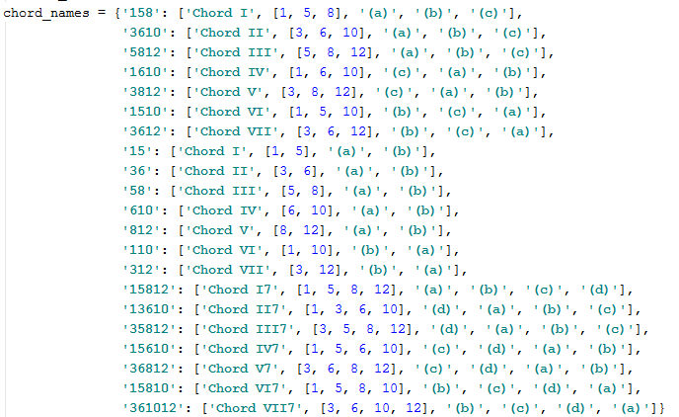

Then the sequences of numbers can also be evaluated to determine whether or not the answer has followed all of the appropriate rules that it needs to.

I will use the pre-existing merge sort algorithm to sort each of my chords (written as numbers) into the correct order to be identified by the dictionary above.

### **UML Class Diagram**

For the purposes of displaying a diagram effectively in this document, I have provided a basic diagram which shows the structure of the Classes and how they fit together, and then in my technical solution I have annotated each Class appropriately to explain what properties and methods are used.

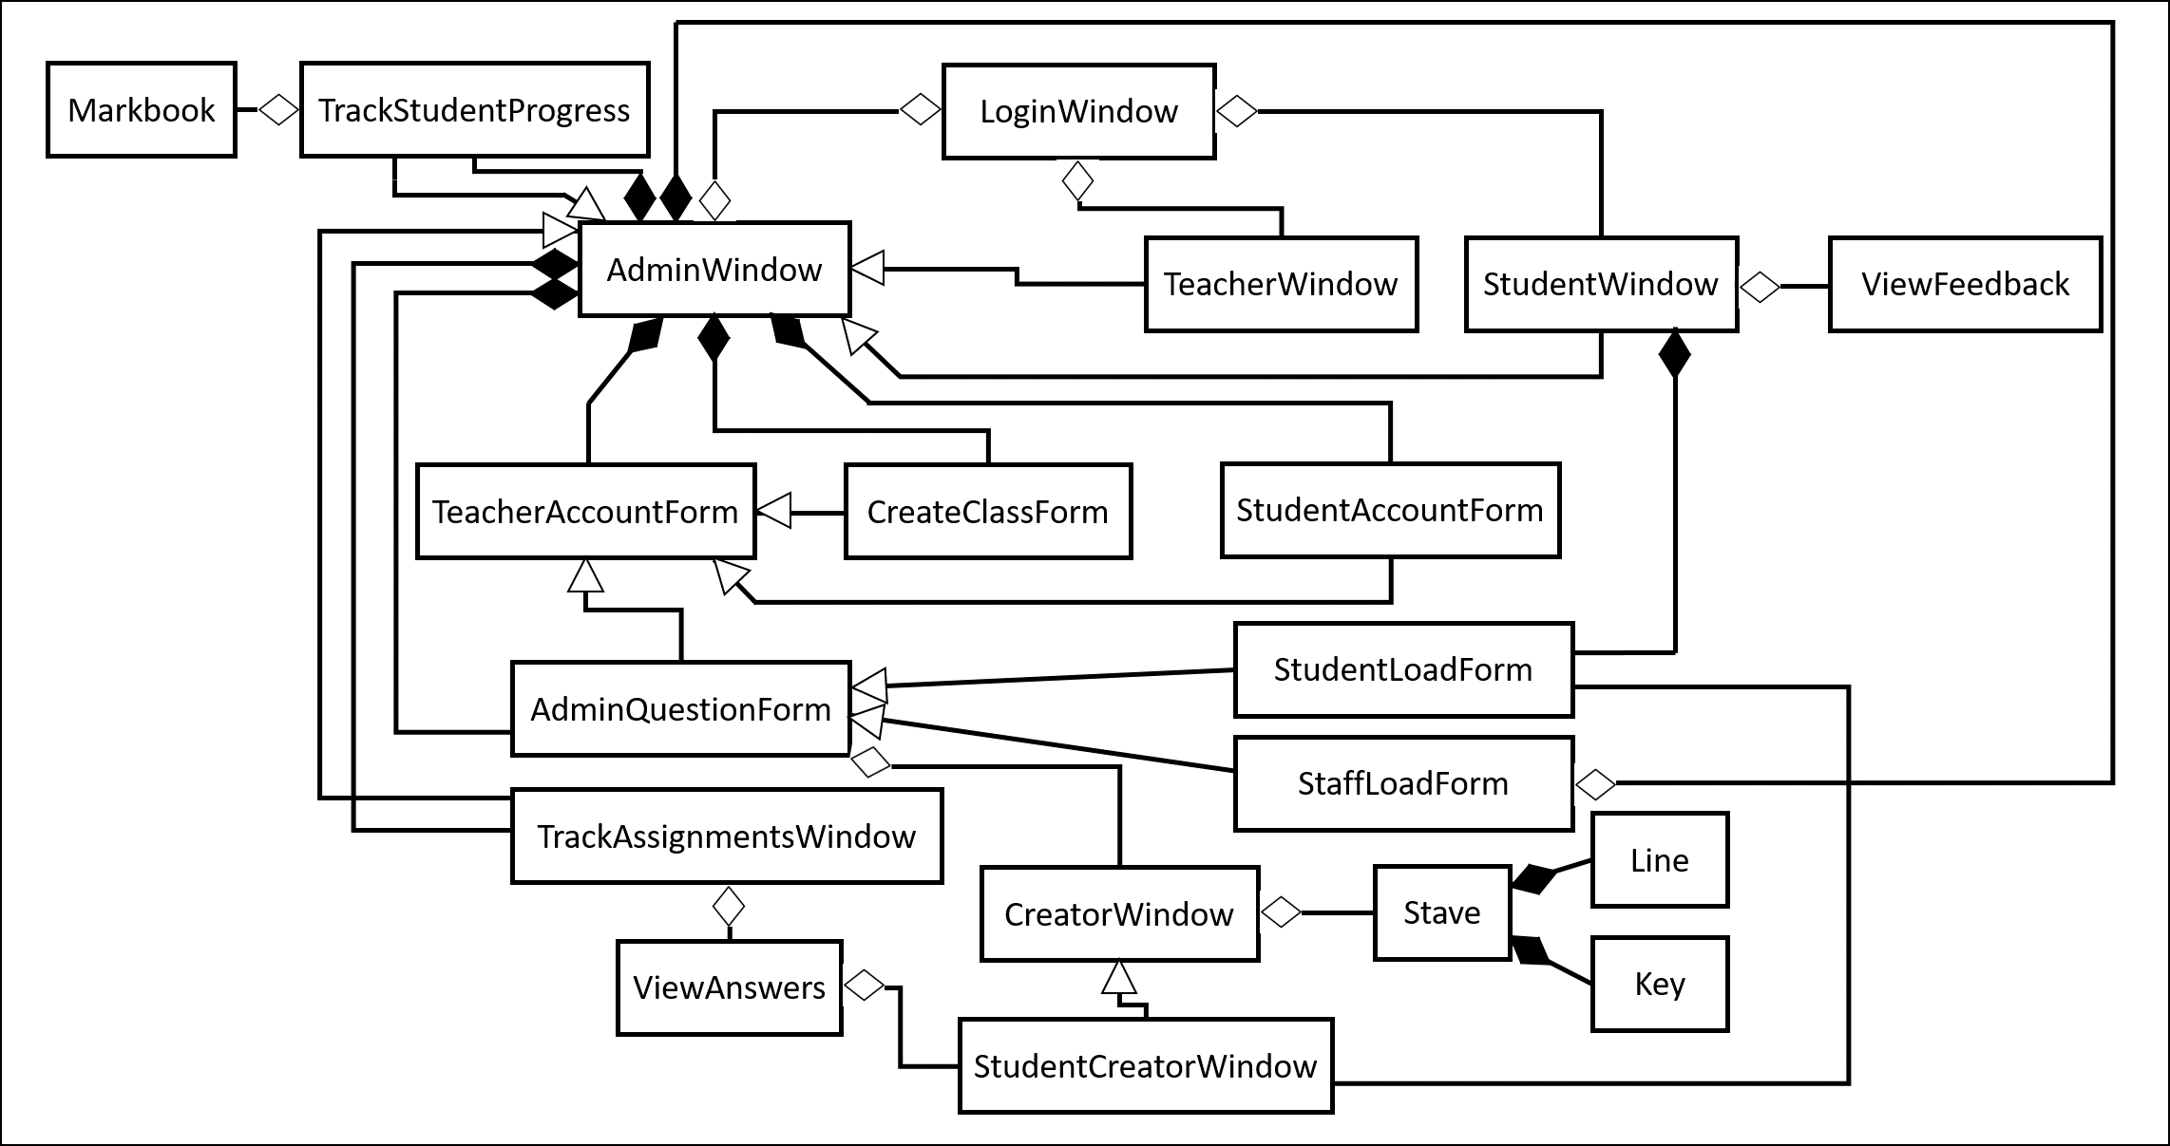

### **Test Plan**

The test plan below shows just a selection of the vast number of tests that I carried out. In my testing section I have shown evidence of tests that I feel are most important to document, including all those tests that gave an unexpected output. Extreme testing for this program was not appropriate in most cases, as the interface is what mainly controls the user input – they only have a finite number of options to choose from.

|  |  |  |  |  |  |
| --- | --- | --- | --- | --- | --- |
| **Test No.** | **Objective** | **Test Description** | **Test Type** | **Test Data/Actions** | **Expected Output** |
| **1** | 1 | A user can login using the admin account. | Normal | “admin”  “default” | Admin Window will display. |
| **2** | 1 | User is not logged in given incorrect username. | Erroneous | “Administrator”  “URJJSNG5738” | “Username not valid. Try again.” |
| **3** | 1 | User is not logged in given incorrect password. | Erroneous | “admin”  “!?*hhh123” | “Invalid password. Try again.” |
| **4** | 3a | Checks an administrator can create a teacher account with admin status given valid input of data. | Normal | “[rbu@uvhs.uk](mailto:rbu@uvhs.uk)”  “RichardButler1”  “Richard”  “Butler” | Window should close and Teacher record should have been inserted into database. Richard Butler should be able to log on with credentials, loading Admin functions. |
| **5** | 3b | Administrator creating a teacher account without admin status only allows them to access certain program functions. | Normal | “[jev@uvhs.uk](mailto:jev@uvhs.uk)”  “JohnEvason1?!”  “John”  “Evason” | Window should close and Teacher record should have been inserted into database. John Evason should be able to log on with credentials, loading Teacher Functions. |
| **6** | 3a | Administrator creating a class and assigning it to a teacher, given correct Class ID input. | Normal | “13A” | Window should close and Class record should have been inserted into database. |
| **7** | 3c | Administrator creating a student account only allows them to access student program functions. | Normal | “[10cw8777@pupil.uvhs.org.uk](mailto:10cw8777@pupil.uvhs.org.uk)”  “ConnorWood1”  “Connor”  “Wood” | Window should close and Student record should be inserted into database. Student should be able to log on with credentials, loading the student functions. |
| **8** | 4 | Creating a Teacher/Admin account with an invalid email address. | Erroneous | “qwerty!@?uvhs.uk”  “RichardButler455”  “Richard”  “Butler” | “Username must take the form ‘abc@uvhs.uk”  Window stays and database not updated. |
| **9** | 4 | Creating an account with an invalid password. | Erroneous | “[jcl@uvhs.uk](mailto:jcl@uvhs.uk)”  “12345a!!”  “Jo”  “Clapham” | “Password must contain 1 Uppercase, 1 Lowercase, 1 number and be at least 8 characters in length”  Window stays open, database does not update. |
| **10** | 4 | Creating a Teacher/Admin account with an invalid email address. | Extreme  (integers instead of a-z characters) | [456@uvhs.uk](mailto:riiiruf@uvhs.co.uk)  “RichardButler455”  “Richard”  “Butler” | “Username must take the form ‘abc@uvhs.uk”  Window stays and database not updated. |
| **11** | 4 | Creating a Teacher/Admin account with a valid password. | Extreme  (in terms of password length) | “[jcl@uvhs.uk](mailto:jcl@uvhs.uk)”  “Joanne22”  “Jo”  “Clapham” | Window closes.  Database updated so that Jo Clapham can log in using credentials. |
| **12** | 4 | Creating Student account with invalid school email address. | Erroneous | “[45connorwood!!@gmail.com](mailto:45connorwood!!@gmail.com)”  “ConnorWood1”  “Connor”  “Wood” | “Username not in the valid form: [12ab3456@pupil.uvhs.org.uk](mailto:12ab3456@pupil.uvhs.org.uk)”  Window stays open and database does not update. |
| **13** | 4 | Creating Student account with invalid school email address. | Extreme  (in terms of year group) | “09cw8777@pupil.uvhs.org.uk”  “ConnorWood1”  “Connor”  “Wood” | “Username not in the valid form: [12ab3456@pupil.uvhs.org.uk](mailto:12ab3456@pupil.uvhs.org.uk)”  Window stays open and database does not update. |
| **14** | 4 | Creating Student account with valid school email address. | Extreme  (in terms of year group) | “12dp4459@pupil.uvhs.org.uk”  “DylanPhelps1”  “Dylan”  “Phelps” | Window closes.  Database updates.  Dylan Phelps can log in using credentials. |
| **15** | 4 | Attempting to create a Teacher which already exists. | Erroneous | [rbu@uvhs.uk](mailto:rbu@uvhs.uk) (already in database)  “RichardTrumpet1”  “Richard”  “Butler” | “Teacher already has an account”  Window shouldn’t close.  Database not updated. |
| **16** | 4 | Attempting to create a Student which already exists. | Erroneous | [10cw8777@pupil.uvhs.uk](mailto:10cw8777@pupil.uvhs.uk) (already in database)  “ConnorWood1”  “Connor”  “Wood” | “Student account already exists.”  Window doesn’t close.  Database not updated. |
| **17** | 3a/b | Attempting to create a Class which already exists. | Erroneous | “13A” | “Class already exists”  Window doesn’t close.  Database not updated. |
| **18** | 3a/b | Creating a class with incorrect ID | Erroneous | “MrButler14C” | “Class ID must be in the form 12A – for Year 12, Option A”  Window doesn’t close.  Database not updated. |
| **19** | 3a/b | Creating a Class when there are no teachers to assign them to. | Erroneous | Pressing Create Class button. | “No teachers to assign classes to. Create Staff account first.” |
| **20** | 3a/b | Creating students when there are no classes to assign them to. | Erroneous | Pressing Create Student Account button. | “No classes to assign students to. Create a class first.” |
| **21** | 7/8/9 | Loading Question when there are no questions to load. | Erroneous | Pressing Load Question Button | “No questions to Load. Create a question first.” |
| **22** | 3a/b/c/4/5 | Ensuring that multiple teacher accounts and classes and students can be created, and that students can be assigned to any class and classes to any teacher. | Normal | I will add multiple classes and students and teachers and provide screenshots of the database. Using the system generally will act as this test. | Database updates correctly. |
| **23** | 6 | Teacher creating a question given valid input. | Normal | Create Question Button Clicked  “Test23”  “4” | Window should close and editor should open.  Database updates. |
| **24** | 6 | Teacher trying to create a question with a name that already exists. | Erroneous | “Test23”  “4” | “Question with this name already exists.” |
| **25** | 6 | Teacher creating a question with an invalid question name. | Erroneous | “Test 25 !”  “4” | “Invalid file name. Only use letters and numbers. 0 not allowed and must be one character long and maximum of 20.” |
| **26** | 6b/d | Question with time signature 2/4 and key signature A Major. | Normal | “Test26”  “4” | Window closes.  Editor opens.  A LilyPond PDF can be viewed showing that Time and Key signatures have been set correctly. |
| **27** | 6b/d | Question with time signature 3/4 and key signature B Major. | Extreme  (5 sharps) | “Test27”  “4” | Window closes.  Editor opens.  A LilyPond PDF can be viewed showing that Time and Key signatures have been set correctly. |
| **28** | 6b/d | Question with time signature 4/4 and key signature Gb Major | Extreme  (6 flats) | “Test28”  “4” | Window closes.  Editor opens.  A LilyPond PDF can be viewed showing that Time and Key signatures have been set correctly. |
| **29** | 6c | Creating a question that is 20 bars long. | Extreme  (max number of bars) | “Test29”  “20” | Window closes.  Editor opens.  A LilyPond PDF can be viewed showing that the question is 20 bars long. |
| **30** | 6c | Creating a question that is 100000 bars long. | Erroneous | “Test30”  “100000” | “Questions have a 20 bar limit. Re adjust and try again.” |
| **31** | 6c | Creating a question with mistake in No. of Bars input. | Erroneous | “Test31”  “!(D(D” | NEED TO FIX THIS ONE USING A TRY EXCEPT BLOCK.  “Error – check input. Try again.” |
| **32** | 6a/b/d/g/h | Question time signature 4/4 and key signature C major. Placing notes of various pitches and lengths to test robustness of editor and check it meets objective requirements. | Normal | “Test32”  “42  Then using editor, added the following:  Sop – Semibreve, Minim, Crotchet, Crotchet, Dotted Minim  Alt – Dotted Crotchet, 5 quavers/dottedquavers  Bass – Dotted Semibreve | The ADTs representing the four lines will be outputted, showing all of these notes displayed correctly. |
| **33** | 6e | Adding notes that are too long for a bar in the question – ensuring they are carried over, as if they were tied. | Erroneous | Setting the time signature to 4/4  Then adding 3 crotchets, followed by a minim. | Output of ADT will show that the minim is placed between two bars and has carried over. |
| **34** | 6e | Adding note too long to be placed on the stave because there isn’t enough space. | Erroneous | Setting time signature to 4/4  2 bars in length  Adding 7 crotchets followed by an attempt to add a dotted minim. | “Note too long to place here”.  “Error: Note not placed.” |
| **35** | 6f | Adding all notes of the scale to a question in D major. | Normal | Adding all notes to a question. | ADT output will show that fn and cn notes have been sharpened. |
| **36** | 6f | Adding all notes of the scale to a question in Ab major. | Normal | Adding all notes to a question. | ADT output will show that bn , en, an, and dn notes have been flattened. |
| **37** | 7 | Checking that questions have been saved and can be re loaded (using a list which shows the teacher the difficulty rating of each question) to continue working on by a teacher. | Normal | Pressing Load Question  Then loading “Test 26”  Add notes to the question. | Pressing Load Question should provide a list of questions created so far to be able to load.  Adding notes to the question once loaded should not cause an error. |
| **38** | 22 | Pressing the ‘View Score’ button multiple times. | Normal | Pressing the ‘View Score’ button 4 times whilst editing a question. | No error should be caused. 4 PDFs should open. |
| **39** | 6i | Assigning a blank question to a class. | Normal | “Test39”  “4”  Pressing Assign button in editor | “Cannot assign blank question.”  “Question not assigned.” |
| **40** | 6i | Assigning a 2 note question to a class. | Erroneous | “TestNumber40”  “4”  2 crotchets added. Assign button pressed. | “Question cannot be assigned. Must finish on the beat and allow for at least 3 chords.” |
| **41** | 10 | Assigning a 3 note question to a class. | Normal | “TestNo41”  “2”  3 notes added finishing on the beat. | “Question now Read Only – students cannot edit question.  Question saved”  Question files will also be saved in students directories. |
| **42** | 6i | Assigning a 4 note question finishing off beat. | Extreme | “Test42”  “2”  Then Crotchet, Crotchet, Quaver, Quaver inputted. | “Question cannot be assigned. Must finish on the beat and allow for at least 3 chords.” |
| **43** | 6i | Assigning a question with no soprano line, but valid alto, tenor and bass lines. | Erroneous | “Test43”  “4”  3 crotchets added to Alto line, Tenor line and Bass line. | “Cannot assign blank question.” (because teacher has to set soprano line)  “Question not assigned” |
| **44** | 10 | Assigning the same question to multiple classes. | Erroneous | Load “Test36” and Assign to classes 13A and 11D | Database should update accordingly with no errors.  “Question now Read Only – students cannot edit question.  Question saved” |
| **45** | 11 | Checking that teachers can track all of these assignments. | Erroneous | (I changed the dateAssigned for two of the questions in the database see if they are organised by date)  Clicking Track Assignments | Assignments should be listed, organised by date, with the most recent assignments at the top. |
| **46** | 13 | Assigning a question to the same class with no new students. | Normal | Assign “Test36” to 13A again. | “Question now Read Only – students cannot change the question.”  “Question saved.”  “Already assigned to this class”  User asked if they want to continue by pressing 1. If they press 1 then the question is assigned to any new pupils in the class, and usernames any who it has already been assigned to are printed out. |
| **47** | 13 | Assigning a question to the same class with 2 new students. | Normal | Add Student 15 and Student 16 to class 13A and assign again. | “Question now Read Only – students cannot change the question.”  “Question saved.”  “Already assigned to this class”  User asked if they want to continue by pressing 1. If they press 1 then the question is assigned to any new pupils in the class, and usernames any who it has already been assigned to are printed out. |
| **48** | 14 | Checking a student can successfully load a question they have been assigned. | Normal | Log in as Student 7  Click Complete Question  Load TestNo41 | List of questions assigned to Student 7 should display correctly and he should be able to load TestNo41 without error.  (They should get the same window to work with as a teacher, but without the assign functionality.(All assignment files should be saved in their own personal directory) |
| **49** | 17 | Checking that a student cannot delete sections of the question set by the teacher. | Extreme due to testing of indexing. | New question created with notes added to all four lines.  Assigned to 13A  Student 15 loads and tries to remove nots in Alto line. | “Note here is part of the question and cannot be changed.  Error: Note not removed” |
| **50** | 15/6 | Testing the remove note button by removing a note already placed. | Normal | Place 2 notes.  Remove 2 notes. | ADT with two notes added and then two notes removed outputted. |
| **51** | 15/6 | Attempting to remove a note from an empty line. | Normal | Richard Butler creates new question.  Presses Remove button before adding any notes. | “Nothing to remove.” |
| **52** | 16/6 | Pressing the undo button 4 times after 3 operations have been carried out on a loaded question. | Erroneous | Add note. Add note. Remove note.  Press undo button 4 times. | Removed note should be added. Added note removed. Added note removed.  “Nothing to undo” |
| **53** | 6/18 | A teacher attempting to edit an assigned question. | Erroneous | Jo Clapham tries to add and remove notes from “TestingNumber49” | “Question has been assigned and so cannot be edited” |
| **54** | 6/18 | Teacher assigning a full question (with no bonus opportunity) and Student giving an answer which scores 11. (parallel 5ths inputted by teacher initially to test final evaluation) | Extreme  (7th will be prepared using the same note rather than note above) | Question “Test54NoBonusCadence” assigned to 13A  Connor Wood gives an answer which is all correct (apart from the teachers mistake - so score should be 11) | Appropriate feedback outputted with a score of 11. |
| **55** | 18 | Another student giving an answer containing an incorrect chord. | Normal | Student 2 gives an answer with an incorrect chord in it. | Appropriate feedback outputted with a score of 9. |
| **56** | 18 | Another student giving an answer with an incorrect chord and an unprepared 7th. Also 2 sets of parallel 5ths and one set of parallel octaves. | Extreme (checking multiple parallel 5ths and octaves in a question are handled properly) | Student 20 gives an answer with Parallel 5ths, Octaves and unprepared 7th. | Appropriate feedback outputted with a score of 6. |
| **57** | 21 | Student tracking their progress before they have completed any questions. | Erroneous | Clicking “View Scores & Feedback” | Blank Table opens.  Now fixed. |

# Technical Solution

### **How To Run The Program**

In order to actually run my program, all you need to do is have the LilyPond software installed, which can be found using this link: <http://lilypond.org/download.html> , and then you just need to have the ‘BachChoraleEvaluator’ folder stored on your computer (or shared storage space when staff and students will be accessing it). You also need to go into the main python file and change the global variable at the top named ‘program_file_path’. So for example, the folder stored on my system is shown below:

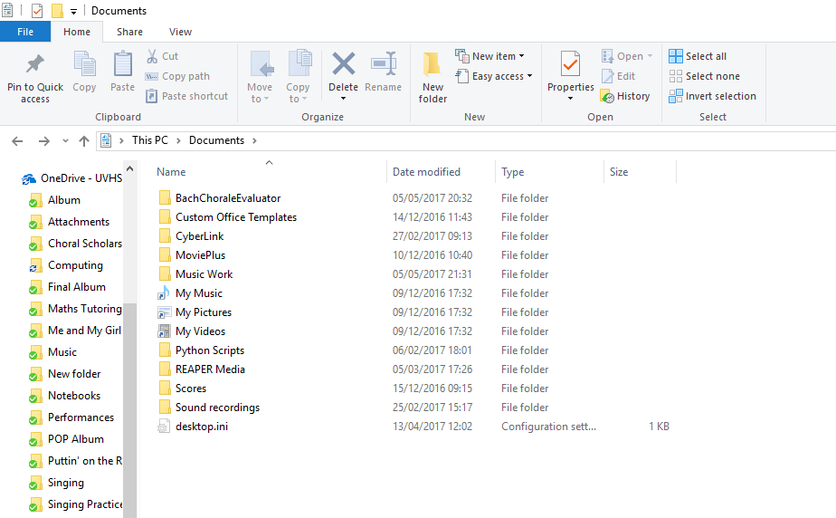

So the program is saved in Documents – the file path is therefore: ‘C:\Users\conno\Documents\BachChoraleEvaluator’. So I would need to open up the main python file inside the folder called ‘BachChoraleEvaluator.py’:

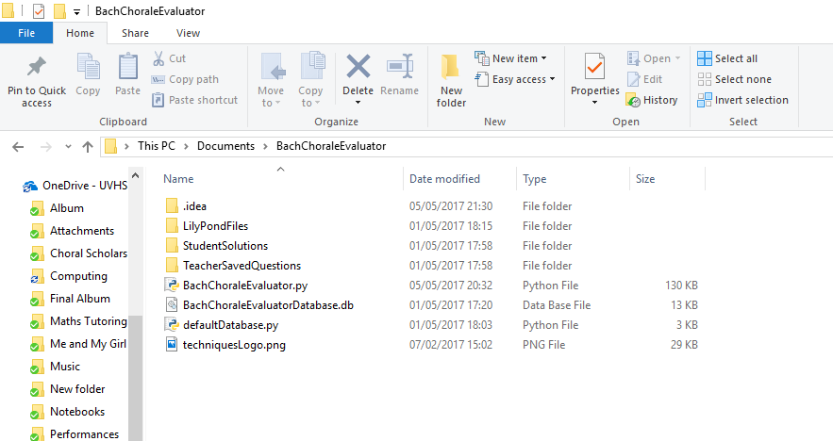

Then I would need to change the global variable to ‘C:/Users/conno/Documents/BachChoraleEvaluator/’ – note that I’ve used forward slashes in Python, and used a forward slash at the end for the correct formatting for use in the program.

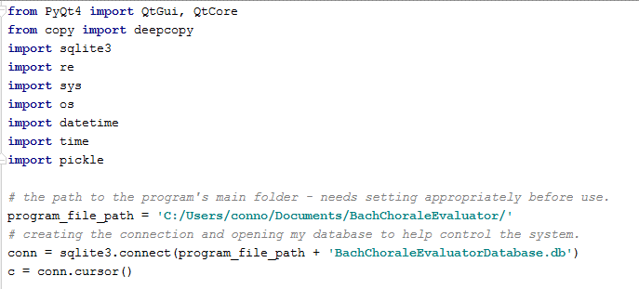

If you would like to reset the program and set the database back to default settings with only the admin account (username: admin , password: default) on the system then simply run the file inside the folder called ‘defaultDatabase.py’.

However, I have logged into the system and created 3 teacher accounts and 5 student accounts (two assigned to a class assigned to each teacher). I have also added some example assignments and student solutions for you to use to explore the program. The details of the user accounts are shown below:

**Student Accounts:**

username: [10cw8777@pupil.uvhs.org.uk](mailto:10cw8777@pupil.uvhs.org.uk)

password: ConnorWood1

username: [10dp6775@pupil.uvhs.org.uk](mailto:10dp6775@pupil.uvhs.org.uk)

password: DylanPhelps1

username: [10js8888@pupil.uvhs.org.uk](mailto:10js8888@pupil.uvhs.org.uk)

password: JaimieSouthern1

username: [10es7254@pupil.uvhs.org.uk](mailto:10es7254@pupil.uvhs.org.uk)

password: EthanSilcox1

username: [10cm8923@pupil.uvhs.org.uk](mailto:10cm8923@pupil.uvhs.org.uk)

password: CharlieMoore1

**Teacher Accounts:**

**With Admin Status:**

username: [rbu@uvhs.uk](mailto:rbu@uvhs.uk)

password: RichardButler1

**Without Admin Status:**

username: [jev@uvhs.uk](mailto:jev@uvhs.uk)

password: JohnEvason1

username: [jcl@uvhs.uk](mailto:jcl@uvhs.uk)

password: JoClapham1

Richard Butler has class 13A, with students Connor Wood and Dylan Phelps assigned to that class.

John Evason has class 12A, with students Jaimie Southern and Ethan Silcox assigned to that class.

Jo Clapham has class 12B, with student Charlie Moore assigned to that class.

These are only initial settings, so obviously as part of the program, teachers, classes and students can be added.

Class 13A and 12B have been Assigned Question1

Connor Wood has answered question 1, achieving a score of: 10

Jaimie Southern has answered question 1, achieving a score of:

**Default Admin Account**

username: admin

password: default

### **Annotation**

I have used docstrings to annotate each of my classes, explaining what the properties and methods in the code do. This is to replace what would have been an extremely complex full Class Diagram which would be too complex to put in this document. An overall Class Diagram showing the structure can be found on page () in the design section. At times it is also necessary to refer to the Documented Design section in order to read explanations of more complex parts of the code or difficult to understand data structures – I have indicated in my docstrings where this is necessary.

### **Technical Solution – The Code**

**defaultDatabase.py**

**import** sqlite3  
  
program_file_path = **'C:/Users/conno/Documents/BachChoraleEvaluator/'**conn = sqlite3.connect(program_file_path + **'BachChoraleEvaluatorDatabase.db'**)  
curs = conn.cursor()  
curs.execute(**"CREATE TABLE Teacher (teacherID varchar(11) primary key,"  
 " firstName varchar(20),"  
 " surname varchar(20),"  
 " password varchar(20),"  
 " admin int"  
 " );"**)  
curs.execute(**"CREATE TABLE Class (classID varchar(3) primary key,"  
 " teacher int,"  
 " FOREIGN KEY(teacher) REFERENCES Teacher(teacherID)"  
 " );"**)  
curs.execute(**"CREATE TABLE Student (studentID varchar(26) primary key,"  
 " class int,"  
 " firstName varchar(10),"  
 " surname varchar(20),"  
 " password varchar(20),"  
 " FOREIGN KEY(class) REFERENCES Class(classID)"  
 " );"**)  
curs.execute(**"CREATE TABLE Question (questionID varchar(11),"  
 " creator int,"  
 " class int,"  
 " dateAssigned datetime,"  
 " assignedBy varchar(11),"  
 " difficulty int,"  
 " PRIMARY KEY (questionID, class)"  
 " FOREIGN KEY(creator) REFERENCES Teacher(teacherID),"  
 " FOREIGN KEY(class) REFERENCES Class(classID)"  
 " );"**)  
curs.execute(**"CREATE TABLE Solution (question varchar(20),"  
 " student varchar(26),"  
 " score int,"  
 " date date,"  
 " PRIMARY KEY (question, student)"  
 " FOREIGN KEY(student) REFERENCES Student(studentID)"  
 " FOREIGN KEY(question) REFERENCES Question(questionID)"  
 " );"**)  
curs.execute(**''' INSERT INTO Teacher(teacherID, firstName, surname, password, admin)  
 VALUES("admin", "Admin", "Account", "default", 1);'''**)  
  
conn.commit()  
conn.close()

**BachChoraleEvaluator.py**

**from** PyQt4 **import** QtGui, QtCore  
**from** copy **import** deepcopy  
**import** sqlite3  
**import** re  
**import** sys  
**import** os  
**import** datetime  
**import** time  
**import** pickle  
  
*# the path to the program's main folder - needs setting appropriately before use.*program_file_path = **'C:/Users/conno/Documents/BachChoraleEvaluator/'***# creating the connection and opening my database to help control the system.*conn = sqlite3.connect(program_file_path + **'BachChoraleEvaluatorDatabase.db'**)  
c = conn.cursor()  
  
  
**class** LoginWindow(QtGui.QMainWindow):  
 *"""  
 The window allows the user to log into the system.  
  
 Properties:  
 Instance.window - initialised to None, ready to store the object of the next class to be instantiated to open a window  
 Instance.username - string ready to store user's input of username  
 Instance.password - string ready to store user's input of password  
 Instance.userType - string will be set according to what kind of user logged in  
 Instance.username_lne - part of the interface (QLineEdit for user to input username)  
 Instance.password_lne - part of the interface (QLineEdit for user to input password)  
  
 Methods:  
 build_login_window - adds the components to the login window ready to display for the user.  
 attempt_login - compares user's input of username and password to database and either allows  
 or denies access to the rest of the program.  
 run_student_window - instantiates () object for student.  
 run_teacher_window - instantiates () object for teacher.  
 run_admin_window - instantiates () object for teacher."""* **def** __init__(self):  
 super(LoginWindow, self).__init__()  
 self.window = **None** self.username = **""** self.password = **""** self.userType = **""** self.setGeometry(450, 100, 500, 500)  
 self.setWindowTitle(**"Bach Chorale Evaluator - Login"**)  
 self.setWindowIcon(QtGui.QIcon(program_file_path + **'techniquesLogo.png'**))  
 self.build_login_window()  
 self.show()  
  
 **def** build_login_window(self):  
 quit_btn = QtGui.QPushButton(**"Quit"**, self)  
 quit_btn.clicked.connect(QtCore.QCoreApplication.instance().quit)  
 quit_btn.resize(100, 25)  
 quit_btn.move(140, 450)  
 login_btn = QtGui.QPushButton(**"Login"**, self)  
 login_btn.clicked.connect(self.attempt_login)  
 login_btn.resize(100, 25)  
 login_btn.move(250, 450)  
 self.username_lne = QtGui.QLineEdit(**""**, self)  
 self.password_lne = QtGui.QLineEdit(**""**, self)  
 self.username_lne.resize(250, 25)  
 self.username_lne.move(120, 200)  
 self.password_lne.resize(250, 25)  
 self.password_lne.move(120, 230)  
 self.password_lne.setEchoMode(2)  
 username_lbl = QtGui.QLabel(**"Username: "**, self)  
 username_lbl.move(50, 197)  
 password_lbl = QtGui.QLabel(**"Password: "**, self)  
 password_lbl.move(50, 227)  
  
 **def** attempt_login(self):  
 self.username = self.username_lne.text()  
 self.password = self.password_lne.text()  
 c.execute(**'''SELECT teacherID  
 FROM Teacher  
 '''**)  
 user_names = c.fetchall()  
 teachers = [x[0] **for** x **in** user_names]  
 c.execute(**'''SELECT studentID  
 FROM Student  
 '''**)  
 user_names = c.fetchall()  
 students = [x[0] **for** x **in** user_names]  
 **if** self.username **in** teachers:  
 self.userType = **"Staff"** c.execute(**''' SELECT password  
 FROM Teacher  
 WHERE teacherID = ?'''**, (self.username,))  
 valid_password = c.fetchone()  
 valid_password = valid_password[0]  
 **elif** self.username **in** students:  
 self.userType = **"Student"** c.execute(**''' SELECT password  
 FROM Student  
 WHERE studentID = ?'''**, (self.username,))  
 valid_password = c.fetchone()  
 valid_password = valid_password[0]  
 **else**:  
 print(**"Username not valid. Try again."**)  
 **return  
 if** self.password == valid_password:  
 self.close()  
 **if** self.userType == **"Student"**:  
 self.run_student_window()  
 **else**:  
 c.execute(**'''SELECT admin  
 FROM Teacher  
 WHERE teacherID = ?'''**, (self.username,))  
 admin_status = c.fetchone()  
 admin_status = admin_status[0]  
 **if** admin_status == 0:  
 self.run_teacher_window()  
 self.userType = **"Teacher"  
 else**:  
 self.run_admin_window()  
 self.userType = **"Admin"  
 else**:  
 print(**"Invalid password. Try again."**)  
  
 **def** run_student_window(self):  
 self.window = StudentWindow(self.username)  
  
 **def** run_teacher_window(self):  
 self.window = TeacherWindow(self.username)  
  
 **def** run_admin_window(self):  
 self.window = AdminWindow(self.username)  
  
  
**class** AdminWindow(QtGui.QMainWindow):  
  
 *"""  
 The window displays buttons for all of the features of the program that an administrator may wish to use,  
 including Creating a Question, tracking their assignments, Tracking Student's progress.  
  
 Properties:  
 Instance.window - initialised to None, ready to store the object of the next class to be instantiated to open a window  
 Instance.username - stores the username of the person who logged in.  
 Instance.layout - used to store the main layout for the PyQt window.  
  
  
 Methods:  
 build_window - adds the components to the window ready to display for the user.  
 rebuild_login_window - instantiates another LoginWindow object if the user has decided to sing out.  
 Also closes any windows associated with that user having been logged in.  
 create_staff_account - instantiates a TeacherAccountForm window object.  
 create_class - instantiates a CreateClassForm window object.  
 create_student_account - instantiates a StudentAccountForm window object.  
 track_assignments - instantiates a TrackAssignments window object.  
 track_student_progress - instantiates a TrackStudentProgress window object.  
 load_question - instantiates a StaffLoadForm window object.  
 create_question - instantiates a AdminQuestionForm window object."""* **def** __init__(self, current_username):  
 super(AdminWindow, self).__init__()  
 self.window = **None** self.username = current_username  
 self.setGeometry(450, 100, 700, 500)  
 self.layout = QtGui.QVBoxLayout()  
 self.setLayout(self.layout)  
 self.setWindowIcon(QtGui.QIcon(program_file_path + **'techniquesLogo.png'**))  
 self.central_widget = QtGui.QWidget()  
 self.setCentralWidget(self.central_widget)  
 self.central_widget.setLayout(self.layout)  
 self.build_window()  
  
 **def** build_window(self):  
 title = **"Bach Chorale Evaluator - Admin - "** + self.username  
 self.setWindowTitle(title)  
 create_btn = QtGui.QPushButton(**"Create Question"**, self)  
 create_btn.clicked.connect(self.create_question)  
 self.layout.addWidget(create_btn)  
 load_btn = QtGui.QPushButton(**"Load Question"**, self)  
 load_btn.clicked.connect(self.load_question)  
 track_assignments_btn = QtGui.QPushButton(**"Track Assignments"**, self)  
 track_assignments_btn.clicked.connect(self.track_assignments)  
 self.layout.addWidget(track_assignments_btn)  
 track_students_btn = QtGui.QPushButton(**"Track Student Progress"**, self)  
 track_students_btn.clicked.connect(self.track_student_progress)  
 self.layout.addWidget(track_students_btn)  
 self.layout.addWidget(load_btn)  
 create_student_btn = QtGui.QPushButton(**"Create Student Account"**, self)  
 create_student_btn.clicked.connect(self.create_student_account)  
 self.layout.addWidget(create_student_btn)  
 create_class_btn = QtGui.QPushButton(**"Create Class"**, self)  
 create_class_btn.clicked.connect(self.create_class)  
 self.layout.addWidget(create_class_btn)  
 create_staff_btn = QtGui.QPushButton(**"Create Staff Account"**, self)  
 create_staff_btn.clicked.connect(self.create_staff_account)  
 self.layout.addWidget(create_staff_btn)  
 quit_btn = QtGui.QPushButton(**"Sign Out"**, self)  
 quit_btn.clicked.connect(self.rebuild_login_window)  
 self.layout.addWidget(quit_btn)  
 self.show()  
  
 **def** rebuild_login_window(self):  
 self.close()  
 app = QtGui.QApplication.instance()  
 app.closeAllWindows()  
 self.window = LoginWindow()  
  
 **def** create_staff_account(self):  
 self.window = TeacherAccountForm(self.username)  
  
 **def** create_class(self):  
 self.window = CreateClassForm(self.username)  
  
 **def** create_student_account(self):  
 self.window = StudentAccountForm(self.username)  
  
 **def** track_assignments(self):  
 self.window = TrackAssignmentsWindow(self.username)  
  
 **def** track_student_progress(self):  
 self.window = TrackStudentProgress(self.username)  
  
 **def** load_question(self):  
 self.window = StaffLoadForm(self.username)  
  
 **def** create_question(self):  
 self.window = AdminQuestionForm(self.username)  
  
  
**class** TrackStudentProgress(AdminWindow):  
  
 *"""  
 This window displays a drop down list of classes for a teacher to select. Selecting a class and clicking  
 Track will instantiate a MarkBook object Inherits general PyQtWindow properties from AdminWindow class.  
  
 Methods:  
 build_window - adds the components to the window ready to display for the user.  
 track_student_progress - instantiates a MarkBook window for the teacher's selected class and closes this window."""* **def** __init__(self, current_user):  
 super(TrackStudentProgress, self).__init__(current_user)  
  
 **def** build_window(self):  
 title = **"Select Class To Track"** self.setWindowTitle(title)  
 self.selection = QtGui.QComboBox(self)  
 c.execute(**'''SELECT classID, teacher  
 FROM Class'''**)  
 classes = c.fetchall()  
 **if** len(classes) == 0:  
 print(**"No classes to track."**)  
 **else**:  
 **for** x **in** range(len(classes)):  
 self.selection.addItem(str(classes[x][0]) + **' '** + str(classes[x][1]))  
 self.layout.addWidget(self.selection)  
 track_btn = QtGui.QPushButton(**"Track"**, self)  
 track_btn.clicked.connect(self.track_student_progress)  
 self.layout.addWidget(track_btn)  
 self.show()  
  
 **def** track_student_progress(self):  
 self.window = Markbook(self.selection.currentText())  
 self.close()  
  
  
**class** Markbook(QtGui.QMainWindow):  
  
 *"""  
 This window displays a table listing all students in a class, along with their average score from answering  
 questions, as well as the 5 most recent scores they received.  
  
 Properties:  
 Instance.to_track - stores the name of the class the teacher has selected to track.  
 Instance.layout - the PyQtLayout for the window  
 Instance.central_widget - again used to produce the PyQt window.  
  
 Methods:  
 build_window - adds the components to the window ready to display for the user.  
 Adds a row to the table for each student in the class, and populates the table with all of the appropriate data."""* **def** __init__(self, to_track):  
 super(Markbook, self).__init__()  
 self.to_track = to_track  
 self.setGeometry(450, 100, 700, 500)  
 self.layout = QtGui.QVBoxLayout()  
 self.setLayout(self.layout)  
 self.setWindowIcon(QtGui.QIcon(program_file_path + **'techniquesLogo.png'**))  
 self.central_widget = QtGui.QWidget()  
 self.setCentralWidget(self.central_widget)  
 self.central_widget.setLayout(self.layout)  
 self.build_window()  
 self.show()  
  
 **def** build_window(self):  
 self.setWindowTitle(**"Mark Book - "** + self.to_track)  
 self.to_track = self.to_track[0] + self.to_track[1] + self.to_track[2]  
 table = QtGui.QTableWidget()  
 c.execute(**'''SELECT firstName, surname, studentID  
 FROM Student  
 WHERE class = (?)  
 ORDER BY surname ASC;'''**, (self.to_track,))  
 students = c.fetchall()  
 table.setRowCount(len(students))  
 table.setColumnCount(7)  
 header = table.horizontalHeader()  
 header.setResizeMode(QtGui.QHeaderView.ResizeToContents)  
 table.setHorizontalHeaderLabels([**"Student"**, **"Average Score"**, **"Most Recent Mark"**, **"2nd"**, **"3rd"**, **"4th"**, **"5th"**])  
 counter = 0  
 **for** x **in** students:  
 c.execute(**'''SELECT score  
 FROM Solution  
 WHERE student = (?)  
 AND score != (?)  
 ORDER BY date ASC;'''**, (x[2], **'#'**))  
 scores = c.fetchall()  
 string = str(x[0] + x[1])  
 table.setItem(counter, 0, QtGui.QTableWidgetItem(string))  
 total_score = 0  
 **if** len(scores) > 0:  
 **for** y **in** scores:  
 total_score += y[0]  
 average_score = total_score/len(scores)  
 average_score = int(round(average_score))  
 table.setItem(counter, 1, QtGui.QTableWidgetItem(str(average_score)))  
 **if** len(scores) < 5:  
 **for** y **in** range(len(scores)):  
 table.setItem(counter, y+2, QtGui.QTableWidgetItem(str(scores[y][0])))  
 **else**:  
 **for** y **in** range(5):  
 table.setItem(counter, y+2, QtGui.QTableWidgetItem(str(scores[y][0])))  
 counter += 1  
 self.layout.addWidget(table)  
  
  
**class** TeacherWindow(AdminWindow):  
  
 *"""  
 The window displays buttons for all of the features of the program that a teacher may wish to use,  
 including Creating a Question, Loading a question, tracking their assignments and Tracking Student's progress.  
  
 Methods:  
 build_window - adds the components to the window ready to display for the user."""* **def** __init__(self, current_user):  
 super(TeacherWindow, self).__init__(current_user)  
  
 **def** build_window(self):  
 title = **"Bach Chorale Evaluator - Staff - "** + self.username  
 self.setWindowTitle(title)  
 create_btn = QtGui.QPushButton(**"Create Question"**, self)  
 create_btn.clicked.connect(self.create_question)  
 self.layout.addWidget(create_btn)  
 load_btn = QtGui.QPushButton(**"Load Question"**, self)  
 load_btn.clicked.connect(self.load_question)  
 self.layout.addWidget(load_btn)  
 track_assignments_btn = QtGui.QPushButton(**"Track Assignments"**, self)  
 track_assignments_btn.clicked.connect(self.track_assignments)  
 self.layout.addWidget(track_assignments_btn)  
 track_students_btn = QtGui.QPushButton(**"Track Student Progress"**, self)  
 track_students_btn.clicked.connect(self.track_student_progress)  
 self.layout.addWidget(track_students_btn)  
 quit_btn = QtGui.QPushButton(**"Sign Out"**, self)  
 quit_btn.clicked.connect(self.rebuild_login_window)  
 self.layout.addWidget(quit_btn)  
 self.show()  
  
  
**class** StudentWindow(AdminWindow):  
  
 *"""  
 The window displays buttons for all of the features of the program that a student may wish to use,  
 including Loading a question to complete, and tracking their own progress.  
  
 Methods:  
 load_question - instantiates a StudentLoadForm object, then a student can load a question to complete.  
 view_feedback - instantiates a ViewFeedback object which will allow students to view their past scores and average score."""* **def** __init__(self, current_user):  
 super(StudentWindow, self).__init__(current_user)  
  
 **def** build_window(self):  
 title = **"Bach Chorale Evaluator - Student - "** + self.username  
 self.setWindowTitle(title)  
 create_btn = QtGui.QPushButton(**"Complete Question"**, self)  
 create_btn.clicked.connect(self.load_question)  
 self.layout.addWidget(create_btn)  
 feedback_btn = QtGui.QPushButton(**"View Scores and Feedback"**, self)  
 feedback_btn.clicked.connect(self.view_feedback)  
 self.layout.addWidget(feedback_btn)  
 quit_btn = QtGui.QPushButton(**"Sign Out"**, self)  
 quit_btn.clicked.connect(self.rebuild_login_window)  
 self.layout.addWidget(quit_btn)  
 self.show()  
  
 **def** load_question(self):  
 self.window = StudentLoadForm(self.username)  
  
 **def** view_feedback(self):  
 self.window = ViewFeedback(self.username)  
  
  
**class** ViewFeedback(QtGui.QMainWindow):  
  
 *"""  
 The window displays a table for students, showing all of the names of questions they have completed  
 (most recent at the top) and then the scores that they received on each. Along with their average score.  
 Pressing the cell at the end of a question labelled "View answer", runs the view_answers method.  
  
 Properties:  
 Instance.loading - this is set to 1, so that if a StudentCreatorWindow is created, then this can be  
 passed in as a parameter, so that th system knows a question is being loaded, not a new one created.  
 Instance.username - stores the username of the current student using the system.  
 Instance.layout - stores the main layout for the window  
 Instance.central_widget - used for the PyQt window  
 Instance.solutions - initialised as an empty array - it will be used to store the data fetched from  
 the database about a student's answers.  
  
 Methods:  
 build_window - builds the window, ready for the user to view. Creates the table populating it with all  
 the appropriate data, and calculates the student's average score to display.  
 view_answers - instantiates a StudentCreatorWindow, which will load whichever question the student selected to view,  
 allowing them to view the LilyPond PDF which shows them their answer on a standard musical stave."""* **def** __init__(self, current_user):  
 super(ViewFeedback, self).__init__()  
 self.loading = 1  
 self.username = current_user  
 self.setGeometry(450, 100, 700, 500)  
 self.layout = QtGui.QVBoxLayout()  
 self.setLayout(self.layout)  
 self.setWindowIcon(QtGui.QIcon(program_file_path + **'techniquesLogo.png'**))  
 self.central_widget = QtGui.QWidget()  
 self.setCentralWidget(self.central_widget)  
 self.central_widget.setLayout(self.layout)  
 self.solutions = []  
 self.window = **None** self.build_window()  
 self.show()  
  
 **def** build_window(self):  
 self.setWindowTitle(**"My Progress"** + **' - '** + self.username)  
 table = QtGui.QTableWidget()  
 c.execute(**'''SELECT date, question, score  
 FROM Solution  
 WHERE score != (?)  
 AND student = (?)  
 ORDER BY date DESC;'''**, (**'#'**, self.username,))  
 self.solutions = c.fetchall()  
 table.setRowCount(len(self.solutions))  
 table.setColumnCount(4)  
 header = table.horizontalHeader()  
 header.setResizeMode(QtGui.QHeaderView.ResizeToContents)  
 table.setHorizontalHeaderLabels([**"Date"**, **"Question"**, **"Score"**, **" "**])  
 counter = 0  
 total_score = 0  
 **for** x **in** self.solutions:  
 table.setItem(counter, 0, QtGui.QTableWidgetItem(str(x[0])))  
 table.setItem(counter, 1, QtGui.QTableWidgetItem(str(x[1])))  
 total_score += int(x[2])  
 table.setItem(counter, 2, QtGui.QTableWidgetItem(str(x[2])))  
 table.setItem(counter, 3, QtGui.QTableWidgetItem(**"View Answer & Feedback"**))  
 counter += 1  
 table.cellClicked.connect(self.view_answers)  
 **if** len(self.solutions) > 0:  
 average_score = total_score/counter  
 average_score = int(round(average_score))  
 average_lbl = QtGui.QLabel(**"Average Score: "** + str(average_score))  
 self.layout.addWidget(table)  
 self.layout.addWidget(average_lbl)  
  
 **def** view_answers(self, row, col):  
 **if** col == 3:  
 student = self.username  
 time_signature = **None** number_of_bars = **None** key_signature = **None** question_id = self.solutions[row][1]  
 self.window = StudentCreatorWindow(time_signature, number_of_bars, key_signature, question_id, student, self.loading)  
  
  
**class** TeacherAccountForm(QtGui.QMainWindow):  
  
 *"""  
 This window allows the user to input information to be added to the database representing a teacher's account,  
 allowing the added teacher to log on and use the system. Other objects also inherit methods written in this class,  
 for example, the method containing all of the regular expressions for the program is here.  
  
 Properties:  
 Instance.username - stores the username of the current student using the system.  
 Instance.loading - this is set to 0, so that when AdminQuestionForm inherits the property it is set  
 appropriately - it can be overridden and set to 1 for any of the Objects that are instantiated to load questions.  
 Instance.main_layout - stores the main layout for the window  
 Instance.form_layout, Instance.labels, Instance.line_edits, Instance.buttons and Instance.central_widget are all  
 part of forming the window layout.  
 Instance.window - initialised to None ready to instantiate an object for the next window required.  
  
 Methods:  
 build_form - use to create and add the components to the window ready for the user to view.  
 create_teacher_account - takes the users inputs and populates the database with the appropriate information.  
 Before doing so, this method ensures that the inputs were appropriate and valid using regex_validation method.  
 regex_validation - called passing in parameters 'user_input' and 'check'. 'user_input' is whatever input needs validating,  
 and 'check' is a string used to tell the method what is to be checked, eg. whether it's a student username or teacher username etc.  
 valid_years - called as part of the regex_validation method - this method uses the current year, to work out which student  
 user names are valid - for example in 2017, Year 13, 12 and 11 student user names begin with 10, 11 and 12 respectively."""* **def** __init__(self, current_user):  
 super(TeacherAccountForm, self).__init__()  
 self.username = current_user  
 self.loading = 0  
 self.setGeometry(450, 100, 500, 500)  
 self.main_layout = QtGui.QVBoxLayout()  
 self.form_layout = QtGui.QHBoxLayout()  
 self.labels = QtGui.QVBoxLayout()  
 self.line_edits = QtGui.QVBoxLayout()  
 self.buttons = QtGui.QHBoxLayout()  
 self.central_widget = QtGui.QWidget()  
 self.setCentralWidget(self.central_widget)  
 self.central_widget.setLayout(self.main_layout)  
 self.main_layout.addLayout(self.form_layout)  
 self.main_layout.addLayout(self.buttons)  
 self.form_layout.addLayout(self.labels)  
 self.form_layout.addLayout(self.line_edits)  
 self.setWindowIcon(QtGui.QIcon(program_file_path + **'techniquesLogo.png'**))  
 self.window = **None** self.build_form()  
  
 **def** build_form(self):  
 self.setWindowTitle(**"Bach Chorale Evaluator - Create Staff Account"**)  
 username_lbl = QtGui.QLabel(**"Enter Username: "**, self)  
 password_lbl = QtGui.QLabel(**"Enter Password: "**, self)  
 first_name_lbl = QtGui.QLabel(**"First Name: "**, self)  
 surname_lbl = QtGui.QLabel(**"Surname: "**, self)  
 admin_lbl = QtGui.QLabel(**"Admin Privelidges: "**, self)  
 self.labels.addWidget(username_lbl)  
 self.labels.addWidget(password_lbl)  
 self.labels.addWidget(first_name_lbl)  
 self.labels.addWidget(surname_lbl)  
 self.labels.addWidget(admin_lbl)  
 self.username_edit = QtGui.QLineEdit()  
 self.password_edit = QtGui.QLineEdit()  
 self.first_name_edit = QtGui.QLineEdit()  
 self.surname_edit = QtGui.QLineEdit()  
 self.line_edits.addWidget(self.username_edit)  
 self.line_edits.addWidget(self.password_edit)  
 self.line_edits.addWidget(self.first_name_edit)  
 self.line_edits.addWidget(self.surname_edit)  
 self.admin_selection = QtGui.QComboBox(self)  
 self.admin_selection.addItem(**"Yes"**)  
 self.admin_selection.addItem(**"No"**)  
 self.line_edits.addWidget(self.admin_selection)  
 back_btn = QtGui.QPushButton(**"Back"**, self)  
 back_btn.clicked.connect(self.close)  
 create_btn = QtGui.QPushButton(**"Create"**, self)  
 create_btn.clicked.connect(self.create_teacher_account)  
 self.buttons.addWidget(back_btn)  
 self.buttons.addWidget(create_btn)  
 self.show()  
  
 **def** create_teacher_account(self):  
 username = self.username_edit.text()  
 password = self.password_edit.text()  
 first_name = self.first_name_edit.text()  
 surname = self.surname_edit.text()  
 admin_status = self.admin_selection.currentText()  
 **if** self.regex_validation(username, **"Teacher"**):  
 **if** self.regex_validation(password, **"Password"**):  
 **if** admin_status == **"Yes"**:  
 admin = 1  
 **else**:  
 admin = 0  
 **try**:  
 c.execute(**'''INSERT INTO Teacher(teacherID, firstName, surname, password, admin)  
 VALUES(?,?,?,?,?)'''**, (username, first_name, surname, password, admin))  
 **except** sqlite3.IntegrityError:  
 print(**"Teacher already has an account."**)  
 **else**:  
 conn.commit()  
 self.close()  
 **else**:  
 print(**"Password must contain 1 uppercase, 1 lowercase, 1 number and be at least 8 characters in length."**)  
 **else**:  
 print(**"Username must take the form 'abc@uvhs.uk'"**)  
  
 **def** regex_validation(self, user_input, check):  
 **if** check == **"Teacher"**:  
 regex = **'[a-z][a-z][a-z]@uvhs.uk'  
 elif** check == **"Student"**:  
 regex = self.valid_years() + **'[a-z][a-z][0-9][0-9][0-9][0-9]@pupil\.uvhs\.org\.uk'  
 elif** check == **"ClassID"**:  
 regex = **'1(1|2|3)[A-Z]'  
 elif** check == **"File"**:  
 regex = **'^[A-Za-z1-9\d]{1,20}$'  
 else**:  
 regex = **'(?=.*?\d)(?=.*?[A-Z])(?=.*?[a-z])[A-Za-z\d]{8,}'** match = re.match(regex, user_input)  
 **if** match **is not None**:  
 **return True  
 else**:  
 **return False  
  
 def** valid_years(self):  
 current_year = datetime.datetime.now().strftime(**'%Y'**)  
 current_year = current_year[2] + current_year[3]  
 regex_for_year = **'('** + str(int(current_year) - 5) + **'|'** + str(int(current_year) - 6) + **'|'** + str(int(current_year) - 7) + **')'  
 return** regex_for_year  
  
  
**class** CreateClassForm(TeacherAccountForm):  
  
 *"""  
 This window allows the user to input a Class ID and assign the class an existing teacher account as their teacher, thus  
 creating a Class.  
  
 Inherits properties and methods from TeacherAccountForm.  
  
 Methods:  
 build_form - Checks if their are any teachers available to assign to classes, and if so, creates the window  
 with a drop down box with all of the teachers on the system listed to be selected. (as well as all the other PyQt  
 components needed.  
 create_class - called if the user clicks 'Create Class', this method adds the appropriate information about the class  
 being created to the database and then closes the window. Before adding the class details to the database, this method  
 also checks that the Class name was inputted in a valid format by the user.  
 """* **def** __init__(self, current_user):  
 super(CreateClassForm, self).__init__(current_user)  
  
 **def** build_form(self):  
 self.setWindowTitle(**"Bach Chorale Evaluator - Create Class"**)  
 class_lbl = QtGui.QLabel(**"Enter Class Number: "**, self)  
 teacher_lbl = QtGui.QLabel(**"Teacher: "**, self)  
 self.labels.addWidget(class_lbl)  
 self.labels.addWidget(teacher_lbl)  
 self.class_edit = QtGui.QLineEdit()  
 self.line_edits.addWidget(self.class_edit)  
 self.teacher_selection = QtGui.QComboBox(self)  
 c.execute(**'''SELECT firstName, surname, teacherID  
 FROM Teacher'''**)  
 teachers = c.fetchall()  
 **if** len(teachers) < 2: *# not one because the admin account will always exist, even if there are no other teachers.* print(**"No teachers to assign classes. Create Staff Account First."**)  
 **else**:  
 **for** x **in** range(len(teachers)):  
 self.teacher_selection.addItem(str(teachers[x][2]) + **' '** + str(teachers[x][0]) + **' '** + str(teachers[x][1]))  
 self.line_edits.addWidget(self.teacher_selection)  
 back_btn = QtGui.QPushButton(**"Back"**, self)  
 back_btn.clicked.connect(self.close)  
 create_btn = QtGui.QPushButton(**"Create"**, self)  
 create_btn.clicked.connect(self.create_class)  
 self.buttons.addWidget(back_btn)  
 self.buttons.addWidget(create_btn)  
 self.show()  
  
 **def** create_class(self):  
 class_id = self.class_edit.text()  
 teacher = self.teacher_selection.currentText()  
 teacher_id = **""  
 for** x **in** range(11):  
 teacher_id += teacher[x]  
 **if** self.regex_validation(class_id, **"ClassID"**):  
 **try**:  
 c.execute(**'''INSERT INTO Class(classID, teacher)  
 VALUES(?,?)'''**, (class_id, teacher_id))  
 **except** sqlite3.IntegrityError:  
 print(**"Class already exists."**)  
 **else**:  
 conn.commit()  
 self.close()  
 **else**:  
 print(**"Class ID must be in the form 12A - for Year 12, option A."**)  
  
  
**class** StudentAccountForm(TeacherAccountForm):  
  
 *"""  
 This window allows the user to input the required information to add a student's login credentials to the system.  
 Inherits properties and methods from TeacherAccountForm.  
  
 Methods:  
 build_form - checks if there are any classes that the user can assign students to, and if so displays the window  
 with the appropriate components for them to use.  
 create_student - checks for valid user input and adds the appropriate information to the database for a student to  
 have an account that they can log onto in order to use the system."""* **def** __init__(self, current_user):  
 super(StudentAccountForm, self).__init__(current_user)  
  
 **def** build_form(self):  
 self.setWindowTitle(**"Bach Chorale Evaluator - Create Student Account"**)  
 username_lbl = QtGui.QLabel(**"Enter Username: "**, self)  
 password_lbl = QtGui.QLabel(**"Enter Password: "**, self)  
 first_name_lbl = QtGui.QLabel(**"First Name: "**, self)  
 surname_lbl = QtGui.QLabel(**"Surname: "**, self)  
 class_lbl = QtGui.QLabel(**"Class: "**, self)  
 self.labels.addWidget(username_lbl)  
 self.labels.addWidget(password_lbl)  
 self.labels.addWidget(first_name_lbl)  
 self.labels.addWidget(surname_lbl)  
 self.labels.addWidget(class_lbl)  
 self.username_edit = QtGui.QLineEdit()  
 self.password_edit = QtGui.QLineEdit()  
 self.first_name_edit = QtGui.QLineEdit()  
 self.surname_edit = QtGui.QLineEdit()  
 self.line_edits.addWidget(self.username_edit)  
 self.line_edits.addWidget(self.password_edit)  
 self.line_edits.addWidget(self.first_name_edit)  
 self.line_edits.addWidget(self.surname_edit)  
 self.class_selection = QtGui.QComboBox(self)  
 c.execute(**'''SELECT classID, teacher  
 FROM Class'''**)  
 classes = c.fetchall()  
 **if** len(classes) == 0:  
 print(**"No classes to assign students to. Create a class first."**)  
 **else**:  
 **for** x **in** range(len(classes)):  
 self.class_selection.addItem(str(classes[x][0]) + **' '** + str(classes[x][1]))  
 self.line_edits.addWidget(self.class_selection)  
 back_btn = QtGui.QPushButton(**"Back"**, self)  
 back_btn.clicked.connect(self.close)  
 create_btn = QtGui.QPushButton(**"Create"**, self)  
 create_btn.clicked.connect(self.create_student_account)  
 self.buttons.addWidget(back_btn)  
 self.buttons.addWidget(create_btn)  
 self.show()  
  
 **def** create_student_account(self):  
 username = self.username_edit.text()  
 class_selection = self.class_selection.currentText()  
 class_id = **''  
 for** x **in** range(3):  
 class_id += class_selection[x]  
 first_name = self.first_name_edit.text()  
 surname = self.surname_edit.text()  
 password = self.password_edit.text()  
 **if** self.regex_validation(username, **"Student"**):  
 **if** self.regex_validation(password, **"Password"**):  
 **try**:  
 c.execute(**'''INSERT INTO Student(studentID, class, firstName, surname, password)  
 VALUES(?,?,?,?,?)'''**, (username, class_id, first_name, surname, password))  
 **except** sqlite3.IntegrityError:  
 print(**"Student account already exists."**)  
 **else**:  
 conn.commit()  
 self.close()  
 **else**:  
 print(**"Password must contain 1 uppercase, 1 lowercase, 1 number and be at least 8 characters in length."**)  
 **else**:  
 print(**"Username not in the valid form: 12ab3456@pupil.uvhs.org.uk"**)  
  
  
**class** TrackAssignmentsWindow(AdminWindow):  
  
 *"""  
 This window allows the user view a list of questions that have been assigned to classes of students, along with how many  
 students in the class have and have not completed the assignment.  
  
 Methods:  
 build_form - fetches all of the data from the database regarding assignments and populates a PyQt table  
 with the information ready to view.  
 view_scores - if a cell is clicked then this method runs, which checks if the cell clicked was in the last column  
 and therefore labelled "View Answers & Scores". If so, the method instantiates a ViewAnswers object for the appropriate  
 question that the row of the table was displaying information about. The question name which was  
 fetched to display in the table is passed into this object instantiation to be used."""* **def** __init__(self, current_user):  
 super(TrackAssignmentsWindow, self).__init__(current_user)  
  
 **def** build_window(self):  
 self.actions = []  
 self.setWindowTitle(**"Track Assignments"**)  
 table = QtGui.QTableWidget()  
 c.execute(**'''SELECT Question.dateAssigned, Question.questionID, Question.class, Teacher.firstName, Teacher.surname  
 FROM Question, Teacher  
 WHERE class != 0  
 AND Question.assignedBy = Teacher.teacherID  
 ORDER BY Question.dateAssigned DESC;'''**)  
 assignments = c.fetchall()  
 table.setRowCount(len(assignments))  
 table.setColumnCount(7)  
 header = table.horizontalHeader()  
 header.setResizeMode(QtGui.QHeaderView.ResizeToContents)  
 table.setHorizontalHeaderLabels([**"Date Assigned"**, **"Question Name"**, **"Class"**, **"Teacher"**, **"Complete"**, **"Incomplete"**, **" "**])  
 **for** x **in** range(len(assignments)):  
 teacher = str(assignments[x][3]) + **' '** + str(assignments[x][4])  
 table.setItem(x, 0, QtGui.QTableWidgetItem(assignments[x][0]))  
 table.setItem(x, 1, QtGui.QTableWidgetItem(assignments[x][1]))  
 table.setItem(x, 2, QtGui.QTableWidgetItem(assignments[x][2]))  
 table.setItem(x, 3, QtGui.QTableWidgetItem(teacher))  
 c.execute(**'''SELECT Solution.score  
 FROM Solution, Student  
 WHERE question = ?  
 AND Student.class = ?  
 AND Student.studentID = Solution.student;'''**, (assignments[x][1], assignments[x][2]))  
 scores = c.fetchall()  
 total = len(scores)  
 incomplete = 0  
 **for** score **in** scores:  
 **if** score[0] == **'#'**:  
 incomplete += 1  
 complete = total - incomplete  
 table.setItem(x, 4, QtGui.QTableWidgetItem(str(complete)))  
 table.setItem(x, 5, QtGui.QTableWidgetItem(str(incomplete)))  
 table.setItem(x, 6, QtGui.QTableWidgetItem(**"View Answers & Scores"**))  
 self.actions.append([assignments[x][1], assignments[x][2]])  
 table.cellClicked.connect(self.view_scores)  
 self.layout.addWidget(table)  
 self.show()  
  
 **def** view_scores(self, row, col):  
 **if** col == 6:  
 action = self.actions[row]  
 self.window = ViewAnswers(action[0], action[1], self.username)  
  
  
**class** AdminQuestionForm(TeacherAccountForm):  
  
 *"""  
 This window allows the user to input the necessary information to create a question ready to assign to a class.  
  
 Methods:  
 build_form - adds the PyQt components to the window ready for the user to view. The time signature and key  
 signature drop down boxes are populated with time signatures and key signatures that can be selected. The  
 difficulty drop down box is also given the values 1 - 5.  
 create_question - the method that validates a teachers inputs and uses them to determine a questions time  
 signature, number of bars in length, question name, the username of the creator and the question name  
 in order to add the question to the database. It then calls the launch_creator_window method.  
 launch_creator_window - this method instantiates a CreatorWindow object, which essentially opens the  
 question for the user to edit, save, view and assign."""* **def** __init__(self, current_user):  
 super(AdminQuestionForm, self).__init__(current_user)  
  
 **def** build_form(self):  
 self.setWindowTitle(**"Bach Chorale Evaluator - Create Question"**)  
 question_lbl = QtGui.QLabel(**"Enter Question Name: "**, self)  
 time_sig_lbl = QtGui.QLabel(**"Time Signature: "**, self)  
 no_of_bars_lbl = QtGui.QLabel(**"Number of Bars: "**, self)  
 key_sig_lbl = QtGui.QLabel(**"Key Signature: "**, self)  
 difficulty_lbl = QtGui.QLabel(**"Difficulty: "**, self)  
 self.labels.addWidget(question_lbl)  
 self.labels.addWidget(time_sig_lbl)  
 self.labels.addWidget(no_of_bars_lbl)  
 self.labels.addWidget(key_sig_lbl)  
 self.labels.addWidget(difficulty_lbl)  
 self.question_edit = QtGui.QLineEdit()  
 self.time_sig = QtGui.QComboBox(self)  
 **for** x **in** range(2, 5):  
 self.time_sig.addItem(str(x) + **"/"** + **"4"**)  
 self.no_of_bars = QtGui.QLineEdit()  
 self.key_sig = QtGui.QComboBox(self)  
 self.key_sig.addItem(**"0 Sharps/Flats"**)  
 self.key_sig.addItem(**"1 Sharp"**)  
 **for** x **in** range(4):  
 value = str(x+2) + **" Sharps"** self.key_sig.addItem(value)  
 self.key_sig.addItem(**"1 Flat"**)  
 **for** x **in** range(5):  
 value = str(x+2) + **" Flats"** *# check these numbers are correct for what you're doing* self.key_sig.addItem(value)  
 self.difficulty = QtGui.QComboBox(self)  
 **for** x **in** range(1, 6):  
 self.difficulty.addItem(str(x))  
 self.line_edits.addWidget(self.question_edit)  
 self.line_edits.addWidget(self.time_sig)  
 self.line_edits.addWidget(self.no_of_bars)  
 self.line_edits.addWidget(self.key_sig)  
 self.line_edits.addWidget(self.difficulty)  
 back_btn = QtGui.QPushButton(**"Back"**, self)  
 back_btn.clicked.connect(self.close)  
 create_btn = QtGui.QPushButton(**"Create"**, self)  
 create_btn.clicked.connect(self.create_question)  
 self.buttons.addWidget(back_btn)  
 self.buttons.addWidget(create_btn)  
 self.show()  
  
 **def** create_question(self):  
 **if** self.loading == 0:  
 **try**:  
 number_of_bars = int(self.no_of_bars.text())  
 **except** ValueError:  
 print(**"Error - check input. Try again."**)  
 **else**:  
 **if** number_of_bars > 20:  
 print(**"Questions have a 20 bar limit. Read adjust and try again."**)  
 **else**:  
 question_id = self.question_edit.text()  
 **if not** self.regex_validation(question_id, **"File"**):  
 print(**"Invalid filename. Only use letters and numbers. 0 not allowed, and must be one character long and maximum of 20."**)  
 **else**:  
 creator = self.username  
 difficulty = int(self.difficulty.currentText())  
 **try**:  
 c.execute(**'''INSERT INTO Question(questionID, creator, class, assignedBy, difficulty)  
 VALUES(?,?,?,?,?)'''**, (question_id, creator, 0, 0, difficulty))  
 conn.commit()  
 **except** sqlite3.IntegrityError:  
 print(**"Question with this name already exists."**)  
 **else**:  
 time_sig = self.time_sig.currentText()  
 time_signature = [int(time_sig[0]), int(time_sig[2])]  
 key_sig = self.key_sig.currentText()  
 key_signature = [0, 0, 0]  
 no_sharps_flats = int(key_sig[0])  
 **if** key_sig[2] == **"F"**:  
 key_signature[0] = 1  
 key_signature[1] = 0 + ((no_sharps_flats * 5) % 12)  
 **else**:  
 key_signature[1] = 0 + ((no_sharps_flats * 7) % 12)  
 key_signature[2] = no_sharps_flats  
 self.close()  
 self.launch_creator_window(time_signature, number_of_bars, key_signature, question_id, self.username, self.loading)  
 **else**:  
 time_signature = **None** number_of_bars = **None** key_signature = **None** selected_question = self.question_edit.currentText() + **' '** question_id = **''** x = 0  
 **while** selected_question[x] != **' '**:  
 question_id += selected_question[x]  
 x += 1  
 self.close()  
 self.launch_creator_window(time_signature, number_of_bars, key_signature, question_id, self.username, self.loading)  
  
 **def** launch_creator_window(self, time_signature, number_of_bars, key_signature, question_id, username, loading):  
 self.window = CreatorWindow(time_signature, number_of_bars, key_signature, question_id, username, loading)  
  
  
**class** StaffLoadForm(AdminQuestionForm):  
  
 *"""  
 This window allows the user to load any existing question that they wish to edit and/or assign to students.  
  
 Properties:  
 Instance.loading - set to 1 so that the system knows that it is loading a question, not creating a new one.  
 The create_question method from the AdminQuestionForm class is used, but with loading set to 1, so that  
 the system knows not to execute some of the code, and to actually load an existing file saved in the system.  
  
 Methods:  
 build_form - loads the PyQt components ready for the user to view and use. Populates the Question to Load list  
 with all of the existing questions for the user to select from. (If there are no questions to load, the user is  
 notified and the window does not display.  
 """* **def** __init__(self, current_user):  
 super(StaffLoadForm, self).__init__(current_user)  
 self.loading = 1  
  
 **def** build_form(self):  
 self.setWindowTitle(**"Bach Chorale Evaluator - Load Question"**)  
 question_lbl = QtGui.QLabel(**"Question to Load: "**, self)  
 self.labels.addWidget(question_lbl)  
 back_btn = QtGui.QPushButton(**"Back"**, self)  
 back_btn.clicked.connect(self.close)  
 self.buttons.addWidget(back_btn)  
 create_btn = QtGui.QPushButton(**"Load"**, self)  
 create_btn.clicked.connect(self.create_question)  
 self.buttons.addWidget(create_btn)  
 self.question_edit = QtGui.QComboBox(self)  
 c.execute(**'''SELECT Question.questionID, Teacher.firstName, Teacher.surname, Question.difficulty  
 FROM Question, Teacher  
 WHERE Question.class = 0  
 AND Question.creator = Teacher.teacherID  
 ORDER BY Question.questionID ASC;'''**)  
 questions = c.fetchall()  
 **if** len(questions) == 0:  
 print(**"No Questions to Load. Create a question first."**)  
 **else**:  
 **for** x **in** range(len(questions)):  
 string = str(questions[x][0]) + **' ('** + str(questions[x][1]) + **' '** + str(questions[x][2]) + **')'** + **' - '** + str(questions[x][3])  
 self.question_edit.addItem(string)  
 self.line_edits.addWidget(self.question_edit)  
 self.show()  
  
  
**class** StudentLoadForm(AdminQuestionForm):  
  
 *"""  
 This window allows the user (in this case a student) to load any question that they have been assigned  
 and need to complete.  
  
 Properties:  
 Instance.loading - set to 1 so that the system knows that it is loading a question, not creating a new one.  
 The create_question method from the AdminQuestionForm class is used, but with loading set to 1, so that  
 the system knows not to execute some of the code, and to actually load an existing file saved in the system.  
  
 Methods:  
 build_form - loads the PyQt components ready for the user to view and use. Populates the Question to Complete list  
 with all of the student's assigned questions for the them to select from. (If there are no questions to complete, the user is  
 notified and the window does not display).  
 launch_creator_window - this method instantiates a StudentCreatorWindow object, allowing the student to edit, view  
 and submit their assigned question. This method is called if the user clicks the "Complete" button."""* **def** __init__(self, current_user):  
 super(StudentLoadForm, self).__init__(current_user)  
 self.loading = 1  
  
 **def** build_form(self):  
 self.setWindowTitle(**"Bach Chorale Evaluator - Load Question"**)  
 question_lbl = QtGui.QLabel(**"Question to Complete: "**, self)  
 self.labels.addWidget(question_lbl)  
 self.question_edit = QtGui.QComboBox(self)  
 c.execute(**'''SELECT class  
 FROM Student  
 WHERE studentID = (?)'''**, (self.username,))  
 user_class = c.fetchone()  
 user_class = user_class[0]  
 c.execute(**'''SELECT Solution.question, Question.dateAssigned, Teacher.surname  
 FROM Solution, Question, Teacher  
 WHERE Solution.student = (?)  
 AND Solution.score = (?)  
 AND Question.class = (?)  
 AND Solution.question = Question.questionID  
 AND Question.assignedBy = Teacher.teacherID  
 ORDER BY Question.dateAssigned ASC;'''**, (self.username, **'#'**, user_class))  
 questions = c.fetchall()  
 **if** len(questions) == 0:  
 print(**"No questions for you to complete at the moment."**)  
 **else**:  
 **for** x **in** range(0, len(questions)):  
 string = str(questions[x][0]) + **' - '** + str(questions[x][1]) + **' - '** + str(questions[x][2])  
 self.question_edit.addItem(string)  
 self.line_edits.addWidget(self.question_edit)  
 create_btn = QtGui.QPushButton(**"Complete"**, self)  
 create_btn.clicked.connect(self.create_question)  
 self.buttons.addWidget(create_btn)  
 back_btn = QtGui.QPushButton(**"Back"**, self)  
 back_btn.clicked.connect(self.close)  
 self.buttons.addWidget(back_btn)  
 self.show()  
  
 **def** launch_creator_window(self, time_signature, number_of_bars, key_signature, question_id, username, loading):  
 self.window = StudentCreatorWindow(time_signature, number_of_bars, key_signature, question_id, username, loading)  
  
  
**class** ViewAnswers(QtGui.QMainWindow):  
  
 *"""  
 This window allows the user to view a table, which is a list of students in a class, along with the score they  
 received for a particular question that the teacher has decided to view the answers for. If they press the "View  
 Answer" cell at the end of each row, that students particular answer is loaded for the teacher to view as a PDF and  
 the feedback the student received is outputted.  
  
 Properties:  
 Instance.action0 - the property which stores the name of the question for which student's scores are to be loaded.  
 Instance.action1 - stores the Class ID of the class that the particular assignment of the question was for.  
 Instance.loading - set to 1 as in indicator for the system so it knows how to behave when launching CreatorWindow.  
 Instance.window - initialised to None, ready to hold a new Object when one needs to be instantiated.  
 Instance.username - stores the username of the current user.  
 Instance.layout - par of the interface.  
 Instance.central_widget - part of the interface.  
 Instance.question_name - initialised to an empty string, ready to be used to store the name of the question that data  
 needs to be fetched about.  
 Instance.students - an empty array, ready to store all of the names of students in a class.  
 Methods:  
 build_form - loads the PyQt components ready for the user to view and use. Populates the table with  
 all of the students names along with their scores for the assignment. If a student has not completed the  
 question then they do not appear in the table.  
 view_answers - this method is used when a cell is clicked. If it was a cell labelled "View Answer", this instantiates  
 a StudentCreatorWindow object which allows the teacher to view the students answer as a PDF."""* **def** __init__(self, action0, action1, current_user):  
 super(ViewAnswers, self).__init__()  
 self.action0 = action0  
 self.action1 = action1  
 self.loading = 1  
 self.window = **None** self.username = current_user  
 self.setGeometry(450, 100, 700, 500)  
 self.layout = QtGui.QVBoxLayout()  
 self.setLayout(self.layout)  
 self.setWindowIcon(QtGui.QIcon(program_file_path + **'techniquesLogo.png'**))  
 self.central_widget = QtGui.QWidget()  
 self.setCentralWidget(self.central_widget)  
 self.central_widget.setLayout(self.layout)  
 self.question_name = **''** self.students = []  
 self.build_window()  
 self.show()  
  
 **def** build_window(self):  
 self.setWindowTitle(**"Bach Chorale Evaluator - Answers & Scores"**)  
 table = QtGui.QTableWidget()  
 c.execute(**'''SELECT Student.firstName, Student.surname, Solution.score, Student.studentID, Solution.date  
 FROM Solution, Student  
 WHERE Solution.question = ?  
 AND score != ?  
 AND Student.class = ?  
 AND Student.studentID = Solution.student  
 ORDER BY Solution.date DESC;'''**, (self.action0, **'#'**, self.action1))  
 answers = c.fetchall()  
 table.setRowCount(len(answers))  
 table.setColumnCount(3)  
 header = table.horizontalHeader()  
 header.setResizeMode(QtGui.QHeaderView.ResizeToContents)  
 table.setHorizontalHeaderLabels([**"Student"**, **"Score"**, **" "**])  
 self.question_name = self.action0  
 **for** x **in** range(len(answers)):  
 student = str(answers[x][0]) + **' '** + str(answers[x][1])  
 table.setItem(x, 0, QtGui.QTableWidgetItem(student))  
 score = str(answers[x][2])  
 table.setItem(x, 1, QtGui.QTableWidgetItem(score))  
 table.setItem(x, 2, QtGui.QTableWidgetItem(**"View Answer"**))  
 self.students.append(answers[x][3])  
 table.cellClicked.connect(self.view_answers)  
 self.layout.addWidget(table)  
  
 **def** view_answers(self, row, col):  
 **if** col == 2:  
 self.loading = 1  
 student = self.students[row]  
 time_signature = **None** number_of_bars = **None** key_signature = **None** question_id = self.question_name  
 self.window = StudentCreatorWindow(time_signature, number_of_bars, key_signature, question_id, student, self.loading)  
  
  
**class** CreatorWindow(QtGui.QMainWindow):  
  
 *"""  
 This Window is used by Teacher and Admin accounts, and allows them to edit, view and assign questions that they have  
 either just created, or saved and then loaded back up again.  
  
 Properties:  
 Instance.username  
 Instance.main_layout, Instance.task_bar, Instance.lower_bar, Instance.note_editor,  
 Instance.labels, Instance.line_edits and Instance.central_widget are all interface related.  
 Instance.length - stores the length in quavers of the next note the user is placing.  
 Instance.line - stores an indicator for the system as to which line (soprano, alto, tenor or base) is  
 being edited.  
 Instance.pitch - stores an indicator to the pitch of the note the user wishes to place.  
 Instance.octave - stores the octave number of the next note to be placed.  
 Instance.dotted - 0 if the note is not dotted, and 1 if the next note to be placed is dotted.  
 Instance.creator_position - will store the position at which the next available space in the line being edited is.  
 The next note can be added to this position.  
 Instance.remove_position - Again stores the position of the next available space in the line being edited.  
 The note before this position is the one that needs removing.  
 Instance.remove_line - depending on which line a note is being removed from, the line_values property of that  
 particular is copied into this property - this means that the code to remove a note is executed on this property  
 every time, and saves writing four versions of the same code (one for each line).  
 Instance.to_remove - this stores the symbol representing the note that is to be removed.  
 Instance.lily_index - use to store a reference of the position of the symbol representing the note at the end of the  
 lily line (the line used to represent lines in LilyPond form) being edited - this allows the note to be removed easily.  
 Also, if this is set to -1 then the line must be empty.  
 Instance.r_lily_line - stores the string of the LilyPond representation of whichever line is being edited.  
 Instance.lily_length, Instance.lily_pitch, Instance.lily_note and Instance.lily_octave are all used to store  
 information about a note in LilyPond form.  
 Instance.note_id - stores the string used to represent a note to be placed on the line.  
 Instance.repeat_id - stores the string used to represent a repeated note symbol being placed  
 For example, a note which is 4 quavers in length will be represented using 1 note_id and then 3 repeat_id s  
 Instance.error - used as an indicator for if anything when placing a note or removing a note has gone wrong.  
 Instance.undo - used as an indicator for the system when the undo button is pressed - the steps for adding and  
 removing notes are slightly different if they are carried out when the undo button is pressed.  
 Instance.operation - used to store the information to represent an operation carried out so that it can be  
 undone if necessary. (see explanation of the undo button in the design section)  
 Instance.question - will store the Stave object representing the specific question (all of its attributes such as  
 time signature, key signature and all of the Soprano, Alto, Tenor and Bass lines and the notes stored.  
 Methods:  
 closeEvent(*args, **kwargs) - a method that closes all PyQt windows open.  
 build_gui - places the necessary components into the window ready for the user to view and use.  
 add_assign_buttons - fetches the appropriate data from the database to populate the assign drop down box  
 with all the Classes stored in the database. This method is only called for Teachers, not when Students are using the editor.  
 create_note_button_clicked - this method is called when "Create Note" is clicked, and starts a chain of methods called to handle   
 adding a note with properties selected by the user, to one of the four lines, selected by the user.  
 remove_note_button_clicked - -this method is called when the "Remove Note" button is clicked, removing the last note from  
 the line selected by the user (unless of course the note can't be removed - validation takes place within the sequence of methods called)  
 undo_button_pressed - this method is called when the "Undo" button is pressed and appropriate creates a note or removes a note (or performs  
 no operation) as necessary given the users previous actions.  
 create_note - This method determines the properties of the note, given the users input, an assigns values to represent each of the properties.  
 prepare_note - this method sharpens or flattens a note if it needs to be sharpened or flattened(depending on the key signature) and   
 creates the "id" used to represent the note in my ADT.  
 place_note - this method actually performs validation and populates the ADT if it is appropriate to do so given the length of a note.  
 place_lily_note - if the note has been successfully place, then this method updates the properties used to produce the text output  
 which produces the LilyPond PDF for the user to view.  
 save_question - saves the question in the approproate directory so that the user can load the question and continue working where they   
 left off.  
 load_question - Loads a question stored in the user's (or teachers directory) setting all the appropriate properties in the program for  
 the user to continue editing a question.  
 assign_question - creates version of the question for each student in a class, saving it in their directory for them to complete. Also updates  
 the database so the system knows this. (of course after checking whether or not the question has already been assigned to the class).  
 read_only - copies each of the ADTs as they are and stores them, so that when a student edits the question, the state of the ADTs at this   
 point determines which parts a student can't delete or change. (Basically ensuring that they can't delete parts of the question that  
 the teacher has already written).  
 """* **def** __init__(self, time_signature, number_of_bars, key_signature, question_id, current_user, loading):  
 super(CreatorWindow, self).__init__()  
 self.username = current_user  
 self.setGeometry(450, 100, 500, 500)  
 self.main_layout = QtGui.QVBoxLayout()  
 self.task_bar = QtGui.QHBoxLayout()  
 self.lower_bar = QtGui.QHBoxLayout()  
 self.note_editor = QtGui.QHBoxLayout()  
 self.main_layout.addLayout(self.task_bar)  
 self.main_layout.addLayout(self.note_editor)  
 self.main_layout.addLayout(self.lower_bar)  
 self.labels = QtGui.QVBoxLayout()  
 self.line_edits = QtGui.QVBoxLayout()  
 self.note_editor.addLayout(self.labels)  
 self.note_editor.addLayout(self.line_edits)  
 self.setWindowTitle(**"Question Editor Keypad"**)  
 self.setWindowIcon(QtGui.QIcon(program_file_path + **'techniquesLogo.png'**))  
 self.central_widget = QtGui.QWidget()  
 self.setCentralWidget(self.central_widget)  
 self.central_widget.setLayout(self.main_layout)  
 self.length = 0  
 self.line = 0  
 self.pitch = 0  
 self.octave = 0  
 self.dotted = 0  
 self.creator_position = [0, 0]  
 self.remove_position = [0, 0]  
 self.remove_line = **None** self.to_remove = **""** self.lily_index = 0  
 self.r_lily_line = **None** self.lily_length = **""** self.lily_pitch = **""** self.lily_note = **""** self.lily_octave = **""** self.note_id = **""** self.repeat_id = **""** self.error = 0  
 self.undo = 0  
 self.operation = **""** self.question = **None  
 if** loading == 0:  
 self.question = Stave(time_signature, number_of_bars, key_signature, question_id)  
 self.question.create_stave()  
 self.build_gui()  
 self.save_question()  
 **else**:  
 self.load_question(question_id)  
 self.build_gui()  
 self.save_question()  
  
 **def** closeEvent(self, *args, **kwargs):  
 super(QtGui.QMainWindow, self).closeEvent(*args, **kwargs)  
  
 **def** build_gui(self):  
 back_btn = QtGui.QPushButton(**"Back"**, self)  
 back_btn.clicked.connect(self.close)  
 self.task_bar.addWidget(back_btn)  
 save_btn = QtGui.QPushButton(**"Save Question"**, self)  
 save_btn.clicked.connect(self.save_question)  
 self.task_bar.addWidget(save_btn)  
 view_score_btn = QtGui.QPushButton(**"View Score"**, self)  
 view_score_btn.clicked.connect(self.question.lily_pond_display)  
 self.task_bar.addWidget(view_score_btn)  
 self.add_assign_buttons()  
 line_lbl = QtGui.QLabel(**"Line to Edit: "**, self)  
 length_lbl = QtGui.QLabel(**"Length: "**, self)  
 pitch_lbl = QtGui.QLabel(**"Pitch: "**, self)  
 octave_lbl = QtGui.QLabel(**"Octave: "**, self)  
 self.labels.addWidget(line_lbl)  
 self.labels.addWidget(length_lbl)  
 self.labels.addWidget(pitch_lbl)  
 self.labels.addWidget(octave_lbl)  
 self.line_list = QtGui.QComboBox(self)  
 self.line_list.addItem(**"Soprano"**)  
 self.line_list.addItem(**"Alto"**)  
 self.line_list.addItem(**"Tenor"**)  
 self.line_list.addItem(**"Bass"**)  
 self.length_list = QtGui.QComboBox(self)  
 self.length_list.addItem(**"Semibreve"**)  
 self.length_list.addItem(**"Minim"**)  
 self.length_list.addItem(**"Crotchet"**)  
 self.length_list.addItem(**"Quaver"**)  
 self.dot_note_edit = QtGui.QCheckBox(**"Dot Note: "**)  
 self.pitch_list = QtGui.QComboBox(self)  
 self.pitch_list.addItem(**"c"**)  
 self.pitch_list.addItem(**"d"**)  
 self.pitch_list.addItem(**"e"**)  
 self.pitch_list.addItem(**"f"**)  
 self.pitch_list.addItem(**"g"**)  
 self.pitch_list.addItem(**"a"**)  
 self.pitch_list.addItem(**"b"**)  
 self.octave_list = QtGui.QComboBox(self)  
 self.octave_list.addItem(**"C2 & above"**)  
 self.octave_list.addItem(**"C3 & above"**)  
 self.octave_list.addItem(**"Middle C & above"**)  
 self.octave_list.addItem(**"C5 & above"**)  
 self.line_edits.addWidget(self.line_list)  
 self.line_edits.addWidget(self.length_list)  
 self.line_edits.addWidget(self.dot_note_edit)  
 self.line_edits.addWidget(self.pitch_list)  
 self.line_edits.addWidget(self.octave_list)  
 create_note_btn = QtGui.QPushButton(**"Add Note"**, self)  
 create_note_btn.clicked.connect(self.create_note_btn_clicked)  
 self.lower_bar.addWidget(create_note_btn)  
 remove_note_btn = QtGui.QPushButton(**"Remove Note"**, self)  
 remove_note_btn.clicked.connect(self.remove_note_btn_clicked)  
 self.lower_bar.addWidget(remove_note_btn)  
 undo_btn = QtGui.QPushButton(**"Undo"**, self)  
 undo_btn.clicked.connect(self.undo_button_pressed)  
 self.lower_bar.addWidget(undo_btn)  
 self.show()  
  
 **def** add_assign_buttons(self):  
 c.execute(**'''SELECT Class.classID, Teacher.firstName, Teacher.surname  
 FROM Class, Teacher  
 WHERE Class.teacher = Teacher.teacherID'''**)  
 classes = c.fetchall()  
 **if** len(classes) == 0:  
 print(**"No classes to assign questions to. Questions can only be saved."**)  
 **else**:  
 assign_btn = QtGui.QPushButton(**"Assign To Class"**, self)  
 assign_btn.clicked.connect(self.assign_question)  
 self.task_bar.addWidget(assign_btn)  
 self.class_list = QtGui.QComboBox(self)  
 **for** x **in** range(len(classes)):  
 class_name = str(classes[x][0]) + **' '** + str(classes[x][1]) + **' '** + str(classes[x][2])  
 self.class_list.addItem(class_name)  
 self.task_bar.addWidget(self.class_list)  
  
 **def** create_note_btn_clicked(self):  
 **if** self.question.assigned == 1:  
 print(**'Question has been assigned so cannot be changed.'**)  
 **elif** self.question.submitted == 1:  
 print(**'Question has been submitted and so cannot be changed.'**)  
 **else**:  
 length = self.length_list.currentText()  
 pitch = self.pitch_list.currentText()  
 line = self.line_list.currentText()  
 octave = self.octave_list.currentText()  
 **if** self.dot_note_edit.isChecked():  
 dotted = 1  
 **else**:  
 dotted = 0  
 self.undo = 0  
 self.create_note(length, pitch, line, octave, dotted)  
  
 **def** remove_note_btn_clicked(self):  
 **if** self.question.assigned == 1:  
 print(**'Question assigned and so cannot be edited.'**)  
 **elif** self.question.submitted == 1:  
 print(**'Question has been submitted and so cannot be changed.'**)  
 **else**:  
 lines = [**"Soprano"**, **"Alto"**, **"Tenor"**, **"Bass"**]  
 line = lines.index(self.line_list.currentText())  
 self.undo = 0  
 self.remove_note(line)  
 self.question.update_display()  
  
 **def** undo_button_pressed(self):  
 **if** self.question.assigned == 1:  
 print(**'Question assigned and so cannot be edited.'**)  
 **elif** self.question.submitted == 1:  
 print(**'Question has been submitted and so cannot be changed.'**)  
 **else**:  
 lengths = [**None**, **"Quaver"**, **"Crotchet"**, **None**, **"Minim"**, **None**, **None**, **None**, **"Semibreve"**]  
 lines = [**"Soprano"**, **"Alto"**, **"Tenor"**, **"Bass"**]  
 octaves = [**"C2 & above"**, **"C3 & above"**, **"Middle C & above"**, **"C5 & above"**]  
 self.undo = 1  
 **if** self.question.operation_stack_pointer == -1:  
 print(**"Nothing to undo."**)  
 **else**:  
 self.operation = self.question.operation_stack[self.question.operation_stack_pointer]  
 self.question.operation_stack.remove(self.operation)  
 self.question.operation_stack_pointer -= 1  
 print(self.operation)  
 **if** self.operation[0] == 0:  
 self.remove_note(self.operation[1])  
 **else**:  
 length = lengths[self.operation[4]]  
 pitch = self.operation[2]  
 line = lines[self.operation[1]]  
 octave = octaves[int(self.operation[3]) - 2]  
 dotted = self.operation[5]  
 self.create_note(length, pitch, line, octave, dotted)  
 self.question.update_display()  
  
 **def** create_note(self, p_length, p_pitch, p_line, p_octave, p_dotted): *# p stands for parameter* lengths = [**None**, **"Quaver"**, **"Crotchet"**, **None**, **"Minim"**, **None**, **None**, **None**, **"Semibreve"**] *# Index represents number of quavers.* lily_lengths = [**None**, **"Semibreve"**, **"Minim"**, **None**, **"Crotchet"**, **None**, **None**, **None**, **"Quaver"**]  
 pitches = [**"c"**, **None**, **"d"**, **None**, **"e"**, **"f"**, **None**, **"g"**, **None**, **"a"**, **None**, **"b"**]  
 lines = [**"Soprano"**, **"Alto"**, **"Tenor"**, **"Bass"**]  
 octaves = [**"C2 & above"**, **"C3 & above"**, **"Middle C & above"**, **"C5 & above"**]  
 lily_octaves = [**","**, **""**, **"'"**, **"''"**]  
 length = p_length  
 self.length = lengths.index(length)  
 self.lily_length = str(lily_lengths.index(length))  
 self.dotted = p_dotted  
 **if** self.dotted == 1:  
 self.length *= 1.5  
 self.length = int(self.length)  
 self.lily_length += **"."** pitch = p_pitch  
 self.pitch = pitches.index(pitch[0])  
 line = p_line  
 self.line = lines.index(line)  
 octave = p_octave  
 self.octave = octaves.index(octave) + 2  
 self.lily_pitch = pitch  
 self.lily_octave = lily_octaves[octaves.index(octave)]  
 self.prepare_note()  
  
 **def** prepare_note(self):  
 **if** self.pitch **in** self.question.key_settings.to_sharpen:  
 self.pitch += 1  
 self.lily_pitch += **'is'  
 if** self.pitch **in** self.question.key_settings.to_flatten:  
 self.pitch -= 1  
 self.lily_pitch += **'es'** self.lily_note = str(self.lily_pitch) + str(self.lily_octave) + str(self.lily_length)  
 self.note_id = str(self.question.key_settings.notes_sharps_flats[self.question.key_signature[0]][self.pitch]) + str(self.octave)  
 self.repeat_id = self.note_id + **"*"** self.note_id += **"!"** self.place_note()  
  
 **def** place_note(self):  
 self.error = 0  
 **if** self.line == 0:  
 self.creator_position = deepcopy(self.question.s_position)  
 self.question.creator_line = deepcopy(self.question.s_line.line_values)  
 self.question.lc_line = deepcopy(self.question.ls_line)  
 **elif** self.line == 1:  
 self.creator_position = deepcopy(self.question.a_position)  
 self.question.creator_line = deepcopy(self.question.a_line.line_values)  
 self.question.lc_line = deepcopy(self.question.la_line)  
 **elif** self.line == 2:  
 self.creator_position = deepcopy(self.question.t_position)  
 self.question.creator_line = deepcopy(self.question.t_line.line_values)  
 self.question.lc_line = deepcopy(self.question.lt_line)  
 **else**:  
 self.creator_position = deepcopy(self.question.b_position)  
 self.question.creator_line = deepcopy(self.question.b_line.line_values)  
 self.question.lc_line = deepcopy(self.question.lb_line)  
 original_position = deepcopy(self.creator_position)  
 **if** self.creator_position[0] >= self.question.number_of_bars:  
 print(**"Note can't be placed, line is full."**)  
 self.error = 1  
 **else**:  
 **for** x **in** range(self.length - 1):  
 self.creator_position[1] += 1  
 **if** self.creator_position[1] == self.question.bar_quaver_limit:  
 self.creator_position[0] += 1  
 self.creator_position[1] = 0  
 **if** self.creator_position[0] == self.question.number_of_bars:  
 **if** self.error != 1:  
 print(**"Note too long to be placed here."**)  
 self.error = 1  
 self.creator_position = deepcopy(original_position)  
 **if** self.error == 1:  
 print(**"Error: Note not placed."**)  
 **else**:  
 self.question.creator_line[self.creator_position[0]][self.creator_position[1]] = self.note_id  
 self.creator_position[1] += 1  
 **if** self.creator_position[1] == self.question.bar_quaver_limit:  
 self.creator_position[0] += 1  
 self.creator_position[1] = 0  
 **for** x **in** range(self.length - 1):  
 self.question.creator_line[self.creator_position[0]][self.creator_position[1]] = self.repeat_id  
 self.creator_position[1] += 1  
 **if** self.creator_position[1] == self.question.bar_quaver_limit:  
 self.creator_position[0] += 1  
 self.creator_position[1] = 0  
 **if** self.error == 0:  
 self.place_lily_note()  
 **if** self.line == 0:  
 self.question.s_line.line_values = deepcopy(self.question.creator_line)  
 self.question.s_position = deepcopy(self.creator_position)  
 self.question.ls_line = deepcopy(self.question.lc_line)  
 **elif** self.line == 1:  
 self.question.a_line.line_values = deepcopy(self.question.creator_line)  
 self.question.a_position = deepcopy(self.creator_position)  
 self.question.la_line = deepcopy(self.question.lc_line)  
 **elif** self.line == 2:  
 self.question.t_line.line_values = deepcopy(self.question.creator_line)  
 self.question.t_position = deepcopy(self.creator_position)  
 self.question.lt_line = deepcopy(self.question.lc_line)  
 **else**:  
 self.question.b_line.line_values = deepcopy(self.question.creator_line)  
 self.question.b_position = deepcopy(self.creator_position)  
 self.question.lb_line = deepcopy(self.question.lc_line)  
 self.question.update_display()  
 **if** self.undo == 0:  
 self.operation = [0, self.line]  
 self.question.operation_stack.append(self.operation)  
 self.question.operation_stack_pointer += 1  
  
 **def** place_lily_note(self):  
 **if "s1" in** self.question.lc_line **or "s2" in** self.question.lc_line **or "s2." in** self.question.lc_line:  
 self.question.lc_line = **""** self.question.lc_line += self.lily_note  
  
 **def** remove_note(self, line):  
 self.error = 0  
 self.line = line  
 **if** self.line == 0:  
 self.remove_position = deepcopy(self.question.s_position)  
 self.remove_line = deepcopy(self.question.s_line)  
 self.r_lily_line = deepcopy(self.question.ls_line)  
 self.question.read_only_line = deepcopy(self.question.ros_line.line_values)  
 **elif** self.line == 1:  
 self.remove_position = deepcopy(self.question.a_position)  
 self.remove_line = deepcopy(self.question.a_line)  
 self.r_lily_line = deepcopy(self.question.la_line)  
 self.question.read_only_line = deepcopy(self.question.roa_line.line_values)  
 **elif** self.line == 2:  
 self.remove_position = deepcopy(self.question.t_position)  
 self.remove_line = deepcopy(self.question.t_line)  
 self.r_lily_line = deepcopy(self.question.lt_line)  
 self.question.read_only_line = deepcopy(self.question.rot_line.line_values)  
 **else**:  
 self.remove_position = deepcopy(self.question.b_position)  
 self.remove_line = deepcopy(self.question.b_line)  
 self.r_lily_line = deepcopy(self.question.lb_line)  
 self.question.read_only_line = deepcopy(self.question.rob_line.line_values)  
 self.remove_position[1] -= 1  
 **if** self.remove_position[1] == -1:  
 self.remove_position[1] = self.question.bar_quaver_limit - 1  
 self.remove_position[0] -= 1  
 self.to_remove = self.remove_line.line_values[self.remove_position[0]][self.remove_position[1]]  
 **if** self.to_remove == **'-n0!'**:  
 print(**"Nothing to remove."**)  
 self.error = 1  
 operation_pitch = self.to_remove[0] + self.to_remove[1]  
 operation_octave = self.to_remove[2]  
 operation_dotted = 0  
 operation_length = 0  
 **while** (self.remove_line.line_values[self.remove_position[0]][self.remove_position[1]])[len(self.remove_line.line_values[self.remove_position[0]][self.remove_position[1]]) - 1] == **"*"**:  
 **if** self.error == 1:  
 self.remove_position[1] -= 1  
 **if** self.remove_position[1] == -1:  
 self.remove_position[1] = self.question.bar_quaver_limit - 1  
 self.remove_position[0] -= 1  
 **elif** self.question.read_only_line[self.remove_position[0]][self.remove_position[1]] != **'-n0!'**:  
 print(**"Note here is part of the question. Cannot edit."**)  
 self.error = 1  
 print(**"Error: Note not removed."**)  
 **else**:  
 self.remove_line.line_values[self.remove_position[0]][self.remove_position[1]] = **"-n0!"** operation_length += 1  
 self.remove_position[1] -= 1  
 **if** self.remove_position[1] == -1:  
 self.remove_position[1] = self.question.bar_quaver_limit - 1  
 self.remove_position[0] -= 1  
 **if** self.error != 1:  
 self.remove_line.line_values[self.remove_position[0]][self.remove_position[1]] = **"-n0!"** operation_length += 1  
 self.lily_index = len(self.r_lily_line) - 1  
 **if** self.r_lily_line[self.lily_index] == **"."**:  
 operation_dotted = 1  
 self.r_lily_line = self.r_lily_line[:-1]  
 self.lily_index -= 1  
 self.r_lily_line = self.r_lily_line[:-1]  
 self.lily_index -= 1  
 **while** self.r_lily_line[self.lily_index] **not in** [**"1"**, **"2"**, **"4"**, **"8"**, **"."**] **and** self.lily_index > 0:  
 self.r_lily_line = self.r_lily_line[:-1]  
 self.lily_index -= 1  
 **if** self.r_lily_line[self.lily_index] **not in** [**"1"**, **"2"**, **"4"**, **"8"**, **"."**]:  
 self.r_lily_line = self.r_lily_line[:-1]  
 **if** operation_dotted == 1:  
 operation_length /= 1.5  
 operation = [1, self.line, operation_pitch, operation_octave, operation_length, operation_dotted]  
 **if** self.undo == 0:  
 self.question.operation_stack.append(operation)  
 self.question.operation_stack_pointer += 1  
 **if** self.line == 0:  
 self.question.s_position = deepcopy(self.remove_position)  
 self.question.s_line = deepcopy(self.remove_line)  
 self.question.ls_line = deepcopy(self.r_lily_line)  
 **elif** self.line == 1:  
 self.question.a_position = deepcopy(self.remove_position)  
 self.question.a_line = deepcopy(self.remove_line)  
 self.question.la_line = deepcopy(self.r_lily_line)  
 **elif** self.line == 2:  
 self.question.t_position = deepcopy(self.remove_position)  
 self.question.t_line = deepcopy(self.remove_line)  
 self.question.lt_line = deepcopy(self.r_lily_line)  
 **else**:  
 self.question.b_position = deepcopy(self.remove_position)  
 self.question.b_line = deepcopy(self.remove_line)  
 self.question.lb_line = deepcopy(self.r_lily_line)  
  
 **def** save_question(self):  
 file = open(self.question.file_name, **'bw'**)  
 pickle.dump(self.question, file)  
 file.close()  
 print(**"Question saved."**)  
  
 **def** load_question(self, question_id):  
 file = question_id  
 file = program_file_path + **"TeacherSavedQuestions/"** + file  
 file = open(file, **'br'**)  
 self.question = pickle.load(file)  
 file.close()  
 print(**"Question loaded."**)  
 self.question.operation_stack = []  
 self.question.operation_stack_pointer = -1  
  
 **def** assign_question(self):  
 self.question.find_final_position()  
 **if** self.question.final_position **is None**:  
 print(**"Question not assigned."**)  
 **else**:  
 **if** self.question.final_position % 2 != 0 **or** self.question.final_position < 4:  
 print(**"Question cannot be assigned. Must finish on the beat and allow for at least 3 chords."**)  
 **else**:  
 self.read_only()  
 self.save_question()  
 self.question.assigned = 0  
 original_file_name = self.question.file_name  
 class_to_assign = self.class_list.currentText()  
 class_id = class_to_assign[0] + class_to_assign[1] + class_to_assign[2]  
 c.execute(**'''SELECT creator  
 FROM Question  
 WHERE questionID = ?'''**, (self.question.question_id,))  
 creator = c.fetchone()  
 **try**:  
 c.execute(**'''INSERT INTO Question(questionID, creator, class, dateAssigned, assignedBy)  
 VALUES (?, ?, ?, ?, ?)'''**, (self.question.question_id, creator[0], class_id, datetime.datetime.now().strftime(**'%y-%m-%d'**), self.username))  
 conn.commit()  
 **except** sqlite3.IntegrityError:  
 print(**"Already assigned to this class of students."**)  
 assign_to_new = input(**"If you have added new students to the class and would like to assign the question to them, press 1, otherwise input any other characters: "**)  
 **else**:  
 assign_to_new = **"1"  
 if** assign_to_new == **"1"**:  
 c.execute(**''' SELECT studentID  
 FROM Student  
 WHERE class = ?'''**, (class_id,))  
 students = c.fetchall()  
 **for** x **in** range(len(students)):  
 **try**:  
 c.execute(**'''INSERT INTO Solution(question, student, score)  
 VALUES (?, ?, ?)'''**, (self.question.question_id, students[x][0], **'#'**))  
 self.question.student = students[x][0]  
 **except** sqlite3.IntegrityError:  
 print(**"Question already assigned to"**, students[x][0])  
 **else**:  
 conn.commit()  
 file_path = program_file_path + **'StudentSolutions/'** + students[x][0]  
 **if not** os.path.exists(file_path):  
 os.makedirs(file_path)  
 self.question.file_name = program_file_path + **'StudentSolutions/'** + students[x][0] + **'/'** + self.question.question_id  
 file = open(self.question.file_name, **'bw'**)  
 pickle.dump(self.question, file)  
 file.close()  
 self.question.student = **' '** self.question.file_name = original_file_name  
 self.question.assigned = 1  
 self.save_question()  
  
 **def** read_only(self):  
 self.question.ros_line = deepcopy(self.question.s_line)  
 self.question.roa_line = deepcopy(self.question.a_line)  
 self.question.rot_line = deepcopy(self.question.t_line)  
 self.question.rob_line = deepcopy(self.question.b_line)  
 print(**"Question now Read Only - students cannot change the question. "**)  
  
  
**class** StudentCreatorWindow(CreatorWindow):  
  
 *"""  
 This Window is used by student accounts, and allows them to edit, view and submit questions that they have  
 been assigned.  
  
 Inherits properties from CreatorWindow  
  
 Methods:  
 build_gui - places the components needed in the window for the user.  
 evaluate - saves the question and runs the two methods needed to evaluate an answer. The first of which   
 determines where the final chord is in the ADTs and converts each of the ADTs into a form (using integers instead  
 of note names) so that the question can be evaluated in the same way, no matter what key signature we're working in.  
 So a C in C major is note 1, but a D in D major is also note 1.  
 load_question - this method fetches the data for the question that the student wishes to edit/answer from their directory  
 and updates the Stave object properties so that the student has all the information they need to edit the question.  
 """* **def** __init__(self, time_signature, number_of_bars, key_signature, question_id, current_user, loading):  
 super(StudentCreatorWindow, self).__init__(time_signature, number_of_bars, key_signature, question_id, current_user, loading)  
  
 **def** build_gui(self):  
 back_btn = QtGui.QPushButton(**"Back"**, self)  
 back_btn.clicked.connect(self.close)  
 self.task_bar.addWidget(back_btn)  
 save_btn = QtGui.QPushButton(**"Save Question"**, self)  
 save_btn.clicked.connect(self.save_question)  
 self.task_bar.addWidget(save_btn)  
 view_score_btn = QtGui.QPushButton(**"View Score"**, self)  
 view_score_btn.clicked.connect(self.question.lily_pond_display)  
 self.task_bar.addWidget(view_score_btn)  
 eval_answer_btn = QtGui.QPushButton(**"Evaluate Answer"**, self)  
 eval_answer_btn.clicked.connect(self.evaluate)  
 self.task_bar.addWidget(eval_answer_btn)  
 line_lbl = QtGui.QLabel(**"Line to Edit: "**, self)  
 length_lbl = QtGui.QLabel(**"Length: "**, self)  
 pitch_lbl = QtGui.QLabel(**"Pitch: "**, self)  
 octave_lbl = QtGui.QLabel(**"Octave: "**, self)  
 self.labels.addWidget(line_lbl)  
 self.labels.addWidget(length_lbl)  
 self.labels.addWidget(pitch_lbl)  
 self.labels.addWidget(octave_lbl)  
 self.line_list = QtGui.QComboBox(self)  
 self.line_list.addItem(**"Alto"**)  
 self.line_list.addItem(**"Tenor"**)  
 self.line_list.addItem(**"Bass"**)  
 self.length_list = QtGui.QComboBox(self)  
 self.length_list.addItem(**"Semibreve"**)  
 self.length_list.addItem(**"Minim"**)  
 self.length_list.addItem(**"Crotchet"**)  
 self.length_list.addItem(**"Quaver"**)  
 self.dot_note_edit = QtGui.QCheckBox(**"Dot Note: "**)  
 self.pitch_list = QtGui.QComboBox(self)  
 self.pitch_list.addItem(**"c"**)  
 self.pitch_list.addItem(**"d"**)  
 self.pitch_list.addItem(**"e"**)  
 self.pitch_list.addItem(**"f"**)  
 self.pitch_list.addItem(**"g"**)  
 self.pitch_list.addItem(**"a"**)  
 self.pitch_list.addItem(**"b"**)  
 self.octave_list = QtGui.QComboBox(self)  
 self.octave_list.addItem(**"C2 & above"**)  
 self.octave_list.addItem(**"C3 & above"**)  
 self.octave_list.addItem(**"Middle C & above"**)  
 self.octave_list.addItem(**"C5 & above"**)  
 self.line_edits.addWidget(self.line_list)  
 self.line_edits.addWidget(self.length_list)  
 self.line_edits.addWidget(self.dot_note_edit)  
 self.line_edits.addWidget(self.pitch_list)  
 self.line_edits.addWidget(self.octave_list)  
 create_note_btn = QtGui.QPushButton(**"Add Note"**, self)  
 create_note_btn.clicked.connect(self.create_note_btn_clicked)  
 self.lower_bar.addWidget(create_note_btn)  
 remove_note_btn = QtGui.QPushButton(**"Remove Note"**, self)  
 remove_note_btn.clicked.connect(self.remove_note_btn_clicked)  
 self.lower_bar.addWidget(remove_note_btn)  
 undo_btn = QtGui.QPushButton(**"Undo"**, self)  
 undo_btn.clicked.connect(self.undo_button_pressed)  
 self.lower_bar.addWidget(undo_btn)  
 self.show()  
 self.question.update_display()  
 self.question.lily_pond_display()  
  
 **def** evaluate(self):  
 **if** self.question.submitted == 1:  
 print(**'Question has been submitted and so cannot be changed.'**)  
 **else**:  
 self.save_question()  
 self.question.find_final_position()  
 self.question.evaluate_answer()  
 self.save_question()  
  
 **def** load_question(self, question_id):  
 file = question_id  
 file = program_file_path + **"StudentSolutions/"** + self.username + **'/'** + file  
 file = open(file, **'br'**)  
 self.question = pickle.load(file)  
 file.close()  
 print(**"File loaded."**)  
 self.question.operation_stack = []  
 self.question.operation_stack_pointer = -1  
  
  
**class** Stave:  
  
 *"""  
 Stave object store all of the properties specific to a paticular question created - so if question are loaded, created or edited  
 these properties are edited accordingly.  
  
 Properties:  
 Instance.incomplete_when_evaluates - a property used when an answer is evaluated, so the system  
 keeps track of if a question contains rests at the end that are not to be evaluated.  
 Instance.question_id - stores the name of the question for use when saving or submitting etc.  
 Instance.student - this will be used to store the name of the student editing the question. (updated by other objects)  
 Instance.file_name - stores the path to which the file is loaded and saved from.  
 Instance.s_position, Instance.a_position, Instance.t_position and Instance.b_position are all arrays  
 storing the next available position in a line to place a note.  
 Instance.operation_stack is the data structure used to keep track of operations carried out for them to be undone  
 if the user wishes to.  
 Instance.operation_stack_pointer - keeps track of the size of the stack, and if this value is -1 then the stack  
 is empty and there are clearly no operations to undo.  
 Instance.time_signature - stores the array representing the time signature  
 Instance.bar_quaver_limit - the number of quavers in each bar given the time signature.  
 Instance.number_of_bars - stores the number of bars in length  
 Instance.key_signature - stores the array which represents the key signature (see design section).  
 Instance.blank_line - Initialised to None, but will store a Line Object representing a blank line  
 of the appropriate number of bars and appropriate number of quavers spaces in each bar for the question.  
 This property can then be copied into the other line properties to represent each of the empty lines:  
 Instance.s_line (soprano)  
 Instance.a_line (alto)  
 Instance.t_line (tenor)  
 Instance.b_line (bass)  
 The read only lines are used to store the notes added to a question by a teacher, so that when the question  
 is assigned to a student, they cannot edit anything that is inside the read only lines:  
 Instance.ros_line (soprano)  
 Instance.roa_line (alto)  
 Instance.rot_line (tenor)  
 Instance.rob_line (bass)  
 Instance.creator_line - the line used to temporarily store a copy of whichever line is to be edited - then any  
 adding operations are performed on the creator_line, and then this property is copied back to the original property.  
 Instance.read_only_line - the appropriate read only line (one of the four above) is copied and temporarily stored  
 here whilst the corresponding line is being edited - again it means any adding or removing need only use this line,  
 so the code doesn't have to be written out four times.  
 Instance.l_blank_line - stores a string that represents a blank soprano/alto/tenor/bass line in terms of LilyPond  
 notation - the string will be different depending on the time signature.  
 This line can then be copied to form each of the lines to be used for LilyPond initially with no notes in them:  
 Instance.ls_line (soprano)  
 Instance.la_line (alto)  
 Instance.lt_line (tenor)  
 Instance.lb_line (bass)  
 Instance.lc_line - this line stores temporarily whichever of the lines is being edited, as with the other  
 properties so that code can just be executed on lc_line rather having to have four different versions.  
 Instance.key_settings - stores a Key object which stores the rules about the key signature for the question.  
 Instance.feedback_text - initialised to an empty string, any feedback given to the user as their answer is  
 evaluated is added to this property.  
 Instance.lily_code - initialise to an empty string, this property will store the text to be output in order for  
 LilyPond to produce a PDF for the user to view.  
 The following four properties will be used to store each of the notes placed in each of the lines, in a form that makes  
 it easier for the program to evaluate, rather for the user to view (see design section):  
 Instance.es_line  
 Instance.ea_line  
 Instance.et_line  
 Instance.eb_line  
 The following four properties will be used to store the notes placed in each line in just a single array, rather  
 than in separate bars, again at some points it is easier for the program to work with the notes in this form.  
 Instance.sop_values  
 Instance.alt_values  
 Instance.ten_values  
 Instance.bas_values  
 Instance.final_position - when the program is evaluated the program works out where the final chord has been written  
 and the position of this chord will be stored here.  
 Instance.current_pointer - used to keep track of the position that the program is evaluated at any given point.  
 Instance.assigned - indicates whether or not a teacher has assigned the question currently open.  
 Instance.submitted - indicates whether or not a student has submitted the question they are working on/viewing.  
 Methods:  
 create_stave - this method initialises all of the properties that are going to represent a question, making all the  
 ADTs blank, creating the Key object that stores the information about the key signature, and calculates the number of quavers  
 that are going to be in a bar, for use when validating adding and removing notes. Also initialises the text output for producing  
 a LilyPond PDF.  
 create_lily_line - this method produces the properties to represent blank lines for the LilyPond PDF.  
 update_display - this method outputs the ADTs whenever called for the user to view.  
 lily_pond_display - this method creates and opens a LilyPond PDF when called.  
 find_final_position - this method works out where the last chord is in an ADT when the user decides to evaluate their answer.  
 This method is also used to find the final position of the soprano line written by a teacher, to ensure that the question is valid  
 to be assigned, and that evaluating it will give an accurate score. It also converts the ADTs into integer form to be evaluated if  
 a student has asked for their answer to be evaluated.  
 evaluate_answer - this is the method that actually interprets the arrays of integers produced by the find_final_position method and   
 uses a dictionary to determine what chords the integers represent. It also checks for all other mistakes as shown in my analysis. All   
 using these integers.  
 mergesort - an existing method used to organise the integers representing chords into ascending order, so that they can be identified  
 using the dictionary - the note with the lowest integer may have been last in the chord, and so the chord wouldn't have been detected  
 by the dictionary and this would cause an inaccurate score to be determined.  
 """* **def** __init__(self, time_signature, number_of_bars, key_signature, question_id):  
 self.incomplete_when_evaluated = 0  
 self.question_id = question_id  
 self.student = **''** self.file_name = str(program_file_path + **"TeacherSavedQuestions/"** + question_id)  
 self.s_position = [0, 0]  
 self.a_position = [0, 0]  
 self.t_position = [0, 0]  
 self.b_position = [0, 0]  
 self.operation_stack = []  
 self.operation_stack_pointer = -1  
 self.time_signature = time_signature  
 self.bar_quaver_limit = 0 *# number of quavers in a bar, given the time signature* self.number_of_bars = number_of_bars  
 self.key_signature = key_signature *# [Sharps or Flats, Note Name, Major or Minor]* print(**'Key signature being used: '**, self.key_signature)  
 self.blank_line = **None** *# used to avoid repetition as each line is created* self.s_line = **None** *# lines for display within interface* self.a_line = **None** self.t_line = **None** self.b_line = **None** self.ros_line = **None** *# lines for read only so that question set by teacher can't be changed by student* self.roa_line = **None** self.rot_line = **None** self.rob_line = **None** self.creator_line = **None** self.read_only_line = **None** self.l_blank_line = **""** *# again used to avoid repetition* self.ls_line = **""** self.la_line = **""** self.lt_line = **""** self.lb_line = **""** self.lc_line = **""** self.key_settings = Key() *# describes the rules that the interface display will need to use and provides the name of key for lily pond* self.feedback_text = **""** self.lily_code = **""** self.es_line = []  
 self.ea_line = []  
 self.et_line = []  
 self.eb_line = []  
 self.sop_values = []  
 self.alt_values = []  
 self.ten_values = []  
 self.bas_values = []  
 self.final_position = 0  
 self.current_pointer = 0  
 self.assigned = 0  
 self.submitted = 0  
  
 **def** create_stave(self):  
 self.key_settings.create_key_settings(self.key_signature)  
 self._set_bar_quaver_limit()  
 self.blank_line = Line(self.number_of_bars, self.bar_quaver_limit)  
 self.s_line = deepcopy(self.blank_line)  
 self.a_line = deepcopy(self.blank_line)  
 self.t_line = deepcopy(self.blank_line)  
 self.b_line = deepcopy(self.blank_line)  
 self.ros_line = deepcopy(self.blank_line)  
 self.roa_line = deepcopy(self.blank_line)  
 self.rot_line = deepcopy(self.blank_line)  
 self.rob_line = deepcopy(self.blank_line)  
 self.l_blank_line = self.create_lily_line(self.time_signature, self.number_of_bars)  
 self.ls_line = self.l_blank_line  
 self.la_line = self.l_blank_line  
 self.lt_line = self.l_blank_line  
 self.lb_line = self.l_blank_line  
 self.lily_code = **"global = { \key"** + **" "** + self.key_settings.lily_key_name + **" \\"** \  
 + self.key_settings.tonality + **" \\"** + **"time "** + str(self.time_signature[0]) \  
 + **"/"** + str(self.time_signature[1]) + **"}"** + **"\n \n"** + **"SopranoMusic = "** + **"{"** + self.ls_line + **"}"** \  
 + **" \n"** + **"AltoMusic = "** + **"{"** + self.la_line + **"}"** + **" \n"** + **"TenorMusic = "** + **"{"** + self.lt_line + **"}"** \  
 + **" \n"** + **"BassMusic = "** + **"{"** + self.lb_line + **"}"** + **" \n \n"** + **"\\score {\n \\new ChoirStaff << \n \\new Staff << \n"** \  
 + **" \\clef \"treble\" \n \\new Voice = \"Soprano\" { \\voiceOne \n \\global \n \\SopranoMusic \n }"** \  
 + **" \n \\new Voice = \"Alto\" { \\voiceTwo \n \\global \n \\AltoMusic \n } \n >> \n \\new Staff << \n"** \  
 + **" \\clef \"bass\" \n \\new Voice = \"Tenor\" { \\voiceThree \n \\global \n \\TenorMusic \n }"** \  
 + **" \n \\new Voice = \"Bass\" { \\voiceFour \n \\global \n \\BassMusic \n } \n >> \n >> \n}"  
  
 def** _set_bar_quaver_limit(self):  
 time_sig_values = [**None**, 8, 4, **None**, 2, **None**, **None**, **None**, 1]  
 self.bar_quaver_limit = time_sig_values.index(self.time_signature[1]) * self.time_signature[0]  
  
 **def** create_lily_line(self, time_signature, bars):  
 lily_line = **""  
 if** time_signature == [4, 4]:  
 symbol = **"s1"  
 elif** time_signature == [3, 4]:  
 symbol = **"s2."  
 else**:  
 symbol = **"s2"  
 for** x **in** range(bars - 1):  
 lily_line += symbol + **" "** lily_line += symbol  
 **return** lily_line  
  
 **def** update_display(self):  
 print(**""**)  
 print(self.s_line.line_values)  
 print(self.a_line.line_values)  
 print(self.t_line.line_values)  
 print(self.b_line.line_values)  
 print(**""**)  
  
 **def** lily_pond_display(self):  
 self.lily_code = **"global = { \key"** + **" "** + self.key_settings.lily_key_name + **" \\"** \  
 + self.key_settings.tonality + **" \\"** + **"time "** + str(self.time_signature[0]) \  
 + **"/"** + str(self.time_signature[1]) + **"}"** + **"\n \n"** + **"SopranoMusic = "** + **"{"** + self.ls_line + **"}"** \  
 + **" \n"** + **"AltoMusic = "** + **"{"** + self.la_line + **"}"** + **" \n"** + **"TenorMusic = "** + **"{"** + self.lt_line + **"}"** \  
 + **" \n"** + **"BassMusic = "** + **"{"** + self.lb_line + **"}"** + **" \n \n"** + **"\\score {\n \\new ChoirStaff << \n \\new Staff << \n"** \  
 + **" \\clef \"treble\" \n \\new Voice = \"Soprano\" { \\voiceOne \n \\global \n \\SopranoMusic \n }"** \  
 + **" \n \\new Voice = \"Alto\" { \\voiceTwo \n \\global \n \\AltoMusic \n } \n >> \n \\new Staff << \n"** \  
 + **" \\clef \"bass\" \n \\new Voice = \"Tenor\" { \\voiceThree \n \\global \n \\TenorMusic \n }"** \  
 + **" \n \\new Voice = \"Bass\" { \\voiceFour \n \\global \n \\BassMusic \n } \n >> \n >> \n}"** file_front = program_file_path + **'LilyPondFiles/LilyPondView-%s'** % datetime.datetime.now().strftime(**'%S-%MS'**)  
 file_name = file_front + **'.ly'** pdf_name = file_front + **'.pdf'** log_name = file_front + **'.log'** file = open(file_name, **'w'**)  
 file.write(self.lily_code)  
 file.close()  
 os.system(file_name)  
 os.system(pdf_name)  
 time.sleep(5)  
 os.remove(file_name)  
 os.remove(pdf_name)  
 os.remove(log_name)  
 **if** self.submitted == 1:  
 print(**"======================================================================\n"  
 " FEEDBACK FOR QUESTION \n"  
 "======================================================================\n"**)  
 print(self.feedback_text)  
 print(**"======================================================================\n"**)  
  
 **def** find_final_position(self):  
 self.es_line = []  
 self.ea_line = []  
 self.et_line = []  
 self.eb_line = []  
 self.sop_values = []  
 self.alt_values =[]  
 self.ten_values =[]  
 self.bas_values = []  
  
 **for** x **in** range(self.number_of_bars):  
 **for** y **in** range(self.bar_quaver_limit):  
 s_string = self.s_line.line_values[x][y]  
 a_string = self.a_line.line_values[x][y]  
 t_string = self.t_line.line_values[x][y]  
 b_string = self.b_line.line_values[x][y]  
 self.sop_values.append(s_string)  
 self.alt_values.append(a_string)  
 self.ten_values.append(t_string)  
 self.bas_values.append(b_string)  
 self.es_line.append([self.key_settings.scale.index(s_string[0] + s_string[1]) + 1, int(s_string[2]), s_string[3]])  
 self.ea_line.append([self.key_settings.scale.index(a_string[0] + a_string[1]) + 1, int(a_string[2]), a_string[3]])  
 self.et_line.append([self.key_settings.scale.index(t_string[0] + t_string[1]) + 1, int(t_string[2]), t_string[3]])  
 self.eb_line.append([self.key_settings.scale.index(b_string[0] + b_string[1]) + 1, int(b_string[2]), b_string[3]])  
 counter = 1  
 rest_symbol = self.es_line[len(self.es_line) - counter][0]  
 **try**:  
 **while** rest_symbol == 13:  
 counter += 1  
 rest_symbol = self.es_line[len(self.es_line) - counter][0]  
 repeat_symbol = self.es_line[len(self.es_line) - counter][2]  
 **except** IndexError:  
 print(**"Cannot assign blank question."**)  
 self.final_position = **None  
 else**:  
 **while** repeat_symbol == **"*"**:  
 counter += 1  
 repeat_symbol = self.es_line[len(self.es_line) - counter][2]  
 self.final_position = len(self.es_line) - counter  
 self.current_pointer = self.final_position  
  
 **def** evaluate_answer(self):  
 score = 12  
 chords = []  
 current_pointer = int(self.current_pointer)  
 **while** current_pointer != 0:  
 chord = [self.eb_line[current_pointer][0], self.et_line[current_pointer][0], self.ea_line[current_pointer][0], self.es_line[current_pointer][0]]  
 chords.append(chord)  
 current_pointer -= 2  
 chord = [self.eb_line[current_pointer][0], self.et_line[current_pointer][0], self.ea_line[current_pointer][0], self.es_line[current_pointer][0]]  
 chords.append(chord)  
 chords = list(reversed(chords))  
 end_cadence = **""** end_melody = [self.es_line[self.final_position][0], self.es_line[self.final_position - 1][0], self.es_line[self.final_position - 2][0]]  
 **if** end_melody == [1, 3, 3]:  
 end_cadence = **"PSR"  
 if** end_melody == [1, 3, 5]:  
 end_cadence = **"3 Blind Mice"** chord_names = {**'158'**: [**'Chord I'**, [1, 5, 8], **'(a)'**, **'(b)'**, **'(c)'**],  
 **'3610'**: [**'Chord II'**, [3, 6, 10], **'(a)'**, **'(b)'**, **'(c)'**],  
 **'5812'**: [**'Chord III'**, [5, 8, 12], **'(a)'**, **'(b)'**, **'(c)'**],  
 **'1610'**: [**'Chord IV'**, [1, 6, 10], **'(c)'**, **'(a)'**, **'(b)'**],  
 **'3812'**: [**'Chord V'**, [3, 8, 12], **'(c)'**, **'(a)'**, **'(b)'**],  
 **'1510'**: [**'Chord VI'**, [1, 5, 10], **'(b)'**, **'(c)'**, **'(a)'**],  
 **'3612'**: [**'Chord VII'**, [3, 6, 12], **'(b)'**, **'(c)'**, **'(a)'**],  
 **'15'**: [**'Chord I'**, [1, 5], **'(a)'**, **'(b)'**],  
 **'36'**: [**'Chord II'**, [3, 6], **'(a)'**, **'(b)'**],  
 **'58'**: [**'Chord III'**, [5, 8], **'(a)'**, **'(b)'**],  
 **'610'**: [**'Chord IV'**, [6, 10], **'(a)'**, **'(b)'**],  
 **'812'**: [**'Chord V'**, [8, 12], **'(a)'**, **'(b)'**],  
 **'110'**: [**'Chord VI'**, [1, 10], **'(b)'**, **'(a)'**],  
 **'312'**: [**'Chord VII'**, [3, 12], **'(b)'**, **'(a)'**],  
 **'15812'**: [**'Chord I7'**, [1, 5, 8, 12], **'(a)'**, **'(b)'**, **'(c)'**, **'(d)'**],  
 **'13610'**: [**'Chord II7'**, [1, 3, 6, 10], **'(d)'**, **'(a)'**, **'(b)'**, **'(c)'**],  
 **'35812'**: [**'Chord III7'**, [3, 5, 8, 12], **'(d)'**, **'(a)'**, **'(b)'**, **'(c)'**],  
 **'15610'**: [**'Chord IV7'**, [1, 5, 6, 10], **'(c)'**, **'(d)'**, **'(a)'**, **'(b)'**],  
 **'36812'**: [**'Chord V7'**, [3, 6, 8, 12], **'(c)'**, **'(d)'**, **'(a)'**, **'(b)'**],  
 **'15810'**: [**'Chord VI7'**, [1, 5, 8, 10], **'(b)'**, **'(c)'**, **'(d)'**, **'(a)'**],  
 **'361012'**: [**'Chord VII7'**, [3, 6, 10, 12], **'(b)'**, **'(c)'**, **'(d)'**, **'(a)'**]}  
 inappropriate_chords = [**'Chord VII(a)'**, **'Chord VII(b)'**, **'Chord VII(c)'**, **'Chord VII7(a)'**, **'Chord VII7(b)'**, **'Chord VII7(c)'**, **'Chord VII7(d)'**]  
 chord_threes = [**'Chord III(a)'**, **'Chord III(b)'**, **'Chord III(c)'**]  
 chord_sixes = [**'Chord VI(a)'**, **'Chord VI(b)'**, **'Chord VI(c)'**]  
 seventh_chords = [**'Chord III7(a)'**, **'Chord III7(b)'**, **'Chord III7(c)'**, **'Chord III7(d)'**, **'Chord VI7(a)'**, **'Chord VI7(b)'**, **'Chord VI7(c)'**, **'Chord VI7(d)'**]  
 all_seventh_chords = [**'Chord I7(a)'**, **'Chord I7(b)'**, **'Chord I7(c)'**, **'Chord I7(d)'**, **'Chord II7(a)'**, **'Chord II7(b)'**, **'Chord II7(c)'**, **'Chord II7(d)'**, **'Chord III7(a)'**, **'Chord III7(b)'**, **'Chord III7(c)'**, **'Chord III7(d)'**, **'Chord IV7(a)'**, **'Chord IV7(b)'**, **'Chord IV7(c)'**, **'Chord IV7(d)'**, **'Chord V7(a)'**, **'Chord V7(b)'**, **'Chord V7(c)'**, **'Chord V7(d)'**, **'Chord VI7(a)'**, **'Chord VI7(b)'**, **'Chord VI7(c)'**, **'Chord VI7(d)'**, **'Chord VII7(a)'**, **'Chord VII7(b)'**, **'Chord VII7(c)'**, **'Chord VII7(d)'**]  
 sorted_chords = []  
 printed_chords = []  
  
 **def** mergesort(to_sort):  
  
 **if** len(to_sort) > 1:  
 centre = len(to_sort)//2  
 left_list = to_sort[:centre]  
 right_list = to_sort[centre:]  
  
 left_list = mergesort(left_list)  
 right_list = mergesort(right_list)  
  
 d = 0  
 e = 0  
 f = 0  
  
 **while** d < len(left_list) **and** e < len(right_list):  
 **if** left_list[d] < right_list[e]:  
 to_sort[f] = left_list[d]  
 d += 1  
 **else**:  
 to_sort[f] = right_list[e]  
 e += 1  
 f += 1  
  
 **while** d < len(left_list):  
 to_sort[f] = left_list[d]  
 d += 1  
 f += 1  
  
 **while** e < len(right_list):  
 to_sort[f] = right_list[e]  
 e += 1  
 f += 1  
 **return** to_sort  
  
 counter = 0  
 pointer = 0  
 self.feedback_text += **"\n...........CHORD SELECTION FEEDBACK...........\n"  
 for** x **in** chords: *# identifying chords and making sure they are appropriate.* bass = x[0]  
 sorted_chord = mergesort(x)  
 without_repeats = []  
 **for** y **in** sorted_chord:  
 **if** y **not in** without_repeats:  
 without_repeats.append(y)  
 sorted_chords.append(without_repeats)  
 identifier = **""  
 for** z **in** range(len(sorted_chords[counter])):  
 identifier += str(sorted_chords[counter][z])  
 **try**:  
 dictionary_result = chord_names[identifier]  
 **except** KeyError:  
 printed_chords.append(**"NONE"**)  
 self.feedback_text += str(counter + 1) + **". "** + **"Unidentified/incorrect chord - check for missing third or incorrect notes. (-2 marks)\n"** score -= 2  
 **else**:  
 name = dictionary_result[0]  
 inversion_value = dictionary_result[1].index(bass)  
 inversion = dictionary_result[inversion_value + 2]  
 name += inversion  
 self.feedback_text += str(counter + 1) + **". "** + name + **'\n'** printed_chords.append(name)  
 **if** name **in** chord_sixes:  
 leading_count = 0  
 **for** y **in** sorted_chord:  
 **if** y == 12:  
 leading_count += 1  
 **if** leading_count > 1:  
 self.feedback_text += **"Doubled Leading Note. (-1 mark)\n"** score -= 1  
 **if** name **in** inappropriate_chords:  
 self.feedback_text += **"Chord VII in any from is banned. Inappropriate (-2 marks)\n"** score -= 2  
 **if** name **in** chord_threes:  
 self.feedback_text += **"Try not to use Chord III - if you have to, make it a III(b)\n"  
 if** name **in** seventh_chords:  
 self.feedback_text += **"Not very appropriate to use a 7th chord here\n"  
 if** name **in** all_seventh_chords:  
 location_of_seventh = dictionary_result.index(**'(d)'**) - 2  
 seventh = dictionary_result[1][location_of_seventh]  
 prepared = 0  
 resolved = 0  
 resolution = (seventh-1) % 12  
 **if** resolution == 0:  
 resolution = 12  
 resolution2 = (resolution - 1) % 12  
 **if** resolution2 == 0:  
 resolution2 = 12  
 preparation = seventh  
 preparation2 = (preparation + 2) % 12  
 **if** preparation2 == 0:  
 preparation2 = 12  
 **if** self.es_line[pointer][0] == seventh:  
 **if** self.es_line[pointer - 1][0] == preparation **or** self.es_line[pointer - 1][0] == preparation2:  
 prepared = 1  
 **if** self.es_line[pointer + 1][0] == resolution:  
 resolved = 1  
 **elif** self.es_line[pointer + 1][0] == resolution2:  
 resolved = 1  
 **elif** self.es_line[pointer + 1][0] == seventh **and** self.es_line[pointer + 2][0] == resolution:  
 resolved = 1  
 **elif** self.es_line[pointer + 1][0] == seventh **and** self.es_line[pointer + 2][0] == resolution2:  
 resolved = 1  
 **elif** self.ea_line[pointer][0] == seventh:  
 **if** self.ea_line[pointer - 1][0] == preparation **or** self.ea_line[pointer - 1][0] == preparation2:  
 prepared = 1  
 **if** self.ea_line[pointer + 1][0] == resolution:  
 resolved = 1  
 **elif** self.ea_line[pointer + 1][0] == resolution2:  
 resolved = 1  
 **elif** self.ea_line[pointer + 1][0] == seventh **and** self.ea_line[pointer + 2][0] == resolution:  
 resolved = 1  
 **elif** self.ea_line[pointer + 1][0] == seventh **and** self.ea_line[pointer + 2][0] == resolution2:  
 resolved = 1  
 **elif** self.et_line[pointer][0] == seventh:  
 **if** self.et_line[pointer - 1][0] == preparation **or** self.et_line[pointer - 1][0] == preparation2:  
 prepared = 1  
 **if** self.et_line[pointer + 1][0] == resolution:  
 resolved = 1  
 **elif** self.et_line[pointer + 1][0] == resolution2:  
 resolved = 1  
 **elif** self.et_line[pointer + 1][0] == seventh **and** self.et_line[pointer + 2][0] == resolution:  
 resolved = 1  
 **elif** self.et_line[pointer + 1][0] == seventh **and** self.et_line[pointer + 2][0] == resolution2:  
 resolved = 1  
 **else**:  
 **if** self.eb_line[pointer - 1][0] == preparation **or** self.eb_line[pointer - 1][0] == preparation2:  
 prepared = 1  
 **if** self.eb_line[pointer + 1][0] == resolution:  
 resolved = 1  
 **elif** self.eb_line[pointer + 1][0] == resolution2:  
 resolved = 1  
 **elif** self.eb_line[pointer + 1][0] == seventh **and** self.eb_line[pointer + 2][0] == resolution:  
 resolved = 1  
 **elif** self.eb_line[pointer + 1][0] == seventh **and** self.eb_line[pointer + 2][0] == resolution2:  
 resolved = 1  
 **if** prepared == 0:  
 self.feedback_text += **"Seventh not prepared correctly (-1 mark)\n"** score -= 1  
 **if** resolved == 0:  
 self.feedback_text += **"Seventh does not resolve correctly (-1 mark)\n"** score -= 1  
 pointer += 2  
 counter += 1  
 *# checking for chord I and chord V* self.feedback_text += **"\n...........CADENCE FEEDBACK (if applicable)...........\n"  
 if** printed_chords[-1] != **"Chord I(a)"**:  
 **if** printed_chords[-1] == **"Chord I (b)" or** printed_chords[-1] == **"Chord I (c)"**:  
 self.feedback_text += **"Final chord should be in root position. (-1 mark)\n"** score -= 1  
 **else**:  
 self.feedback_text += **"Chord is inappropriate. Should be a chord I (-2 marks)\n"** score -= 2  
 **if** printed_chords[-2] != **"Chord V(a)" and** printed_chords[-2] != **"Chord V(b)" and** printed_chords[-2] != **"Chord V(c)" and** printed_chords[-2] != **"Chord V7(a)" and** printed_chords[-2] != **"Chord V7(b)" and** printed_chords[-2] != **"Chord V7(c)" and** printed_chords[-2] != **"Chord V7(d)"**:  
 self.feedback_text += **"Chord is inappropriate. Should be a chord V or V7 (-2 marks)\n"** *# checking for falling 7ths* self.feedback_text += **"\n...........GENERAL FEEDBACK (if applicable)...........\n"** counter = 0  
 **for** x **in** range(len(self.ea_line)-1):  
 notes = [self.ea_line[x][0], self.et_line[x][0], self.eb_line[x][0]]  
 **if** notes[0] == 12:  
 **if** self.ea_line[x+1][0] == 11 **and** self.ea_line[x+1][0] != 12:  
 self.feedback_text += **"Leading note falls. "** + str(counter + 1) + **" quavers in. (-1 mark)\n"** score -= 1  
 **if** notes[1] == 12:  
 **if** self.et_line[x+1][0] == 11 **and** self.et_line[x+1][0] != 12:  
 self.feedback_text += **"Leading note falls. "** + str(counter + 1) + **" quavers in. (-1 mark)\n"** score -= 1  
 **if** notes[2] == 12:  
 **if** self.eb_line[x+1][0] == 11 **and** self.eb_line[x+1][0] != 12:  
 self.feedback_text += **"Leading note falls. "** + str(counter + 1) + **" quavers in. (-1 mark)\n"** score -= 1  
 bass_alto_5th = 0  
 bass_tenor_5th = 0  
 bass_soprano_5th = 0  
 tenor_alto_5th = 0  
 tenor_soprano_5th = 0  
 alto_soprano_5th = 0  
 bass_alto_8ve = 0  
 bass_tenor_8ve = 0  
 bass_soprano_8ve = 0  
 tenor_alto_8ve = 0  
 tenor_soprano_8ve = 0  
 alto_soprano_8ve = 0  
 counter = 0  
 **for** x **in** range(len(self.ea_line)):  
 **try**:  
 raw_notes = [self.key_settings.raw_scale.index(self.alt_values[x][0] + self.alt_values[x][1]), self.key_settings.raw_scale.index(self.ten_values[x][0] + self.ten_values[x][1]), self.key_settings.raw_scale.index(self.bas_values[x][0] + self.bas_values[x][1]), self.key_settings.raw_scale.index(self.sop_values[x][0] + self.sop_values[x][1])]  
 **except** ValueError:  
 **if** self.incomplete_when_evaluated == 0:  
 **if** counter > self.final_position:  
 print(**"Rests after question."**)  
 **else**:  
 print(**"Question is incomplete."**) *# Rests here so cannot evaluate for the things below* self.incomplete_when_evaluated = 1  
 **else**:  
 octaves = [int(self.ea_line[x][1]), int(self.et_line[x][1]), int(self.eb_line[x][1]), int(self.es_line[x][1])]  
 **if** octaves[2] > octaves[1] **or** ((octaves[2] == octaves[1]) **and** (raw_notes[2] > raw_notes[1])): *# these notes need to be indexed using the raw scale in the main program instead and then comparing to each other* self.feedback_text += **"Bass and Tenor have crossed. "** + str(counter + 1) + **" quavers in. (-1 mark)\n"** score -= 1  
 **if** octaves[1] > octaves[0] **or** (octaves[1] == octaves[0] **and** raw_notes[1] > raw_notes[0]):  
 self.feedback_text += **"Tenor and Alto have crossed. "** + str(counter + 1) + **" quavers in. (-1 mark)\n"** score -= 1  
 **if** octaves[0] > octaves[3] **or** (octaves[0] == octaves[3] **and** raw_notes[0] > raw_notes[3]):  
 self.feedback_text += **"Soprano and Alto have crossed. "** + str(counter + 1) + **" quavers in. (-1 mark)\n"** score -= 1  
 **if** octaves[1] > octaves[0] **and** raw_notes[1] > raw_notes[0]:  
 self.feedback_text += **"Tenor and Alto more than an octave apart. "** + str(counter + 1) + **" quavers in. (-1 mark)\n"** score -= 1  
 *# below are all the rules for checking for parallel 5ths - currently picks out 5ths and octaves even if there is no movement.* **if** (raw_notes[2] + 7) % 12 == raw_notes[0] **and** (self.bas_values[x][3] == **'!' or** self.alt_values[x][3] == **'!'**):  
 bass_alto_5th += 1  
 **elif** (raw_notes[2] + 7) % 12 == raw_notes[0]:  
 bass_alto_5th = 1  
 **else**:  
 bass_alto_5th = 0  
 **if** (raw_notes[2] + 7) % 12 == raw_notes[1] **and** (self.bas_values[x][3] == **'!' or** self.ten_values[x][3] == **'!'**):  
 bass_tenor_5th += 1  
 **elif** (raw_notes[2] + 7) % 12 == raw_notes[1]:  
 bass_tenor_5th = 1  
 **else**:  
 bass_tenor_5th = 0  
 **if** (raw_notes[2] + 7) % 12 == raw_notes[3] **and** (self.bas_values[x][3] == **'!' or** self.sop_values[x][3] == **'!'**):  
 bass_soprano_5th += 1  
 **elif** (raw_notes[2] + 7) % 12 == raw_notes[3]:  
 bass_soprano_5th = 1  
 **else**:  
 bass_soprano_5th = 0  
 **if** (raw_notes[1] + 7) % 12 == raw_notes[0] **and** (self.ten_values[x][3] == **'!' or** self.alt_values[x][3] == **'!'**):  
 tenor_alto_5th += 1  
 **elif** (raw_notes[1] + 7) % 12 == raw_notes[0]:  
 tenor_alto_5th = 1  
 **else**:  
 tenor_alto_5th = 0  
 **if** (raw_notes[1] + 7) % 12 == raw_notes[3] **and** (self.ten_values[x][3] == **'!' or** self.sop_values[x][3] == **'!'**):  
 tenor_soprano_5th += 1  
 **elif** (raw_notes[1] + 7) % 12 == raw_notes[3]:  
 tenor_soprano_5th = 1  
 **else**:  
 tenor_soprano_5th = 0  
 **if** (raw_notes[0] + 7) % 12 == raw_notes[3] **and** (self.alt_values[x][3] == **'!' or** self.sop_values[x][3] == **'!'**):  
 alto_soprano_5th += 1  
 **elif** (raw_notes[0] + 7) % 12 == raw_notes[3]:  
 alto_soprano_5th = 1  
 **else**:  
 alto_soprano_5th = 0  
 **if** bass_alto_5th >= 2:  
 self.feedback_text += **"Parallel 5ths between bass and alto. "** + str(counter + 1) + **" quavers in. (-1 mark)\n"** score -= 1  
 **if** bass_tenor_5th >= 2:  
 self.feedback_text += **"Parallel 5ths between bass and tenor. "** + str(counter + 1) + **" quavers in. (-1 mark)\n"** score -= 1  
 **if** bass_soprano_5th >= 2:  
 self.feedback_text += **"Parallel 5ths between bass and soprano. "** + str(counter + 1) + **" quavers in. (-1 mark)\n"** score -= 1  
 bass_soprano_5th = 1  
 **if** tenor_alto_5th >= 2:  
 self.feedback_text += **"Parallel 5ths between tenor and alto. "** + str(counter + 1) + **" quavers in. (-1 mark)\n"** score -= 1  
 **if** tenor_soprano_5th >= 2:  
 self.feedback_text += **"Parallel 5ths between and tenor. "** + str(counter + 1) + **" quavers in. (-1 mark)\n"** score -= 1  
 **if** alto_soprano_5th >= 2:  
 self.feedback_text += **"Parallel 5ths between bass and tenor. "** + str(counter + 1) + **" quavers in. (-1 mark)\n"** score -= 1  
 *# below are all the rules for checking for parallel octaves* **if** raw_notes[2] == raw_notes[0] **and** (self.bas_values[x][3] == **'!' or** self.alt_values[x][3] == **'!'**):  
 bass_alto_8ve += 1  
 **elif** raw_notes[2] == raw_notes[0]:  
 bass_alto_8ve = 1  
 **else**:  
 bass_alto_8ve = 0  
 **if** raw_notes[2] == raw_notes[1] **and** (self.bas_values[x][3] == **'!' or** self.ten_values[x][3] == **'!'**):  
 bass_tenor_8ve += 1  
 **elif** raw_notes[2] == raw_notes[1]:  
 bass_tenor_8ve = 1  
 **else**:  
 bass_tenor_8ve = 0  
 **if** raw_notes[2] == raw_notes[3] **and** (self.bas_values[x][3] == **'!' or** self.sop_values[x][3] == **'!'**):  
 bass_soprano_8ve += 1  
 **elif** raw_notes[2] == raw_notes[3]:  
 bass_soprano_8ve = 1  
 **else**:  
 bass_soprano_8ve = 0  
 **if** raw_notes[1] == raw_notes[0] **and** (self.ten_values[x][3] == **'!' or** self.alt_values[x][3] == **'!'**):  
 tenor_alto_8ve += 1  
 **elif** raw_notes[1] == raw_notes[0]:  
 tenor_alto_8ve = 1  
 **else**:  
 tenor_alto_8ve = 0  
 **if** raw_notes[1] == raw_notes[3] **and** (self.ten_values[x][3] == **'!' or** self.sop_values[x][3] == **'!'**):  
 tenor_soprano_8ve += 1  
 **elif** raw_notes[1] == raw_notes[3]:  
 tenor_soprano_8ve = 1  
 **else**:  
 tenor_soprano_8ve = 0  
 **if** raw_notes[0] == raw_notes[3] **and** (self.alt_values[x][3] == **'!' or** self.sop_values[x][3] == **'!'**):  
 alto_soprano_8ve += 1  
 **elif** raw_notes[0] == raw_notes[3]:  
 alto_soprano_8ve = 1  
 **else**:  
 alto_soprano_8ve = 0  
 **if** bass_alto_8ve >= 2:  
 self.feedback_text += **"Parallel octaves between bass and alto."** + str(counter + 1) + **" quavers in. (-1 mark)\n"** score -= 1  
 **if** bass_tenor_8ve >= 2:  
 self.feedback_text += **"Parallel octaves between bass and tenor."** + str(counter + 1) + **" quavers in. (-1 mark)\n"** score -= 1  
 **if** bass_soprano_8ve >= 2:  
 self.feedback_text += **"Parallel octaves between bass and soprano."** + str(counter + 1) + **" quavers in. (-1 mark)\n"** score -= 1  
 **if** tenor_alto_8ve >= 2:  
 self.feedback_text += **"Parallel octaves between tenor and alto."** + str(counter + 1) + **" quavers in. (-1 mark)\n"** score -= 1  
 **if** tenor_soprano_8ve >= 2:  
 self.feedback_text += **"Parallel octaves between and tenor."** + str(counter + 1) + **" quavers in. (-1 mark)\n"** score -= 1  
 **if** alto_soprano_8ve >= 2:  
 self.feedback_text += **"Parallel octaves between bass and tenor."** + str(counter + 1) + **" quavers in. (-1 mark)\n"** score -= 1  
 counter += 1  
 *# checking that 7ths in chords are prepared and resolve down* self.feedback_text += **'\n...........BONUS CADENCE FEEDBACK (if applicable)...........\n'** cadence_chords = []  
 cadence_chords.append(printed_chords[-3])  
 cadence_chords.append(printed_chords[-2])  
 cadence_chords.append(printed_chords[-1])  
 **if** end_cadence == **"PSR" and** cadence_chords == [**'Chord II7(b)'**, **'Chord V7(a)'**, **'Chord I(a)'**]:  
 self.feedback_text += **"Bonus Cadence used. (+1 mark)\n"** score += 1  
 **elif** end_cadence == **"3 Blind Mice" and** cadence_chords == [**'Chord I(c)'**, **'Chord V7(a)'**, **'Chord I(a)'**]:  
 self.feedback_text += **"Bonus Cadence used. (+1 mark)\n"** score += 1  
 **elif** end_cadence == **"PSR"**:  
 self.feedback_text += **"PSR Cadence opportunity missed.\n"  
 elif** end_cadence == **"3 Blind Mice"**:  
 self.feedback_text += **"3 Blind Mice Cadence opportunity missed.\n"  
 else**:  
 self.feedback_text += **"No bonus opportunity in this question.\n"  
 if** score > 12:  
 score = 12  
 **elif** score < 0:  
 score = 0  
 self.feedback_text += **"\n Final Score: "** + str(score) + **"\n"** c.execute(**'''UPDATE Solution  
 SET score = ?  
 WHERE question = ?  
 AND student = ?'''**,(score, self.question_id, self.student))  
 conn.commit()  
 c.execute(**'''UPDATE Solution  
 SET date = ?  
 WHERE question = ?  
 AND student = ?'''**,(datetime.datetime.now().strftime(**'%y-%m-%d'**), self.question_id, self.student))  
 conn.commit()  
 print(self.feedback_text)  
 self.submitted = 1  
  
  
**class** Key:  
  
 *"""  
 Key objects store all of the rules about a key signature for a particular question, indicating which notes in a question  
 should be sharpened or flattened. This object also contains a 2-d array which stores all of the notes that exist  
 naming them in terms of sharps, and in terms of flats (because c# = bb etc.). Finding a notes index, means that all of the  
 notes/pitches can be represented using numbers as well as letters. The numbers can then be manipulated, so that no  
 matter what the key signature, all answers can be evaluated in the same way. For example, in c major, the note C would  
 be note one, and the chord C chord one - the evaluation must ensure that the final chord is a I. However if the key  
 signature is D major, then D is chord I - the evaluation still need only ensure that the final chord is a I, regardless  
 of whether the key is C major or D major.  
  
 Properties:  
 Instance.key_name - this will be used to store the name of the key as a string  
 Instance.tonality - a string indicating that the key is major - this could potentially be set to minor  
 if anyone develops the program in the future.  
 Instance.lily_key_name - the string that will be used to represent the key signature in LilyPond form.  
 Instance.notes_sharps_flats - this is the 2-d array described above that stores every note so that indexing  
 can be used to represent numbers.  
 Instance.raw_scale - if the key signature is described in terms of flats then the second array in  
 Instance.notes_sharps_flats is stored here, but if the key signature is defined in terms of sharps, then  
 the first array is stored here.  
 Instance.scale - this stores the exact scale for the given key signature, so for example, if the key is D  
 major, then this array will store the notes of the scae beginning on dn rather than cn.  
 Instance.sharps - an array containing all of the possible notes (the integers that represent them) that could  
 be sharpened in a key signature.  
 Instance.flats - an array containing all of the possible notes (the integers that represent them) that could  
 be flattened in a key signature.  
 Instance.number_of_sharps_flats - this property will store the integer number of sharps or flats as selected  
 by the teacher creating the question.  
 Instance.to_sharpen - this array will store the notes (integers representing them) if any, that the program  
 has worked out will need to be sharpened given the key signature.  
 Instance.to_flatten - this array will store the notes (integers representing them) if any, that the program  
 has worked out will need to be sharpened given the key signature.  
 Methods:  
 create_key_settings - this method determines the name of a key and which notes need to be sharpened or flattened  
 by the system (if any).  
 """* **def** __init__(self):  
 self.key_name = **""** self.tonality = **""** *# key name and tonality will be used for lily pond representation* self.lily_key_name = **""** self.notes_sharps_flats = [[**"cn"**, **"c#"**, **"dn"**, **"d#"**, **"en"**, **"fn"**, **"f#"**, **"gn"**, **"g#"**, **"an"**, **"a#"**, **"bn"**], [**"cn"**, **"db"**, **"dn"**, **"eb"**, **"en"**, **"fn"**, **"gb"**, **"gn"**, **"ab"**, **"an"**, **"bb"**, **"bn"**]] *# currently only representing key signatures with up to 5 sharps or flats* self.raw_scale = []  
 self.scale = []  
 self.sharps = [5, 0, 7, 2, 9, 4, 11]  
 self.flats = [11, 4, 9, 2, 7, 0, 5]  
 self.number_of_sharps_flats = 0  
 self.to_sharpen = []  
 self.to_flatten = []  
  
 **def** create_key_settings(self, key_sig):  
 self.key_name = self.notes_sharps_flats[key_sig[0]][key_sig[1]]  
 self.lily_key_name = self.notes_sharps_flats[key_sig[0]][key_sig[1]]  
 self.lily_key_name = str(self.lily_key_name)  
 **if** self.lily_key_name[1] == **"b"**:  
 self.lily_key_name = self.lily_key_name[0] + **"es"  
 elif** self.lily_key_name[1] == **"#"**:  
 self.lily_key_name = self.lily_key_name[0] + **"is"  
 else**:  
 self.lily_key_name = self.lily_key_name[0]  
 self.tonality = **"major"  
 for** x **in** range(12):  
 self.raw_scale.append(self.notes_sharps_flats[key_sig[0]][x])  
 self.scale.append(self.notes_sharps_flats[key_sig[0]][(key_sig[1] + x) % 12])  
 self.scale.append(**"-n"**)  
 self.number_of_sharps_flats = key_sig[2]  
 **if** key_sig[0] == 0:  
 **for** x **in** range(self.number_of_sharps_flats):  
 self.to_sharpen.append(self.sharps[x])  
 **else**:  
 **for** x **in** range(self.number_of_sharps_flats):  
 self.to_flatten.append(self.flats[x])  
  
  
**class** Line:  
  
 *"""  
 Line objects represent each of the Soprano, Alto, Tenor and Bass lines. Instance.line_values stores the ADT that  
 I explained in my design. The lines can be edited through use of the CreatorWindow, editing the Line objects stored as  
 properties in Stave objects.  
  
 Properties:  
 Instance.bars - stores the number of bars in length of the question  
 Instance.quavers_remaining - stores the number of free quaver spaces that are available in the  
 current bar (so if it reaches zero then notes are placed in the next bar, and if there are no more  
 bars then the line is full).  
 Instance.line_values - will store the ADT which will be created.  
 Methods:  
 build_line - this is the method that produces ADTs of appropriate length containing the appropriate   
 number of bars and spaces, given a question's time signature.  
 """* **def** __init__(self, bars, quavers_remaining):  
 self.bars = bars  
 self.quavers_remaining = quavers_remaining  
 self.line_values = []  
 self.build_line()  
  
 **def** build_line(self):  
 **for** x **in** range(self.bars):  
 bar = []  
 **for** y **in** range(self.quavers_remaining):  
 bar.append(**"-n0!"**)  
 self.line_values.append(bar)  
  
  
**def** run():  
 app = QtGui.QApplication(sys.argv)  
 gui = LoginWindow()  
 sys.exit(app.exec_())  
run()

# Testing

### **Screenshots of Tests**

Test numbers below refer to those in my Test Plan in the design section. I have shown the tests I feel most important to show evidence of, to give a broad overview of the testing carried out.

**Test 1**

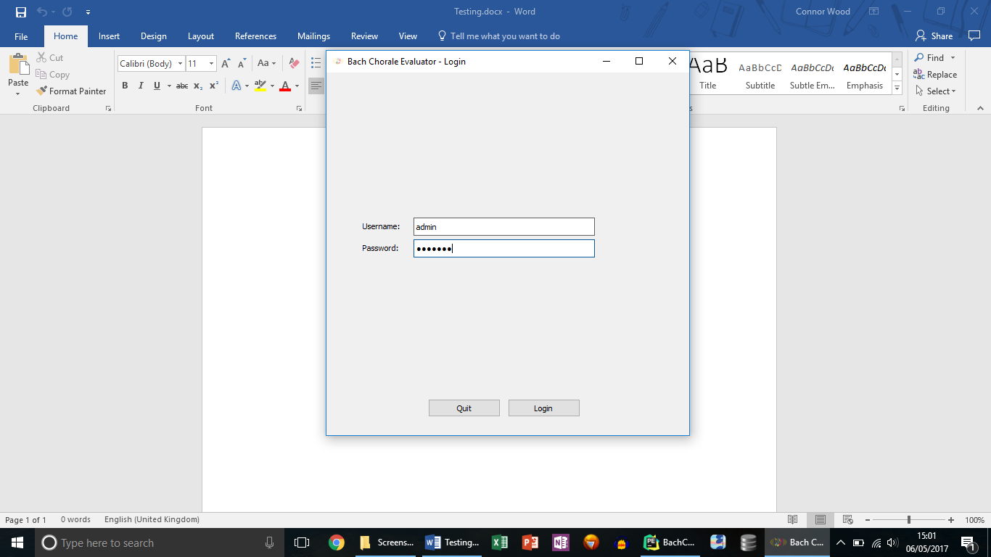

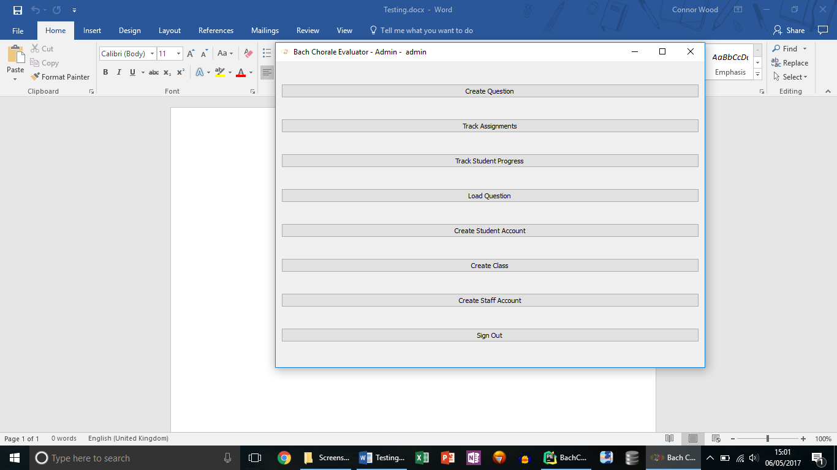

**Test 2**

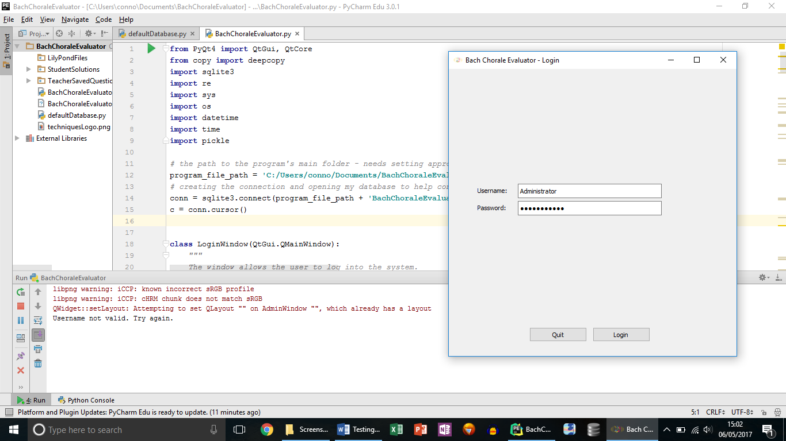

### **Changes Made & Re-testing**

**Test 3**

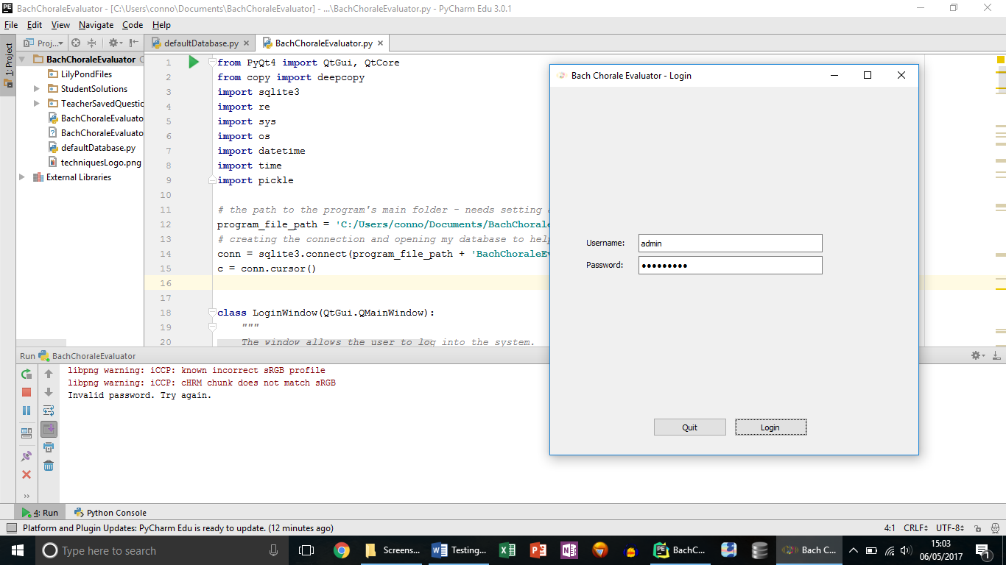

**Test 5**

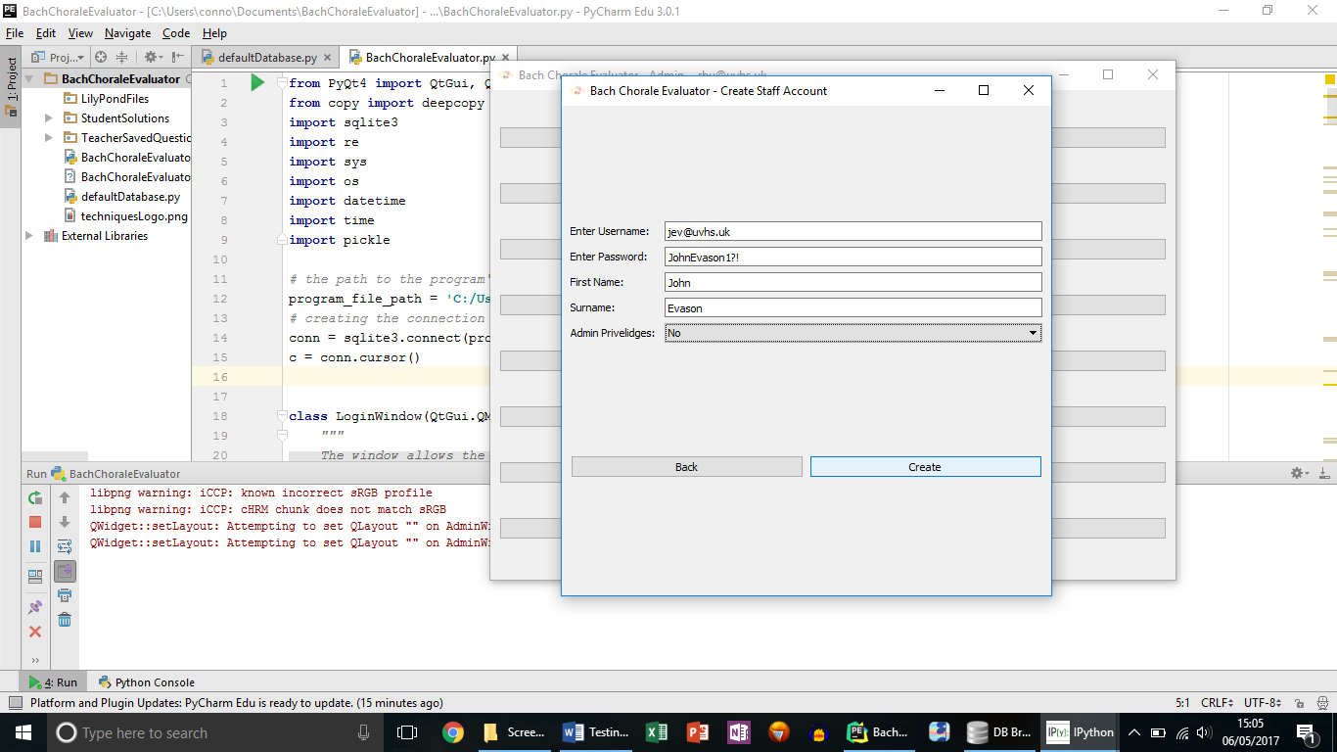

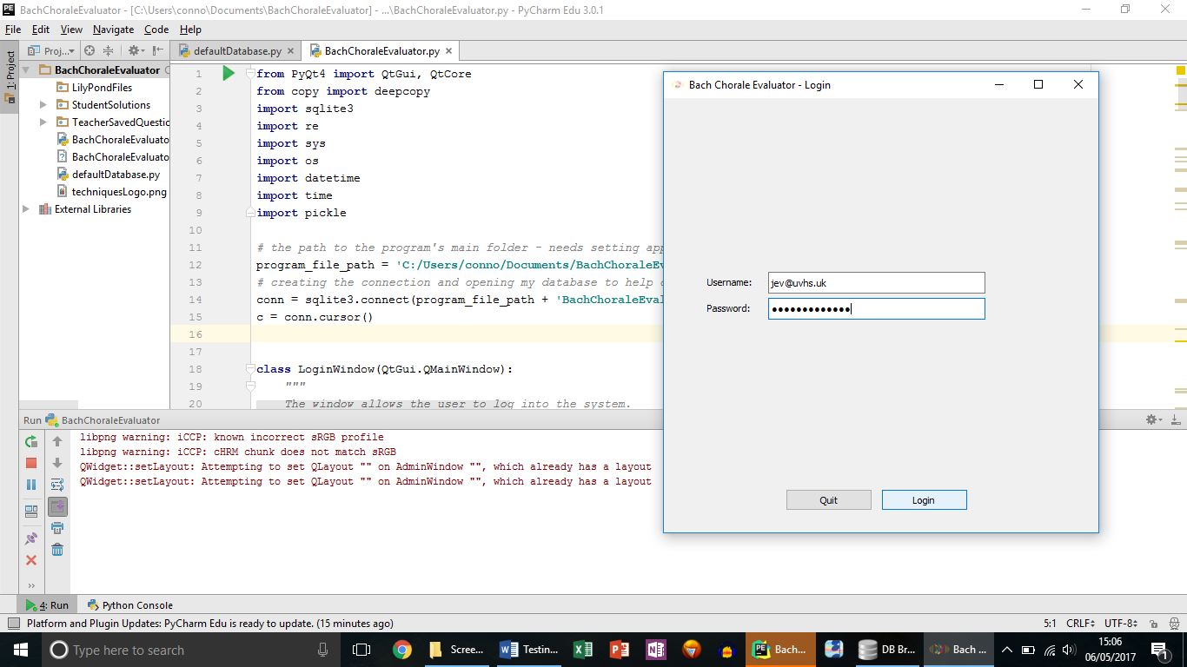

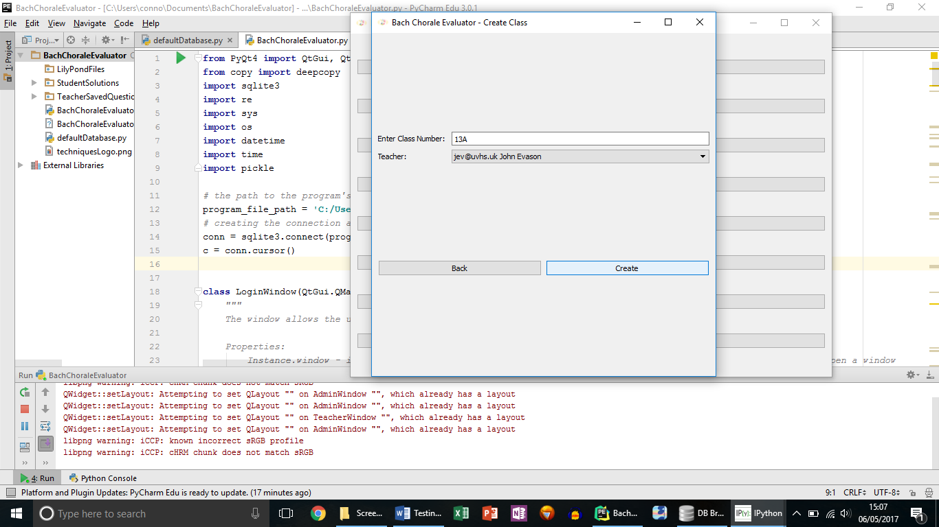**Test 6**

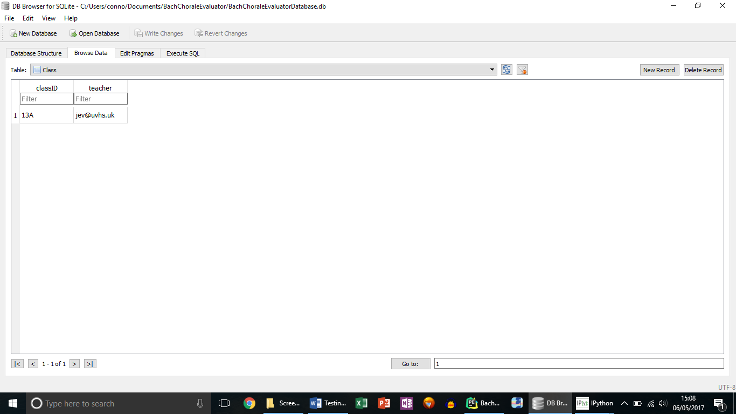

Window did not close when class was created which was unexpected and has now been rectified.

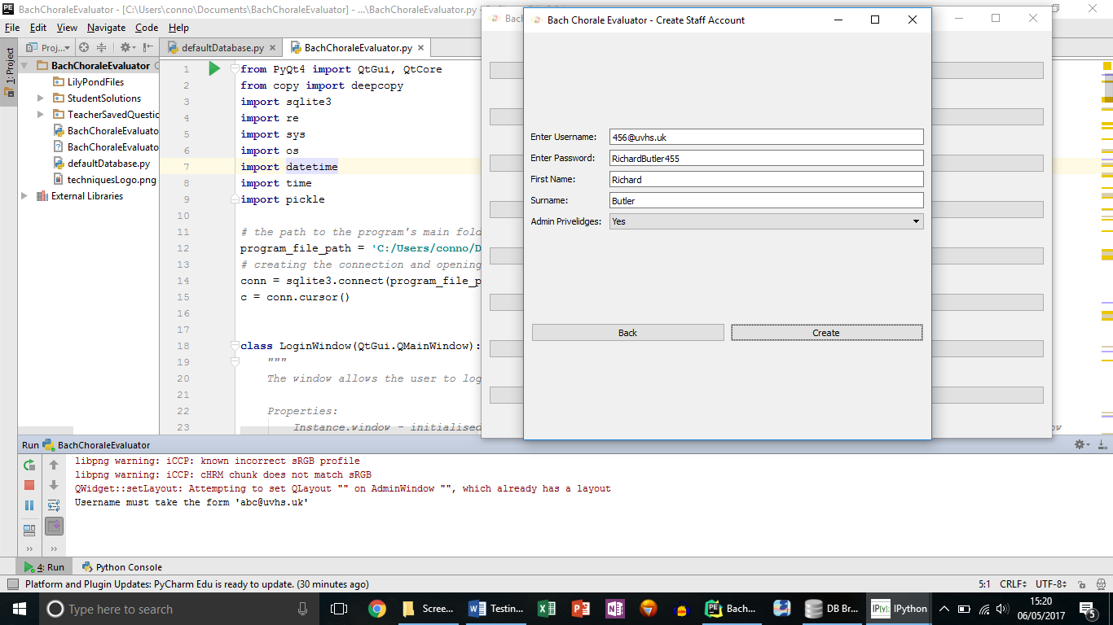**Test 10**

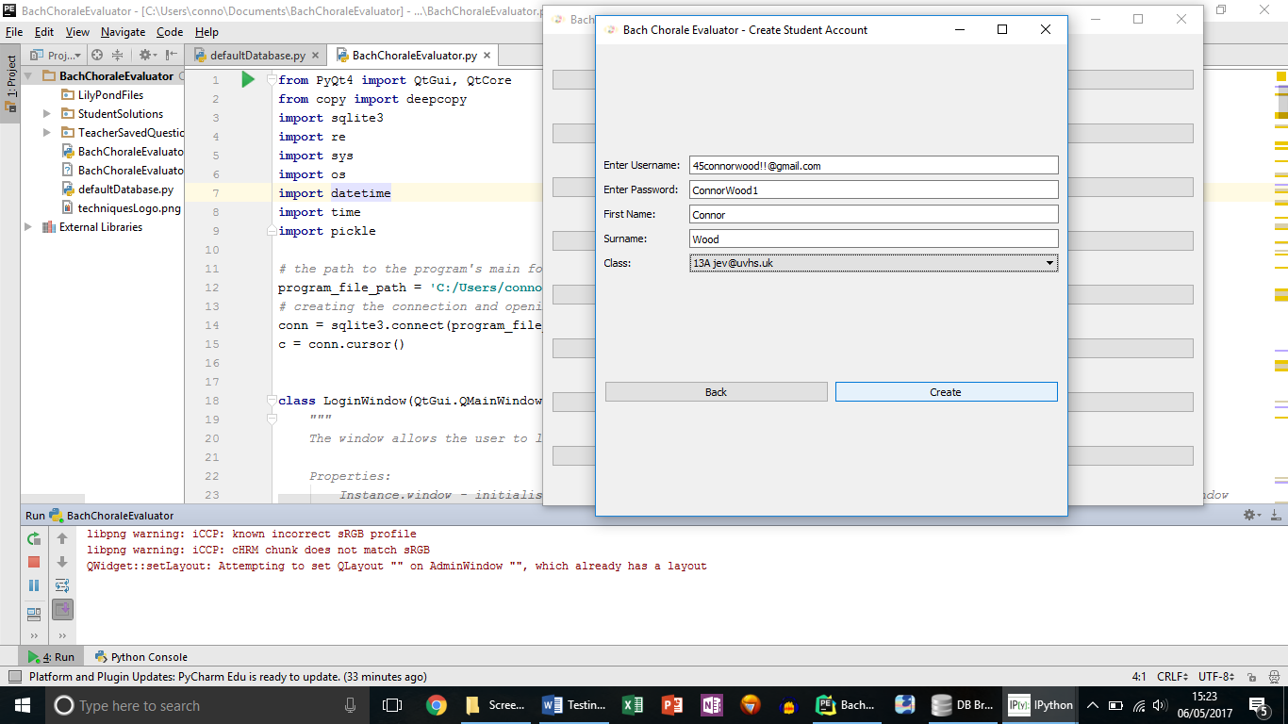**Test 12**

**Test 15**

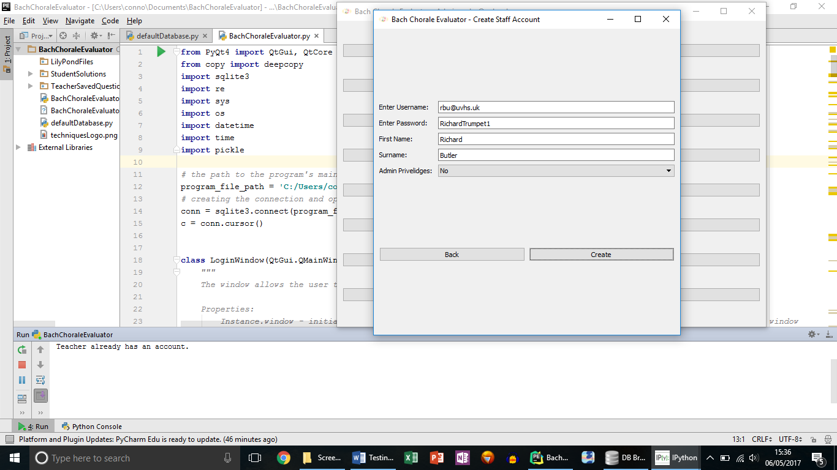

**Test 18**

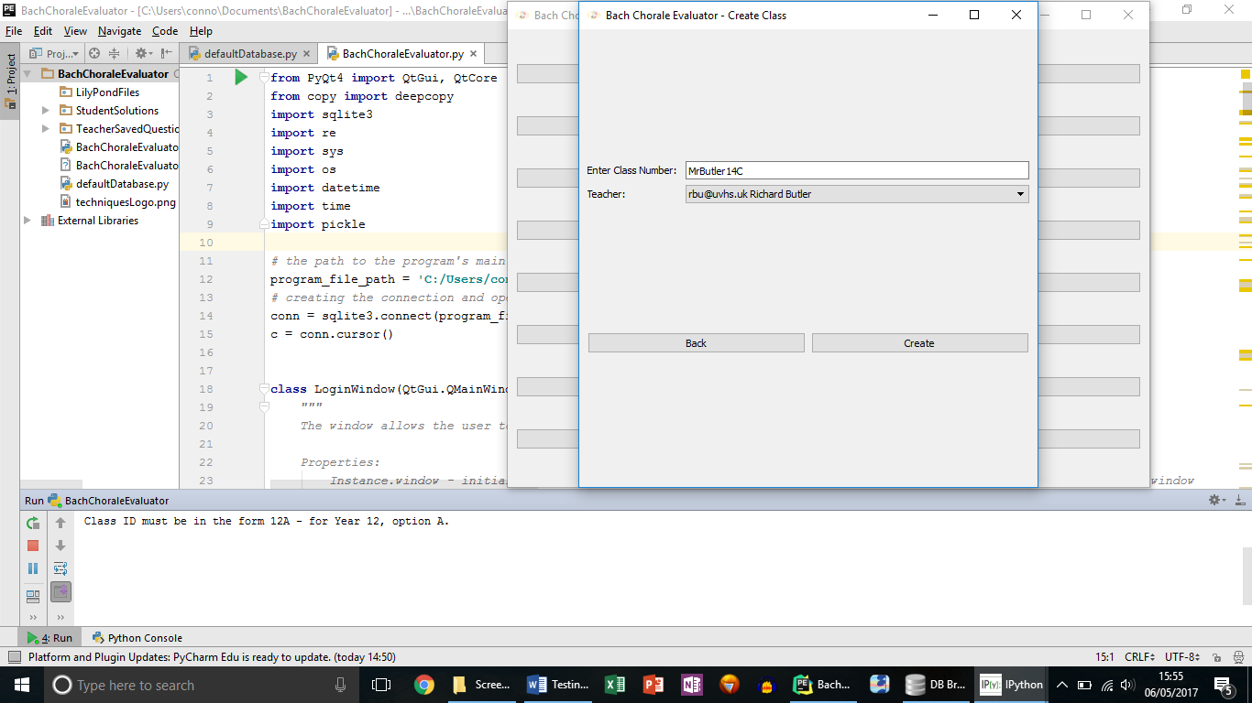

**Test 22**

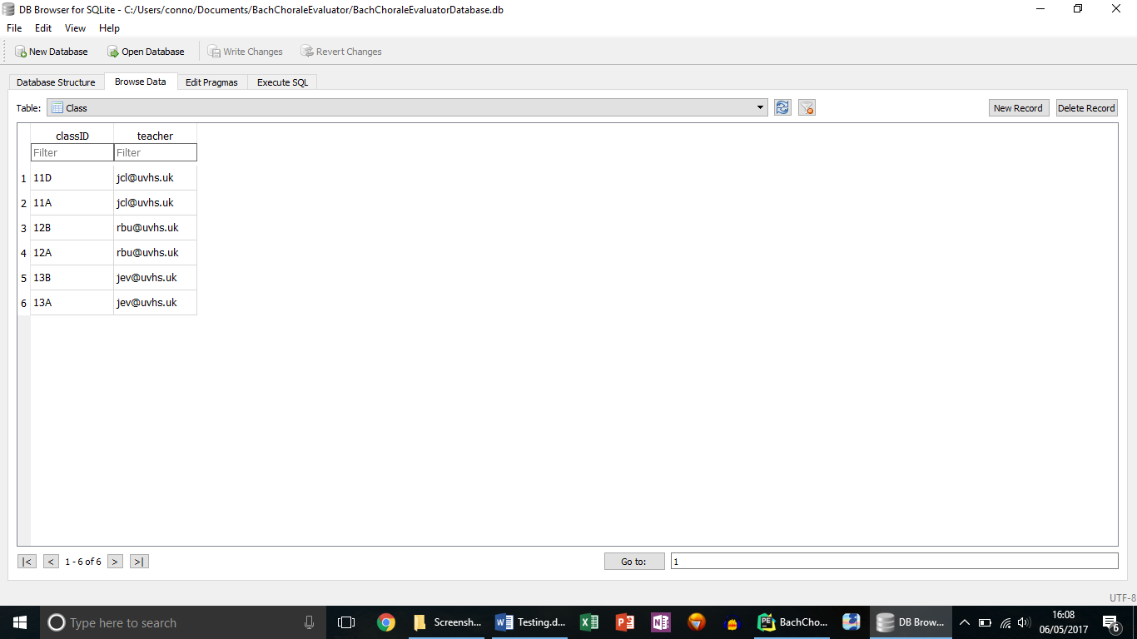As you can see from the screenshots below, I used the interface to add multiple classes, students and teachers, which are all linked together to be able to work with each other, thanks to my database design.

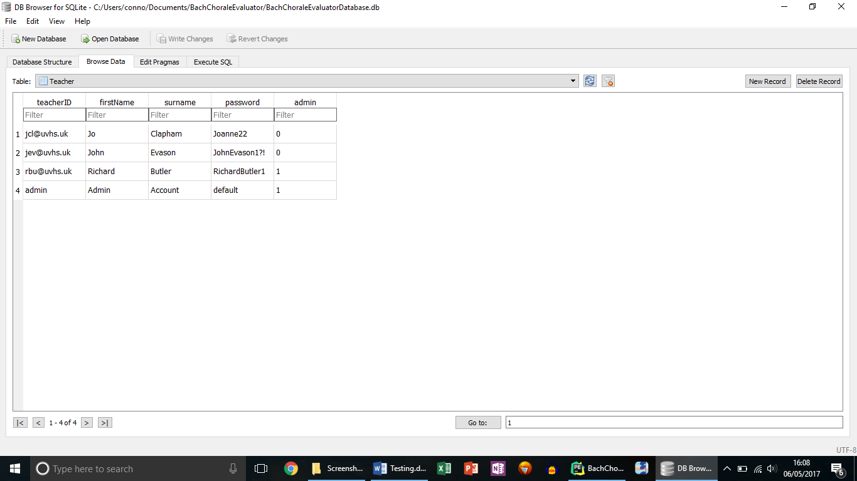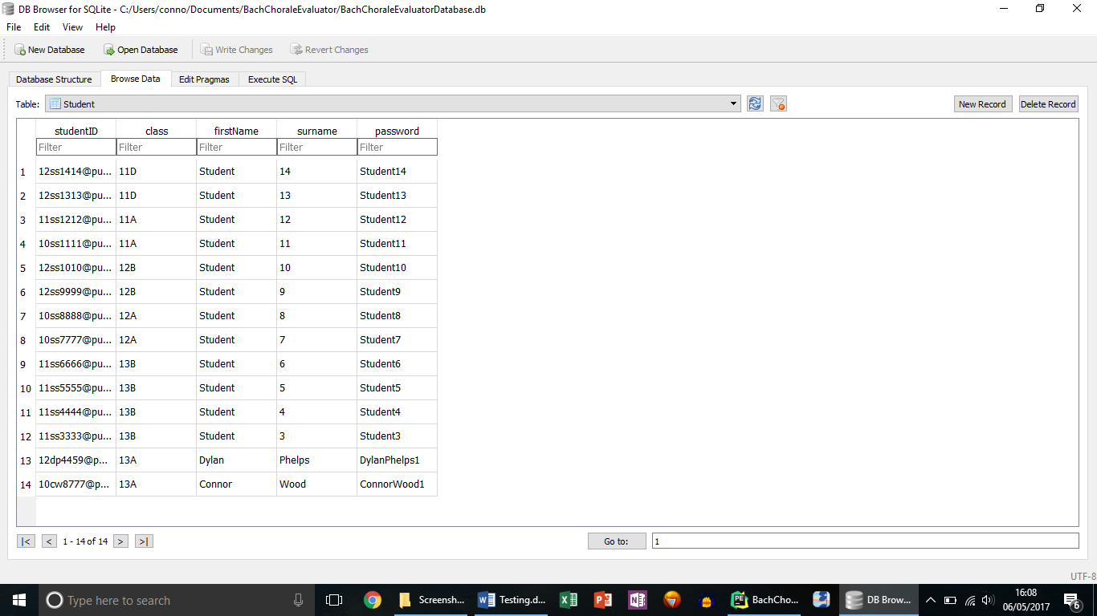

**Test 24**

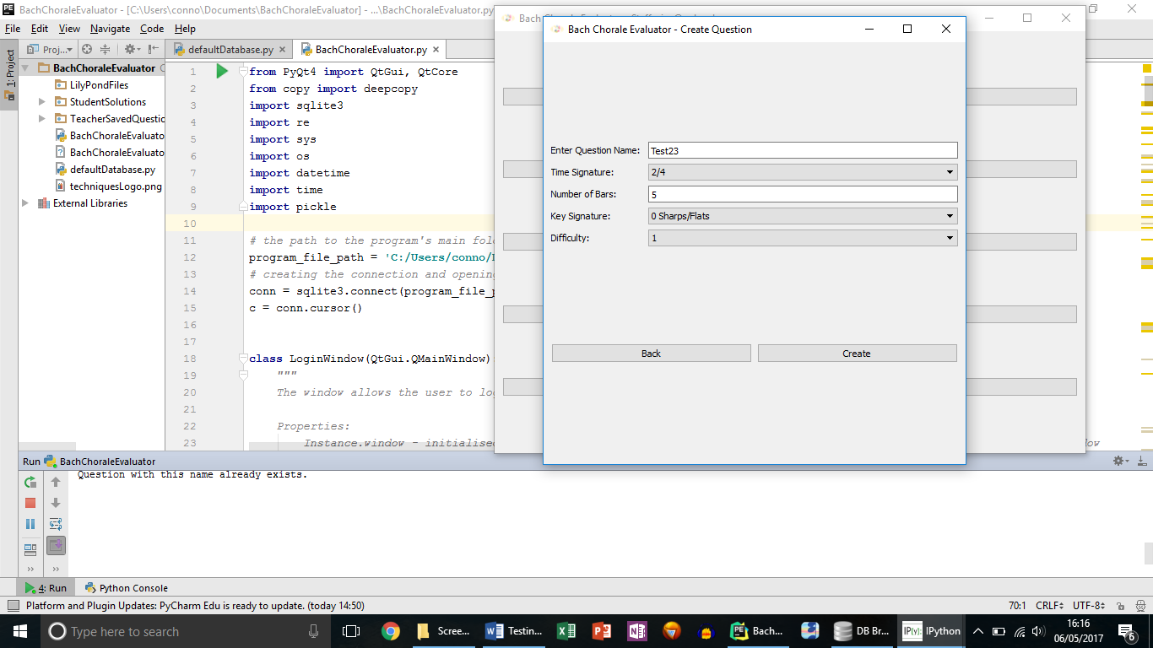

**Test 25**

Test gave an unexpected output by allowing the question to be created.

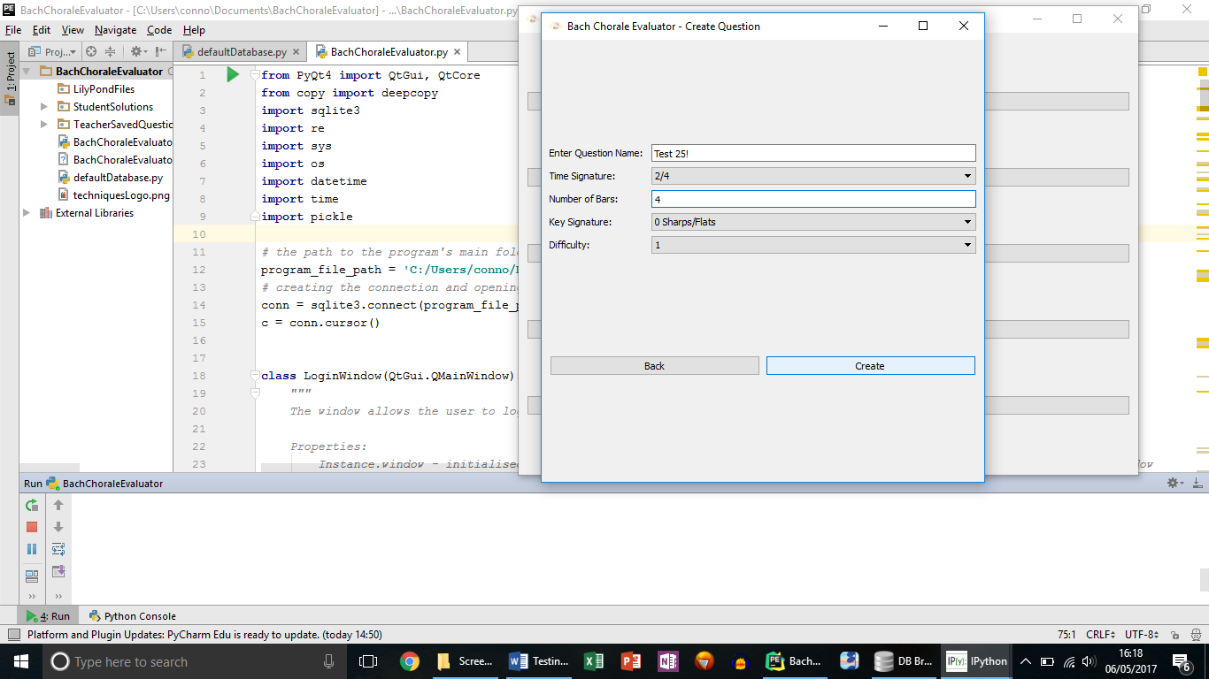

**Test 27**

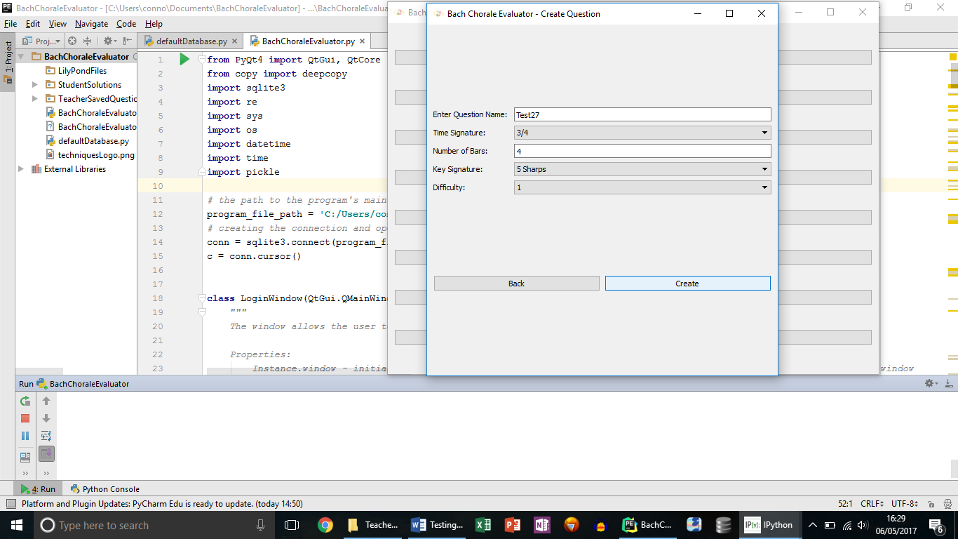

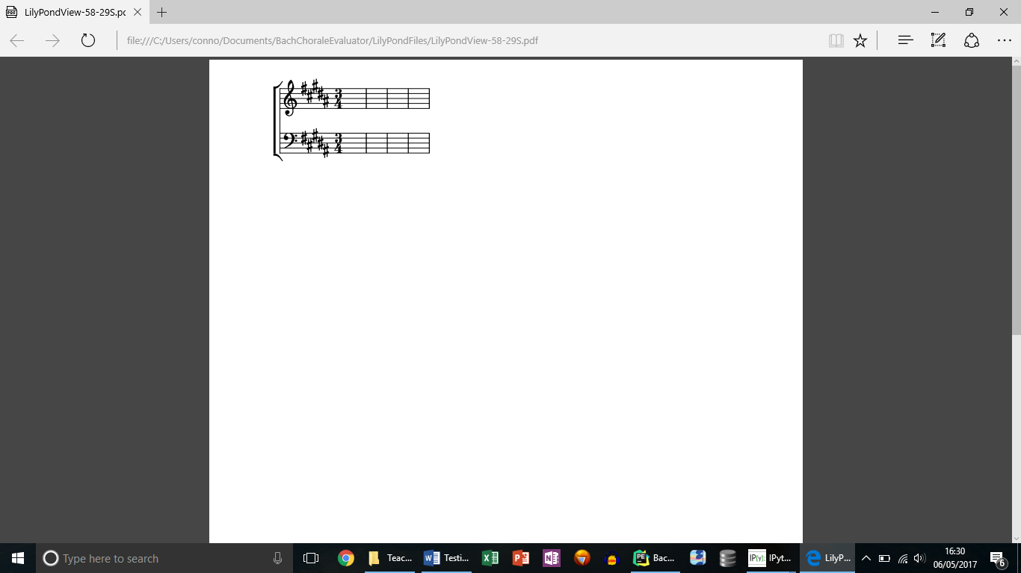

**Test 29**

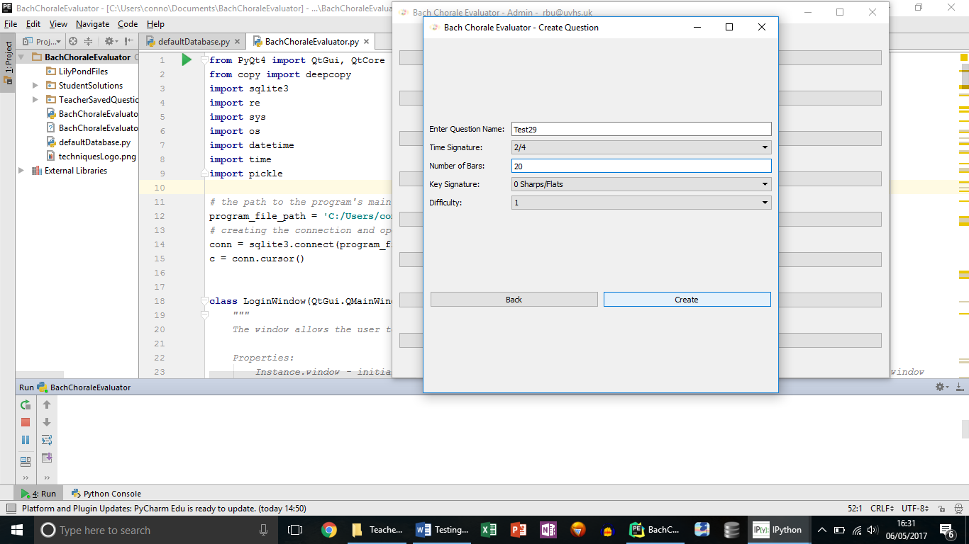

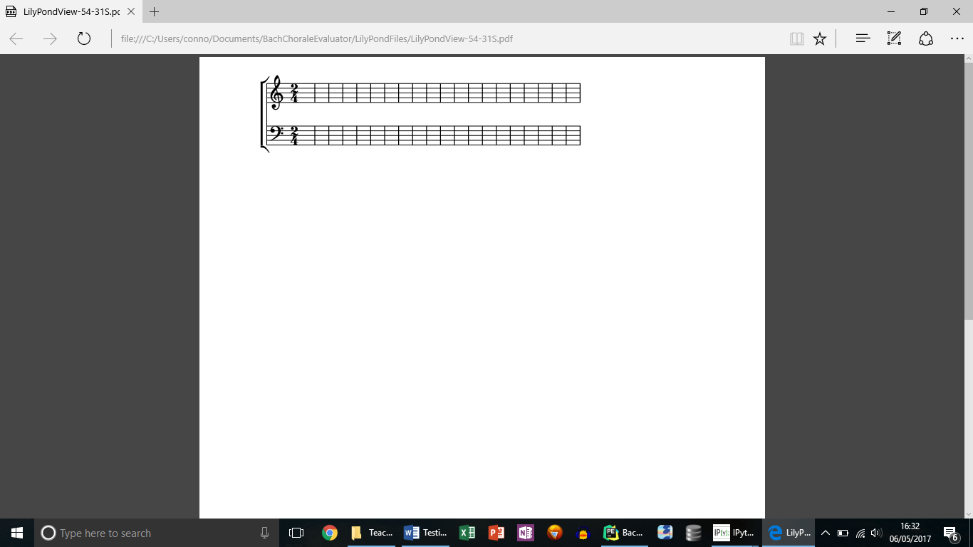

**Test 30**

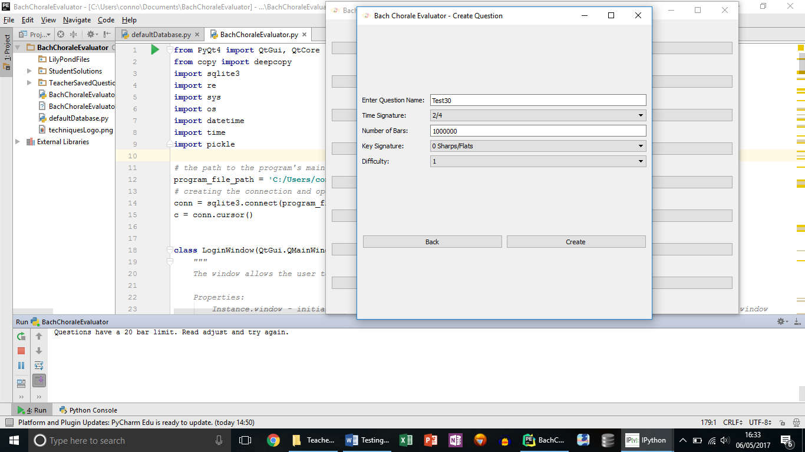

**Test 31**

Output was not as expected.

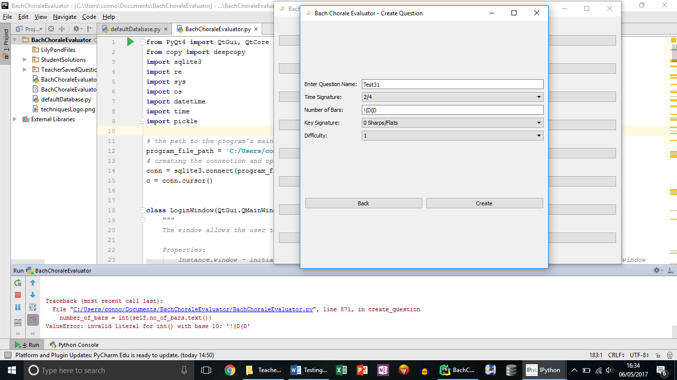

**Test 32**

This test shows all of the different note values represented in the ADTs.

Semibreves never actually need to be dotted for techniques questions, so students and teachers will not place dotted semibreves.

Placing a dotted quaver just places a quaver, because the smallest values the system works in is quavers.

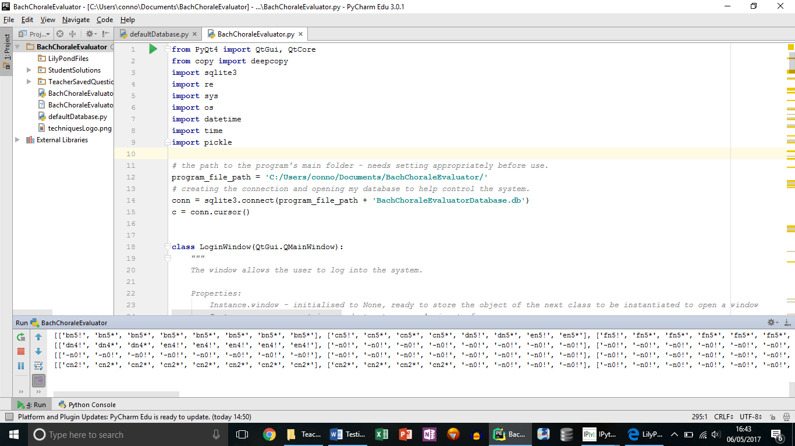**Test 33**

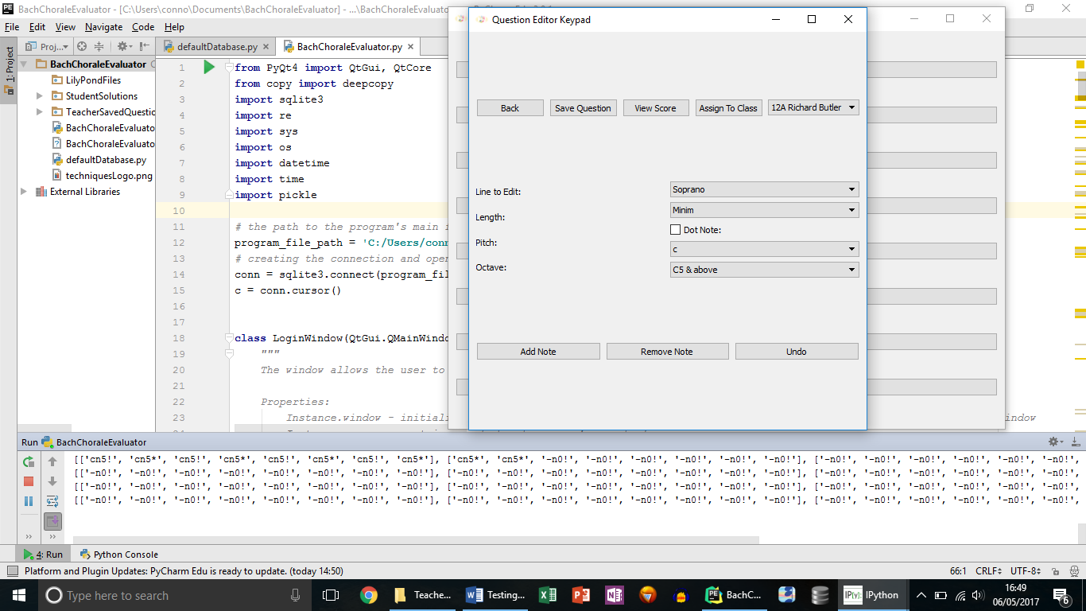

**Test 34**

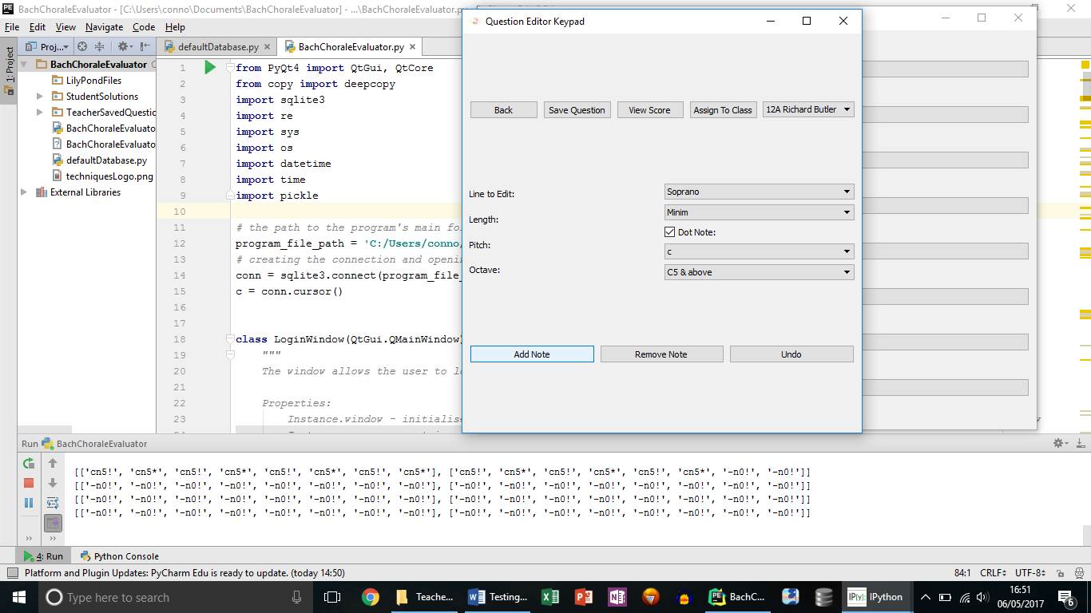

**Test 35**

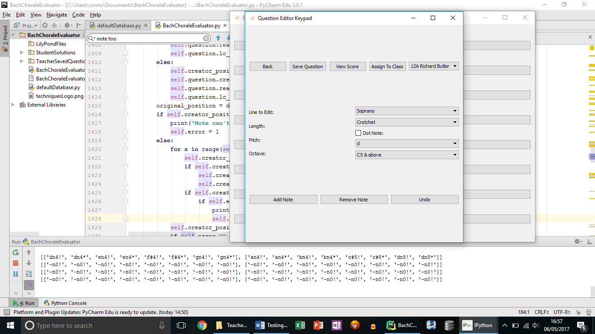

**Test 40**

Top ADT showing 2 crotchets is cut off screenshot.

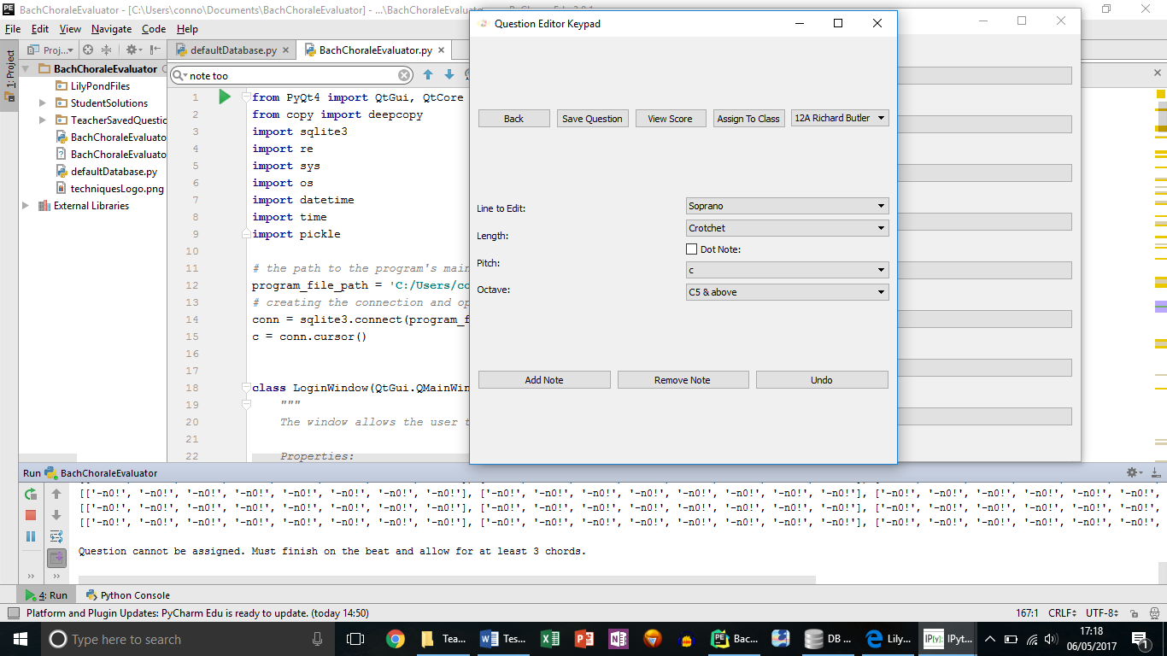

**Test 41**

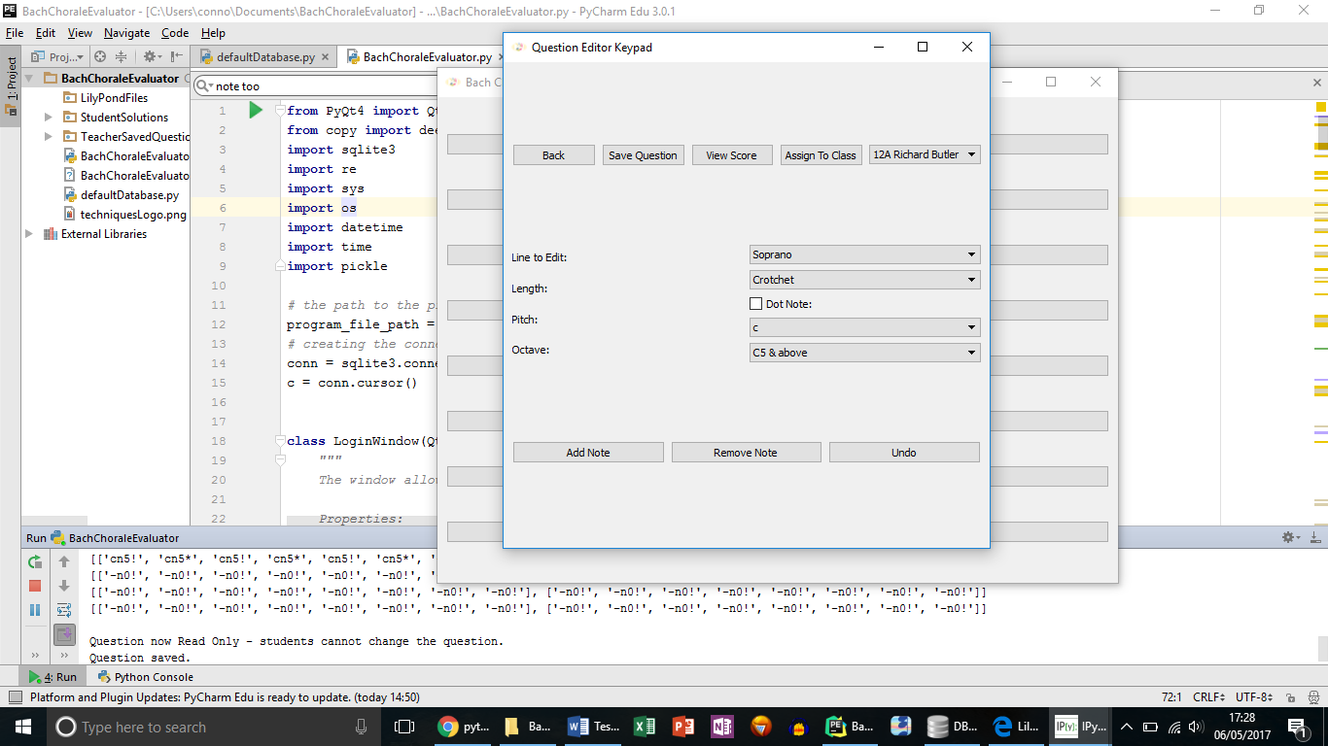

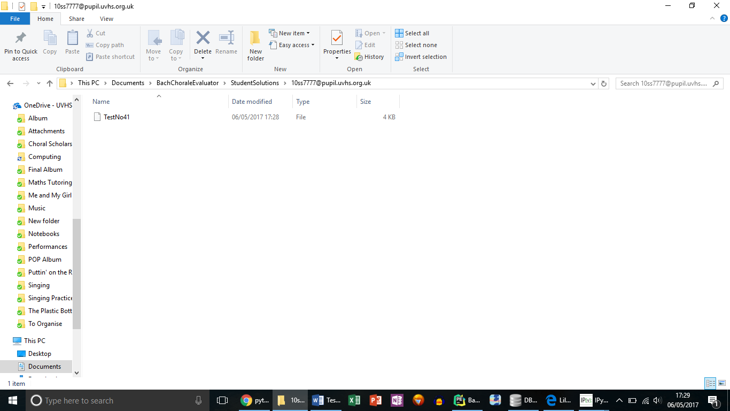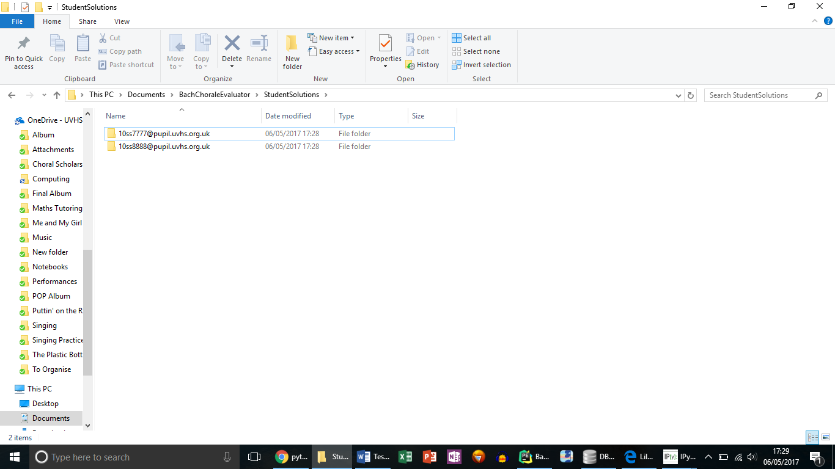

**Test 42**

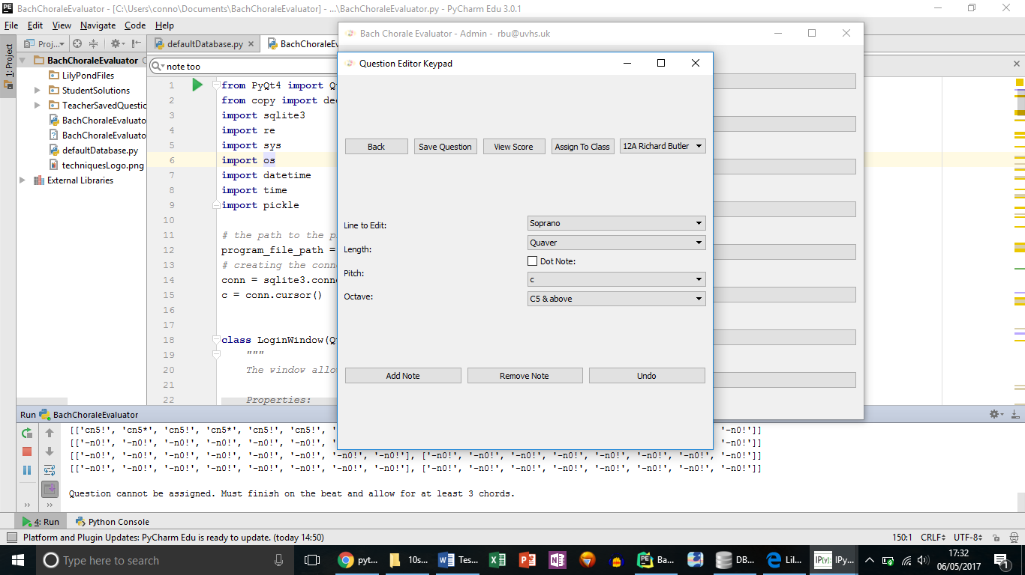

**Test 45**

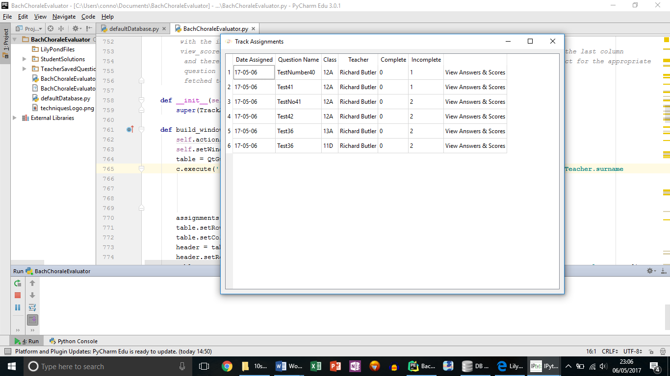

**Test 47**

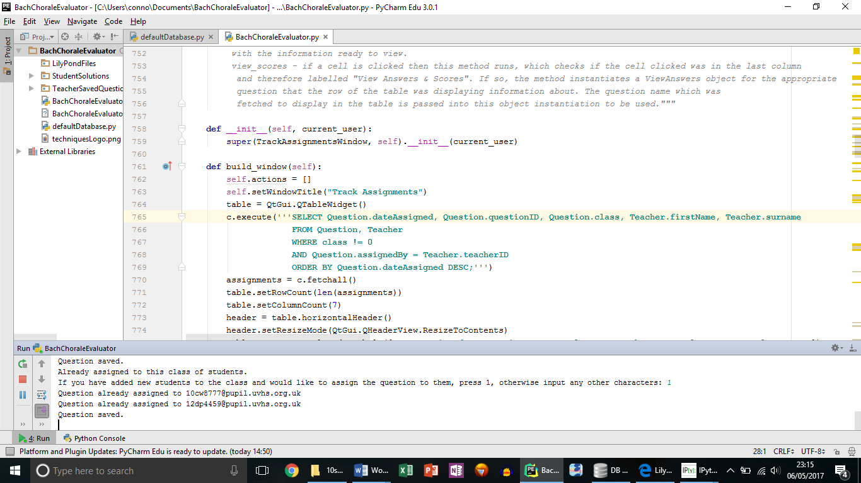

**Test 48**

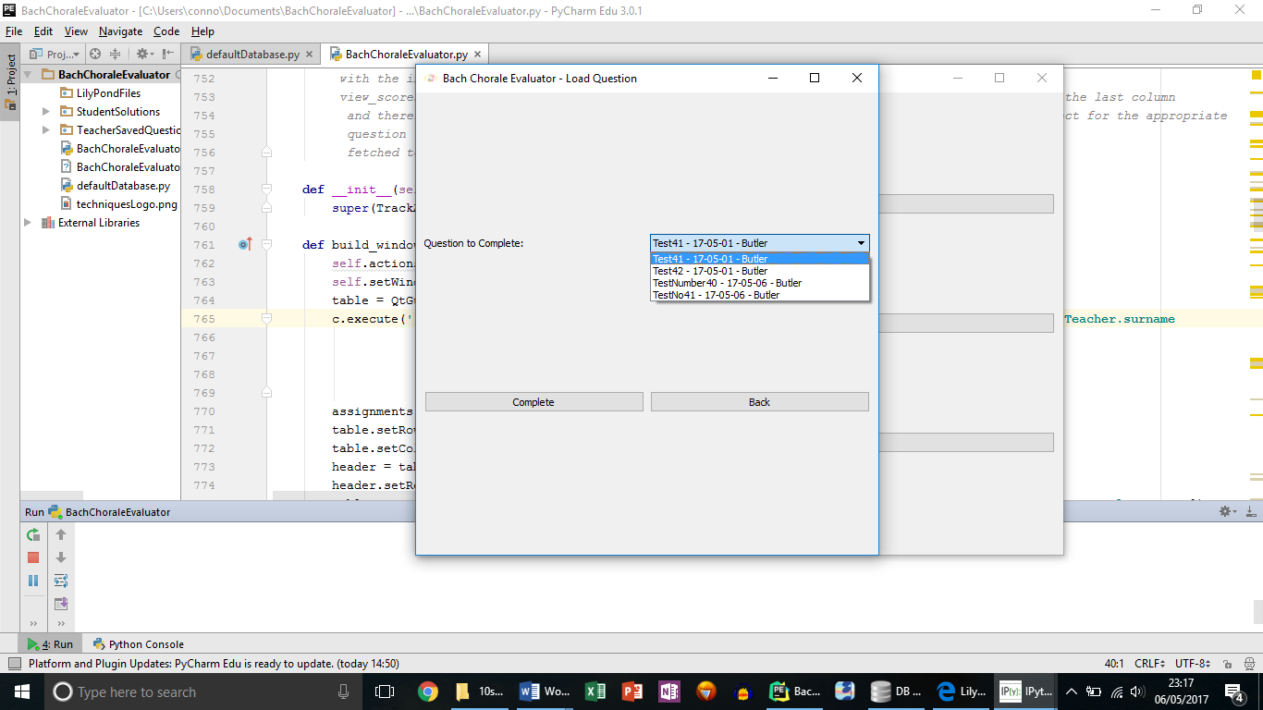

Slightly unexpected output below, as students don’t need to edit the soprano line. This has now been fixed.

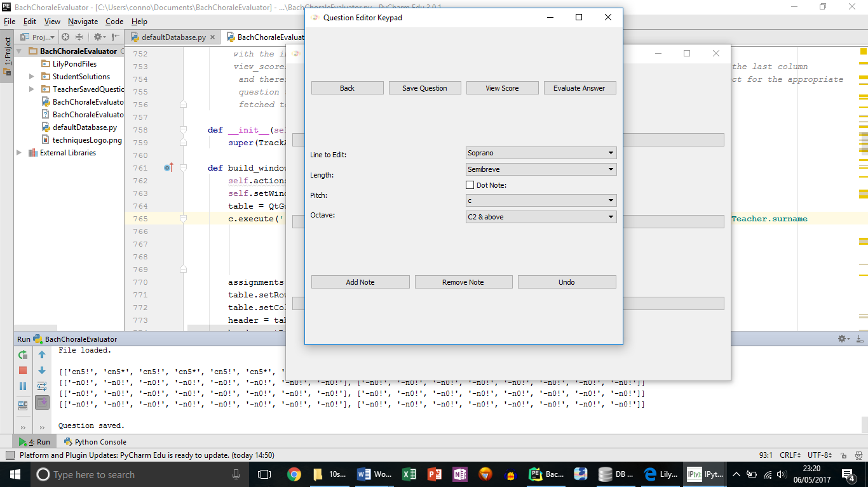

**Test 49**

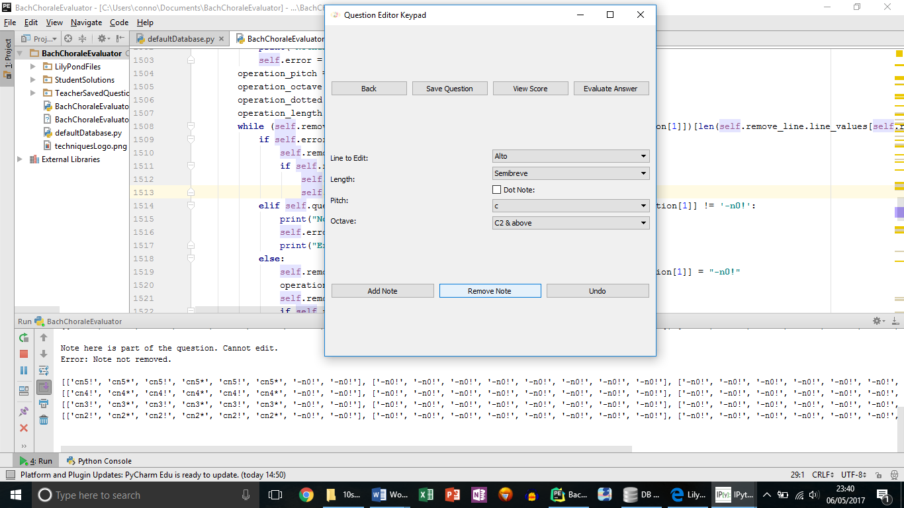

**Test 52**

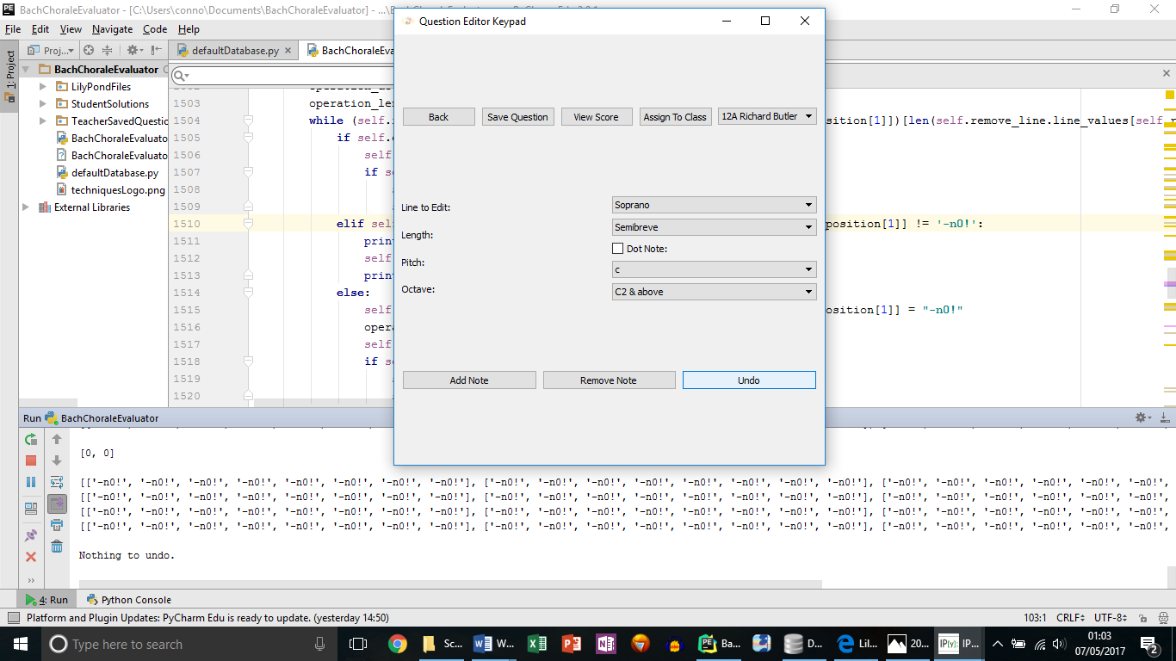

**Test 53**

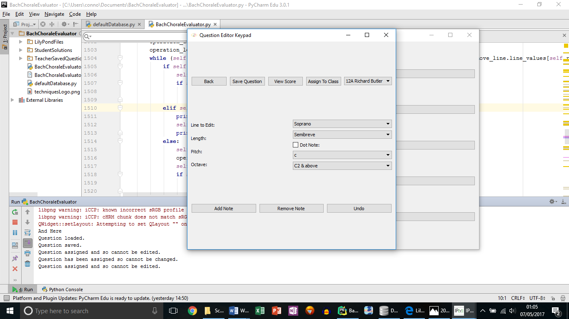

The console has printed out that statement 3 times, because 3 actions were attempted.

**Test 54**

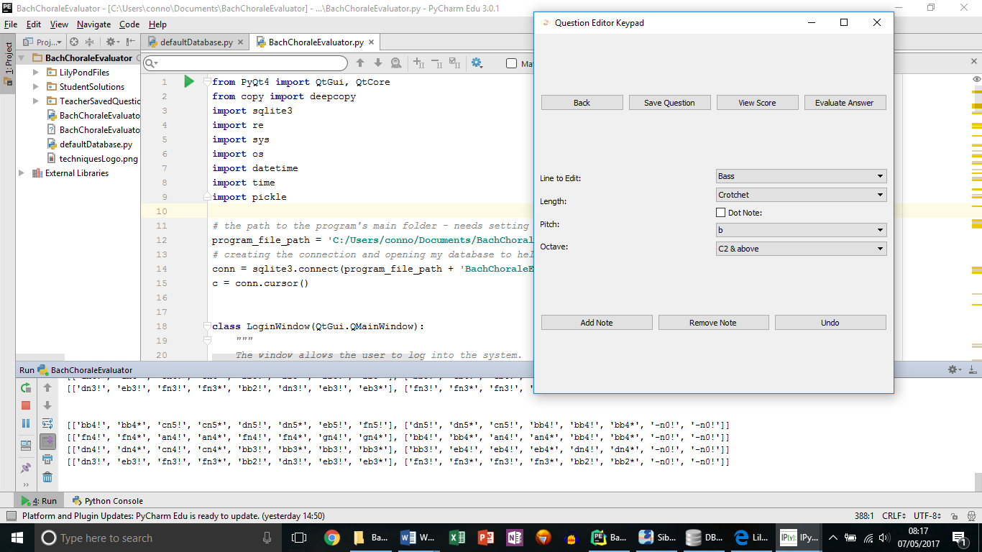

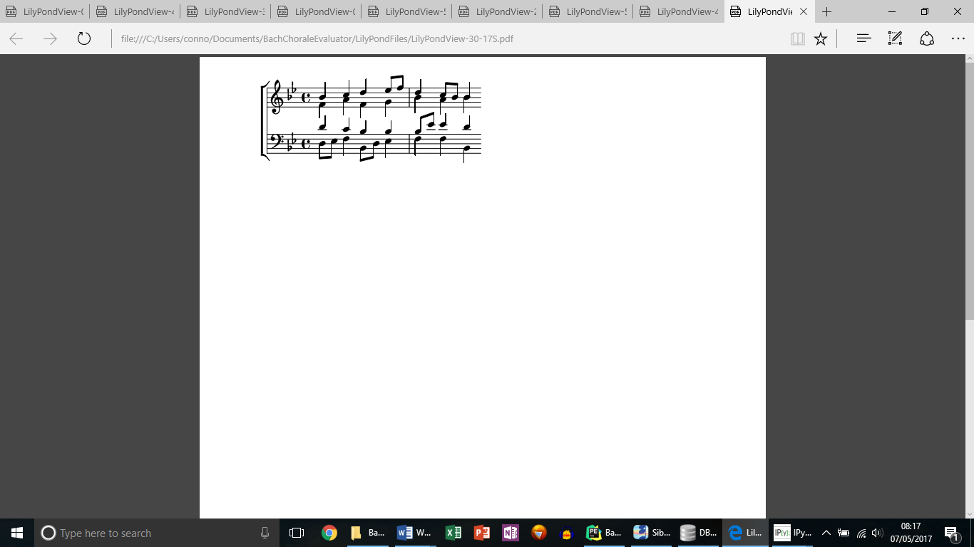

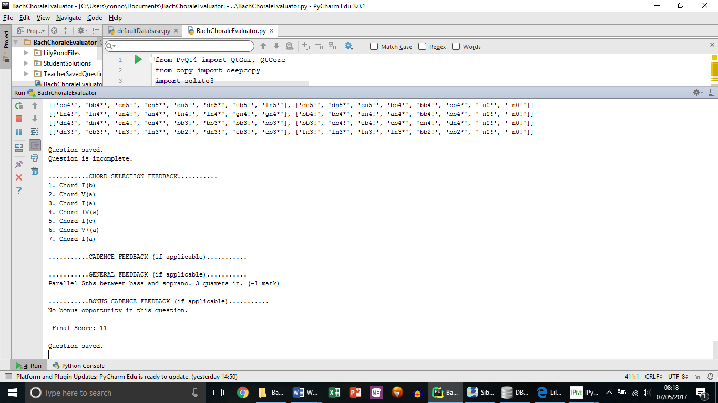

**Test 56**

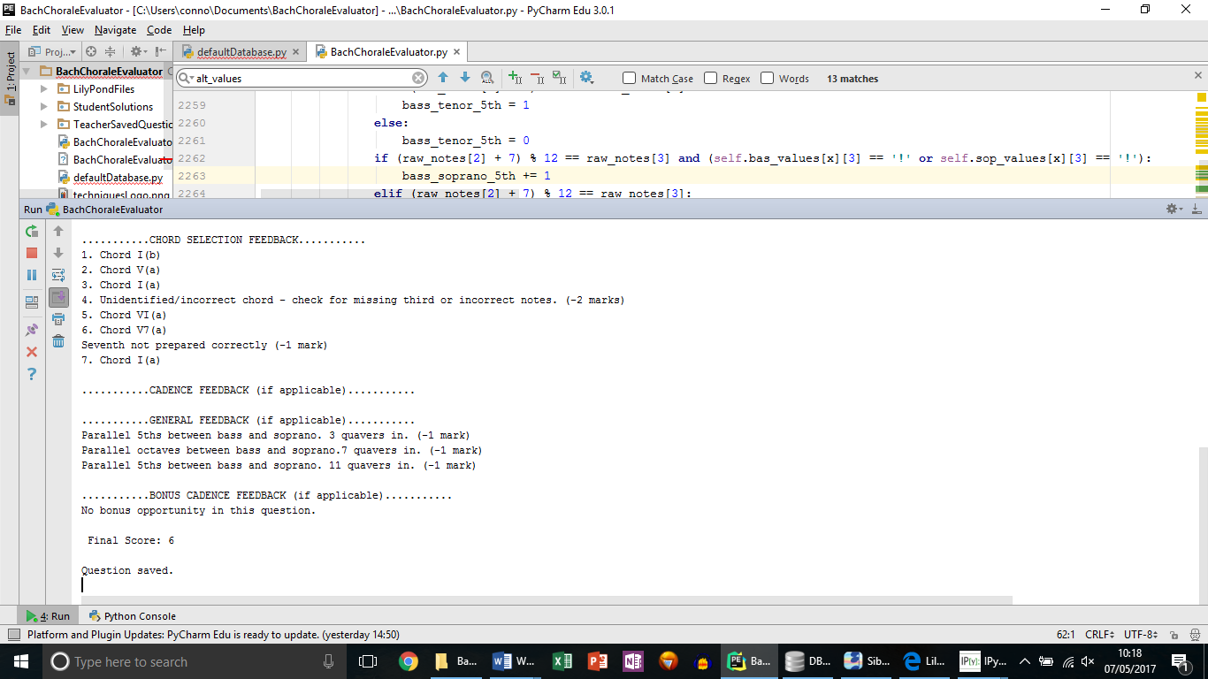

**Test 57**

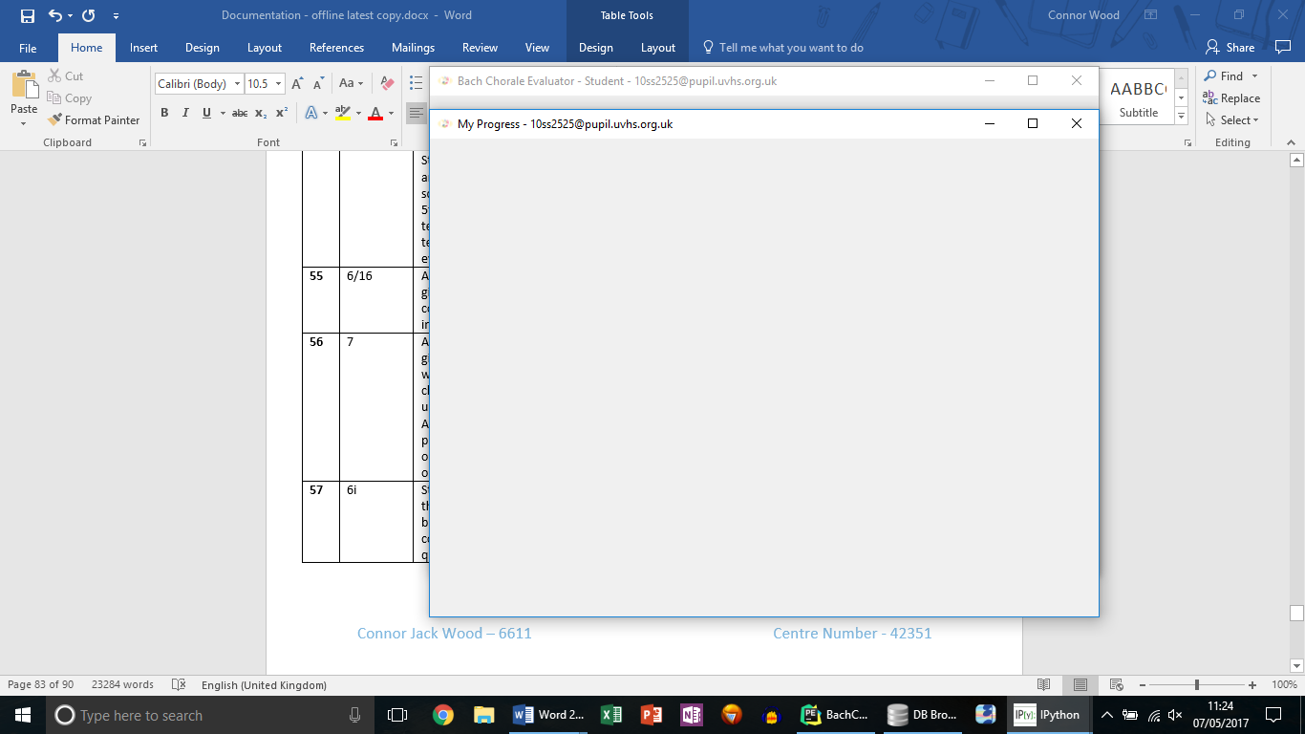

### **Unexpected Test Outcomes/Issues To Fix When Programming & Re-Testing**

Below I have explained some of the times whilst programming, when unexpected things happened and there were problems I had to fix.

1. 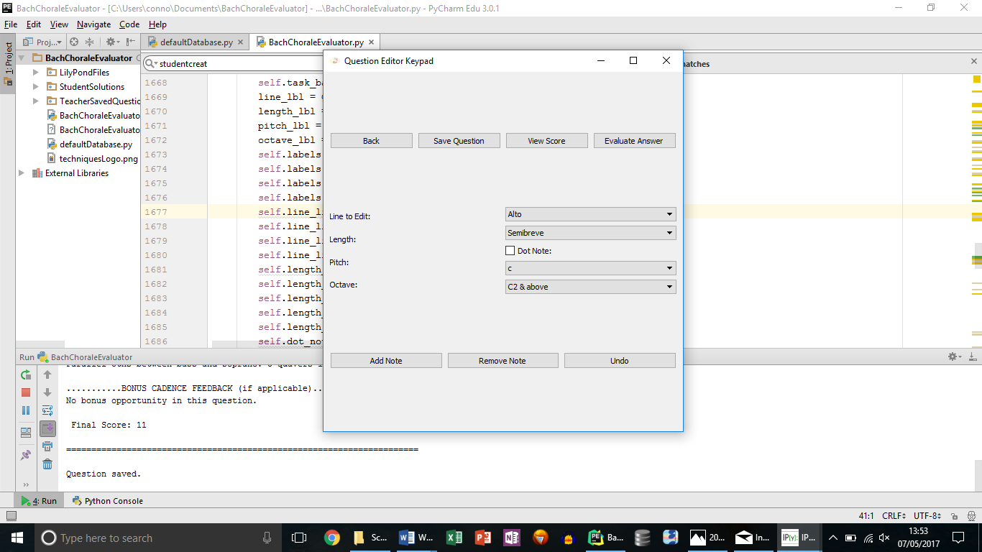When testing I discovered that Students had the option (according to the interface) to edit the Soprano line when there was no need for them to. This has now been fixed and the screenshot below shows the editor window as it opens for students, with the Line to Edit set to Alto as default.
2. Another unexpected outcome from testing was regarding Test 25, when a question name containing spaces and special characters which should have been preventing from being used by the program, was allowed to be used. Special characters and spaces in the question names can cause problems, because they are used to form the file names that the program creates, and file names can’t use special characters or there is a risk of errors in the program.

**The problem was with my regular expression:** regex = **'[A-Za-z1-9\d]{1,20}'**

It checked for letters and numbers but did not prevent other characters from being used.

**It has now been updated to:** regex = **'^[A-Za-z1-9\d]{1,20}$'**

The carat and dollar symbols show the in between the start and the end of the file name there can only be letters and numbers used.

New Screenshots of Re Testing:

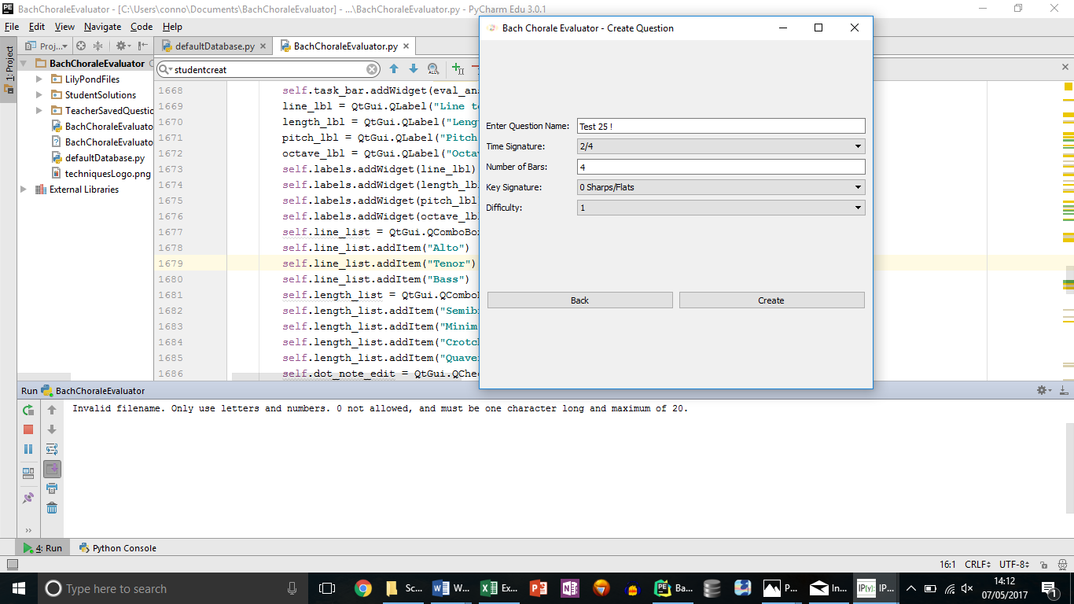

1. I had a third problem with Test 6 – when a Class was successfully created and the data base updated, the window didn’t close. I had simply missed a ‘self.close()’ statement out of my code.
2. Another problem that I had when testing early on building the program, was that when Teachers wanted to load questions, the same question to load was being listed multiple times:

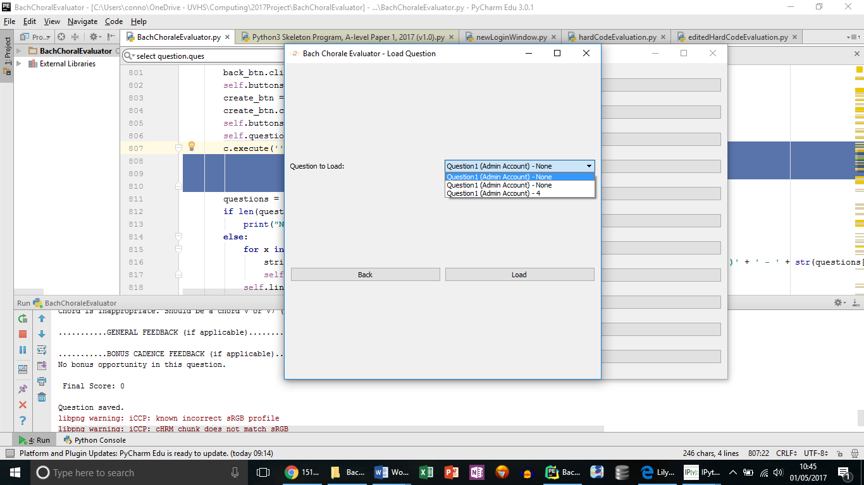

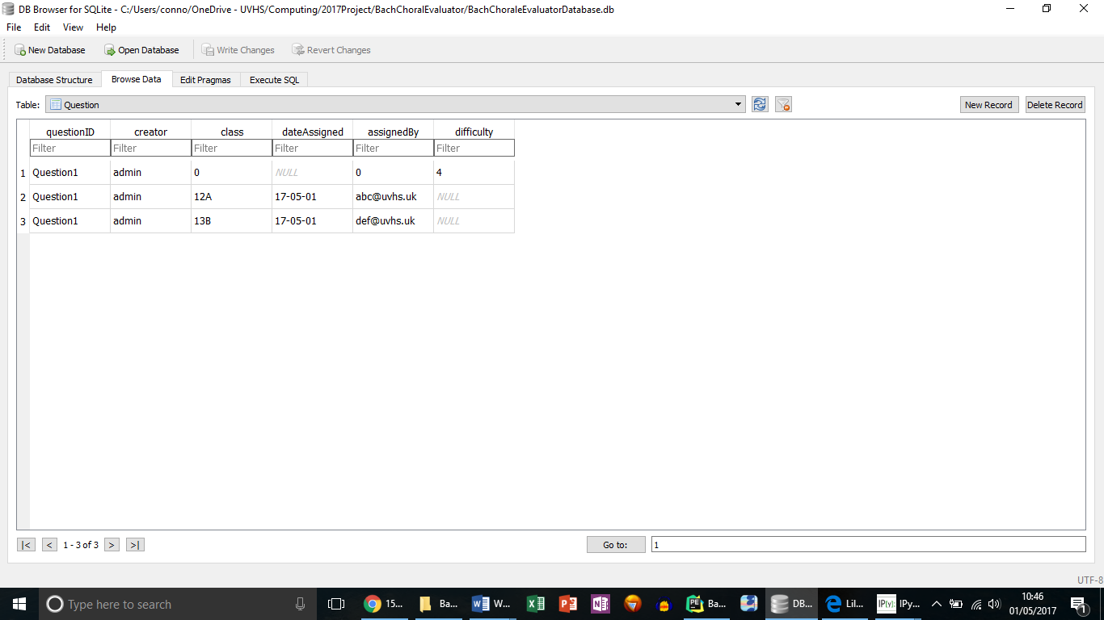

This was because when questions were assigned, new versions of them were added to the database, with information on which class they were assigned to. My SQL statement was fetching each version. Some simple validation checking for Question.class = 0 fixed the problem.

**Old Statement:**

SELECT Question.questionID, Teacher.firstName, Teacher.surname, Question.difficulty  
FROM Question, Teacher  
WHERE Question.creator = Teacher.teacherID  
ORDER BY Question.questionID ASC;

**New statement:**

SELECT Question.questionID, Teacher.firstName, Teacher.surname, Question.difficulty  
FROM Question, Teacher  
WHERE Question.class = 0  
AND Question.creator = Teacher.teacherID  
ORDER BY Question.questionID ASC;

And as seen in the main testing above, now only one of each question assignment appears when listed.

1. Missing out a simple Try Except block caused the unexpected output in Test 31.

**try**:  
 number_of_bars = int(self.no_of_bars.text())  
**except** ValueError:  
 print(**"Error - check input. Try again."**)  
**else**:

New Screenshot of Re Testing:

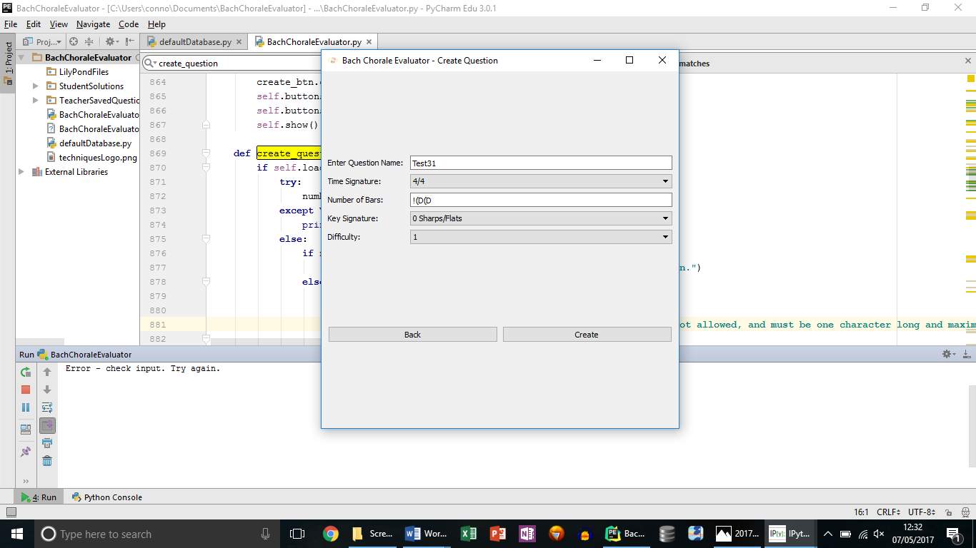

1. And one of the biggest problems I had initially with my program was with the behaviour of adding and removing notes. When I was making copies of properties to edit, they weren’t properly copying, so when the new property was updated, the old one was too – and this caused infinite loops such as the one seen here:

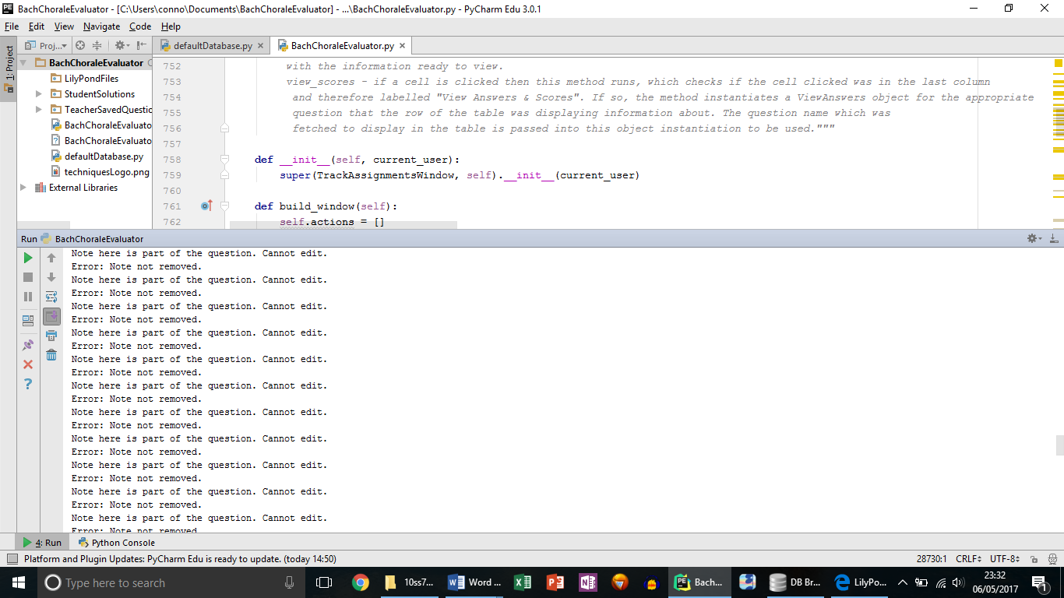

I did some reading up on the problem, and discrovered that when copying the properties, I should use “deepcopy” to avoid the problem:

<http://www.python-course.eu/python3_deep_copy.php>

And as you can see from my main testing above, the problem was fixed.

# Evaluation

### **Table Of Objectives**

Below is a table, making reference to my objectives. The table shows whether the objective was met, if it wasn’t fully met, in what way, as well as showing the potential for future development of the system, given more time and resources.

Overall I feel that my system solves the problem and carries out the actions I intended it to. After having a final conversation with Mr Richard Butler, it is clear that he is very happy with the system. We have both agreed that there is need for improving the overall interface to make the system slicker and faster to use in the future. Perhaps looking at using an interface other than PyQt4 would be interesting, as I found it difficult to work with at times. It would also be useful if in the future students could have their answers played back to them as a WAV file, so that they know what their answers sound like – this was something that I think I could have implemented given more time.

But we’ve also agreed that there is potential to develop the system further, so that it could be used to evaluated higher level questions – more like those answered in the second year of the music course. Below are some of the potential ideas that would help with this, such as working in minor keys, or working with more complex time signatures. There is also potential for the system to become an online system, allowing students to even access their work at home.

|  |  |
| --- | --- |
| Objective | Objective Met? |
| 1 | Complete |
| 2 | Complete |
| 3a | Complete |
| B | Complete |
| C | Complete |
| 4 | Complete |
| 5 | Exceeded – the only thing that limits the number of classes to be stored is the storage capacity of the system that the program is running on. |
| 6a | Complete |
| B | Complete – there is potential for the system to work with a greater number of keys with slightly different rules in the future. The system could also potentially work with minor keys in the future, and I have prepared the program for such an eventuality given more time. |
| C | Complete |
| D | Complete – again there is potential for in the future the system to be able to evaluate questions with more complex time signatures. |
| E | Mostly Complete – however it was difficult to show tied notes in LilyPond (but this is just an interface issue which could be resolved given more time). |
| F | Complete – there is potential for students to be more creative with their answers in the future if the ability to sharpen and flatten notes contrary to the key signature was added. That is a feature that could allow for techniques questions beyond the AS specification to be answered. |
| G | Mostly Complete – again there is a slight interface issue in terms of LilyPond tying dotted semibreves – but they aren’t required by Richard Butler for techniques questions. And as agreed the smallest note value the system handles currently is a quaver, so dotting a quaver still places a quaver. |
| H | Complete |
| I | Complete |
| 7 | Complete |
| 8 | Complete |
| 9 | Complete – potential for a search feature, allowing teachers to browse questions by difficulty or key? |
| 10 | Complete |
| 11 | Complete |
| 12 | Complete |
| 13 | Complete |
| 14 | Complete |
| 15 | Complete |
| 16 | Complete |
| 17 | Complete |
| 18 | Complete |
| 19 | Complete |
| 20 | Complete |
| 21 | Complete |